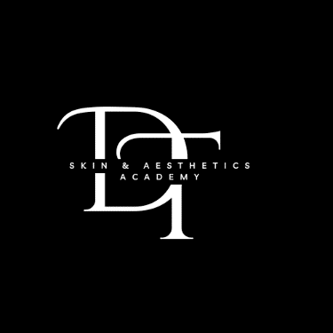

## **Ultimate Skin Boosters Package — D&T Academy**

**Ready to take your aesthetic skills to the next level?**

Our **Advanced Skin Booster Training** is designed for both medics and non-medics looking to master the art of injectable skin rejuvenation using varying concentrations of **Hyaluronic Acid (HA)**. Perfect for clients with skin lacking volume, hydration, and elasticity, this course will leave you confident and qualified to deliver incredible results.

### **What You'll Learn:**

✅ Treat the **full face**, including upper & lower eye areas  
✅ Work on **neck, chest, hands, knees, and stomach**  
✅ Explore multiple product types and advanced injection techniques

### **Course Format:**

📚 **1 Day In-Person Training + Online Theory Course**  
💻 Online demonstrations, quizzes, and exams  
📲 24/7 WhatsApp support group  
🛒 Curated list of product & equipment suppliers  
📝 Insurance company contacts & guidance  
🤝 Opportunity to join our D&T Team  
🎨 Access to professional social media content & graphic design services  
📣 Business advice and discounted progression onto other advanced courses

### **You’ll Also Receive:**

🎓 CPD Accredited Certificate  
📄 Consultation templates & aftercare guides  
📈 Social media content on your training day  
🩺 Comprehensive health & safety, anatomy, and contraindication training  
📖 Learn skin types, conditions, and treatment planning  
💉 Step-by-step product tutorials for each area

**Become part of a supportive, professional network and elevate your aesthetic business today!**

### **Your Course Journey:**

* **Online Theory, Demonstrations, Quizzes & Exams**
* **Training Manuals (Online & In-Person)**
* **In-Person Theory & Practical Training Day (Day’s)**
* **Live Models for Practical Assessments**
* **Aftercare Advice & Consultation Templates**
* **24/7 WhatsApp Support Group**
* **Guidance on Equipment, Product Suppliers & Insurance**
* **Assistance with Social Media Content, Business Plans & Branding**
* **Introductions to CPD, AIT and Industry Experts**

### **Additional Course Highlights:**

📌 Health & Safety Legislation  
📌 Treatment Areas & Injecting Methods  
📌 Infection Control & Contraindications  
📌 Product Knowledge & Training  
📌 Social Media Marketing Strategies  
📌 Client Consultations & Aftercare Essentials

By enrolling in this comprehensive program, you’ll gain not just qualifications — but confidence, real-world skills, business savvy, and an invaluable network to support your journey.

**Ready to start your new career with us?**

**Join the D&T Academy family today.**