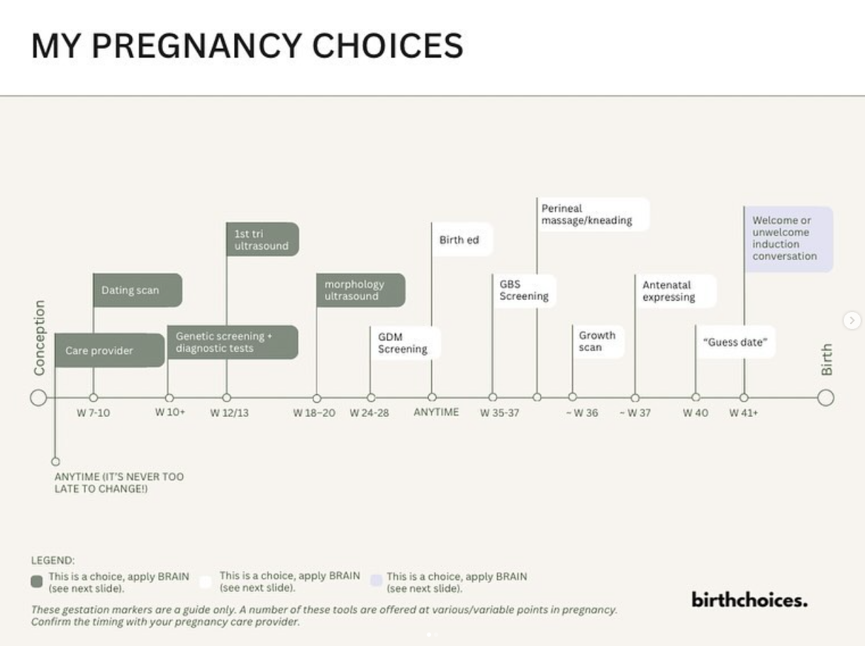
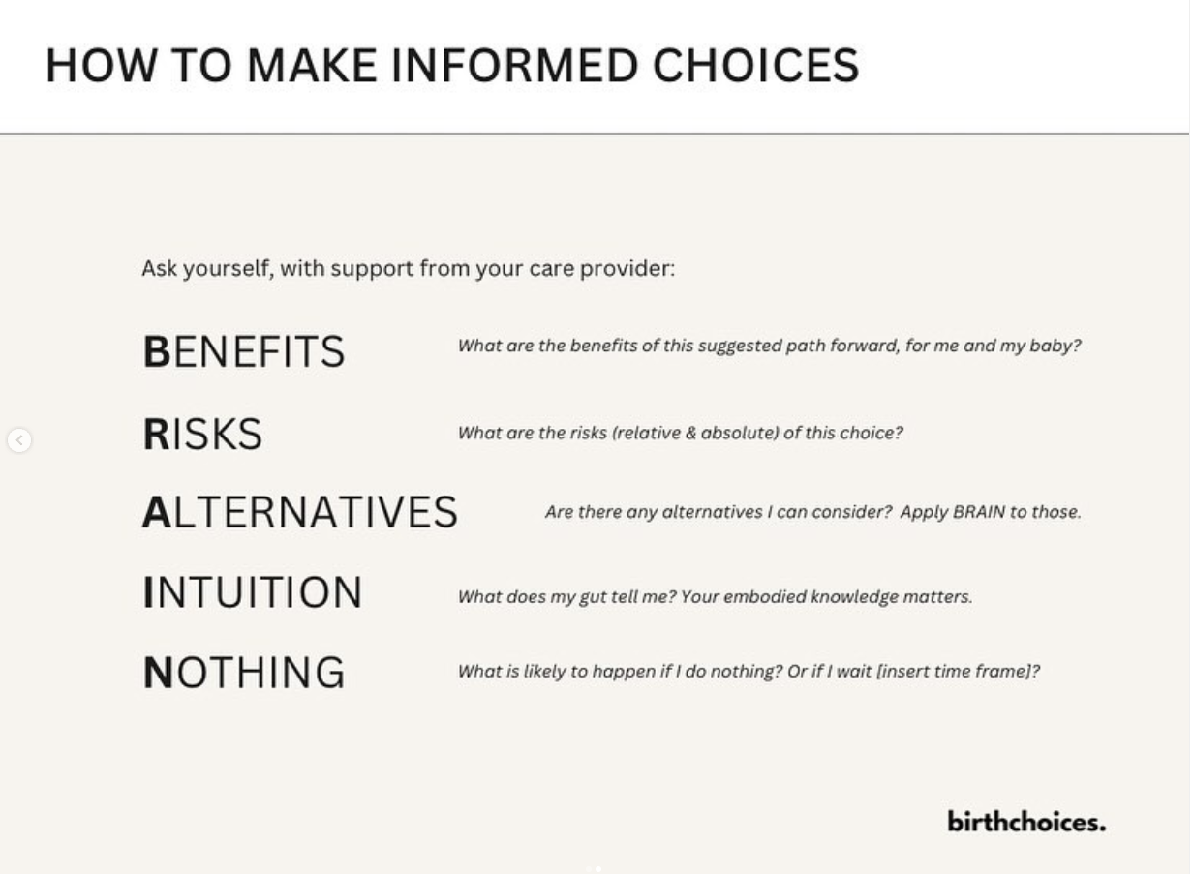

Benefits – What are the benefits of this suggested path forward, for me and my baby?
Risks – What are the risks (relative and absolute) of this choice?
Alternatives – Are there any alternatives I can consider? Apply BRAIN to those
Intuition – What is my gut saying? Your innate wisdom matters
Nothing – What is likely to happen if I do nothing? Or if I wait (insert timeframe)?

Here is a snapshot of some of the tests/screening tools/interventions that may be offered to you in pregnancy.
They are plotted like this to give you an idea of what may be coming up, not because it is the road you necessarily need to travel. Every one of these is a choice for you, ideally to make in an informed way, with full support from your chosen care provider to assess the benefits/risks/alternatives before deciding if it’s a full body yes for you. Some of these are more “standard” than others (a growth scan for example, should never be “standard”, but is something that frequently arises, and more commonly in pregnancies with certain “risk” profiles/certain models of care).
It can be easier to follow the standard path, and certainly you may face resistance in deviating from it, but that shouldn’t be what dictates your decisions. I know for me (Alice), even choosing not to do a dating scan (and also delaying the NIPS I had elected to do) until my 13 week scan, felt like hard work (much confusion on the part of medical receptionists when the system expected me to have ticked certain, very much optional!), boxes. For me, having had a previous loss after a dating scan, I knew it wouldn’t be helpful for me, and wouldn’t change the course of my care. Make decisions based on what is right for YOU, and find a care provider (and/or alternative supports) who backs you in that.
These gestation markers are a guide only. A number of these tools are offered at various/variable points in pregnancy.
This list isn’t exhaustive (there are other tests and screening tools offered particularly in early pregnancy), and some choices around interventions in late pregnancy geared towards induction, that we will address separately. As always, discuss the timing and appropriateness for you with your pregnancy care provider.
Source: Department of Health (2018) Clinical Practice Guidelines: Pregnancy Care. Canberra: Australian Government Department of Health. | Queensland Health (2023) Clinical Guidelines. Perineal care. Guideline No. MN23.30-V5-R28

