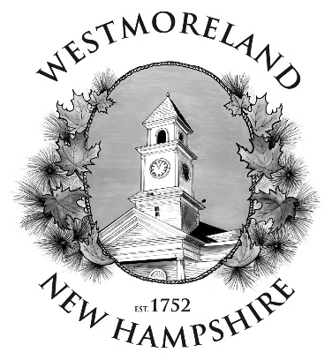
Zoning Board of Adjustment
Town of Westmoreland
780 Route 63
PO Box 55
Westmoreland, NH 03467

21 June 2024

Hubbard Farm, LLC
195 Main St.
Walpole, NH 03461

Dear Hubbard Farm LLC,

You are hereby notified that the Zoning Board of Adjustment voted to grant the variance cited in your application of 6 May 2024. The application requested a variance to install 450 solar panels to match the electric demand at this Hubbard Farm location at 973 River Road (R1, Lot 6) in accordance with Article IV Section 432.1 of the Town Ordinance. This decision was reached during the public hearing held at Westmoreland Town Hall on 19 June 2024.

During the public hearing, you satisfactorily described in detail the 5 requirements for granting a variance. The documents that were received and the meeting minutes will be filed at the Westmoreland Town Office.

Please contact me if you have any questions pertaining to this decision.

Regards,

Kaelyn Willette
Zoning Board of Adjustment Clerk

Cc: Town Administrator, Planning Board, Zoning Administrator, Building Inspector

PHONE (603) 399-4471
FAX (603) 399-4386
E-mail: zbaclerk03467@gmail.com

