Good Advice from Benjamin Franklin
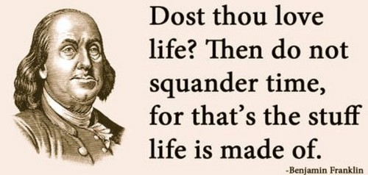
Did you know that today is Benjamin Franklin day?
No. I didn’t either.
But according to my calendar of unusual and little known holidays, we celebrate the life of this great American patriot on his birthday, January 17th.
Born in1706, Franklin became one of the most well-known and celebrated Americans in history. In addition to being one of our founding fathers, Franklin was an inventor, printer, politician, diplomat, musician and postmaster. He was also an author who published several books under the pseudonym Richard Saunders. One his most famous works, Poor Richard’s Almanac, was published annually for 25 years which contained poems, weather and astrological information.
Many of his quotes and sayings are often repeated today. I noticed that Franklin had a good deal to day regarding the proper use of time.
Lost time is never found again.
By failing to prepare, you are preparing to fail.
One today is worth two tomorrows
Some people die at 25 and aren’t buried until 75.
Never leave that til tomorrow which you can do today.
You may delay, but time will not.
Much of Franklin’s advice about time is obviously rooted in Biblical admonitions.
“Do not boast about tomorrow, for you do not know what a day may bring.” (Prov. 27:1).
The Psalmist said “Teach us to number our days, that we may gain a heart of wisdom.” (Ps. 90:12).
“Be wise in the way you act toward outsiders; make the most of every opportunity. (Col. 4:6).
“Be very careful, then, how you live—not as unwise but as wise, making the most of every opportunity, because the days are evil. Therefore do not be foolish, but understand what the Lord’s will is” (Eph. 5:15-17).
“Now listen, you who say, “Today or tomorrow we will go to this or that city, spend a year there, carry on business and make money.” Why, you do not even know what will happen tomorrow. What is your life? You are a mist that appears for a little while and then vanishes. Instead, you ought to say, “If it is the Lord’s will, we will live and do this or that.” (Jas. 4:13-15).
Then there is probably one of the most famous exhortations regarding time penned by Solomon in Ecclesiastes 3:1-8.
To everything there is a season,
A time for every purpose under heaven:
A time to be born,
And a time to die;
A time to plant,
And a time to pluck what is planted;
A time to kill,
And a time to heal;
A time to break down,
And a time to build up;
A time to weep,
And a time to laugh;
A time to mourn,
And a time to dance;
A time to cast away stones,
And a time to gather stones;
A time to embrace,
And a time to refrain from embracing;
A time to gain,
And a time to lose;
A time to keep,
And a time to throw away;
A time to tear,
And a time to sew;
A time to keep silence,
And a time to speak;
A time to love,
And a time to hate;
A time of war,
And a time of peace.
The Lord who has given us time desires that we value time. Appreciate its brevity. Use it wisely. And employ it according to His purpose.
The title of an old song, “Time Waits for No One,” is a truism that cannot be denied. What are you doing about it?
We’re already 17 days into the new year. What changes are you making? What opportunities are you seeking? What goals are you pursuing? How are you using your time.
Time is life. As Ben Franklin counsels, “Dost thou love life? Then do not squander time, for that is the stuff life is made of.”
–Ken Weliever, The Preacherman

