Studying God’s Word-Putting it together Part 2
Two weeks ago, I tried to show why we should study the Bible; it is God’s word.
As we study there must be a logical way to read and understand what is written. Haphazardly turning the pages and reading verses without rhyme or reason will lead to faulty conclusions.
One problem people have is not considering the totality of the Bible. “The entirety of Your word is truth, and every one of Your righteous judgements endure forever” (Psalms 119:160). People sometimes fall in love with on particular passage without considering what other passages say. This has led some people to conclude that man is saved by faith and grace but not by themselves.
Consider the temptation of Jesus. Satan wanted Jesus to throw Himself from the pinnacle. Why would Jesus do such a thing as that? Satan quoted Psalms 91: 11-12 but Jesus quoted Deuteronomy 6:16. Satan was misapplying Psalms to make it seem as if Jesus should intentionally kill Himself. Jesus knowing the scriptures pointed out that God will protect Him but He is not to tempt God. We today would be wise in making the distinction between faith and foolishness. Believing in God’s providence is good but throwing one self in to danger is another.
Some passages can be used to clear up others. Plain passages are used to explain difficult passages. We notice in the four Gospels that each one is different. Some events are recorded in just one Gospel while other events are in more than one. Taken in their totality they give us an accurate portrait of the life of Christ.
During the days of the Apostles, they went out teaching the word of God. Each inspired teacher taught the truth. We also know notice that letters were written to different churches. Those letters did not stay but were circulated to other congregations. “Now when this epistle is read among you, see that it is read also in the church of the Laodiceans, and that you likewise read the epistle from Laodicea.” (Colossians 4:16). Hand written copies were made of these “letters” and read in other places. We can honestly say that Paul’s letter to the church at Rome was not only read in Rome but also in Corinth, Ephesus, and Colossae, etc.
While no one letter addressed all that needed to be taught in every place entirety, they taught in every place needed.
Different letters were speaking to various issues. Take for instance the qualifications of elders. 1 Timothy 3 and Titus 1 both give a list. They are not identical. To get the complete picture we harmonize the passages to get a comprehensive list.
In studying the book of Acts, we read of various conversations. What did they do in in order to be saved? Look at the following chart:
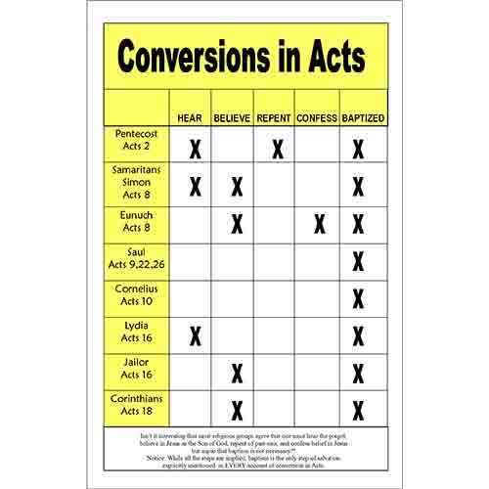
The above chart deals with seven different conversions. Do we conclude that there are seven plans of salvation? The Enoch confessed Christ. Was he the only one to do so? The Jews on the day of Pentecost were told to repent and be baptized, were they to only ones to repent of their sins? Of course not. Jesus said all must repent, Luke 13:3. In a few conversions we do not read of believing, yet Jesus said we must believe that He is the Son of God, John 8:28
The chart of conversions only make sense if we take them in together. The Jews on the day of Pentecost believed, repented of their sins, confessed Christ and were baptized. The Samaritans did the same and so did every soul that was saved. There were not seven or eight messages of salvation but only one. In every case we read of their baptism. The Jews at Jerusalem were told to be baptized in order to receive the remissions of their sins, Acts 2:38. Saul was baptized in order to have his sins washed away, Acts 22:16. Were they baptized for different reasons? No, having one’s sins remitted is the same as having one’s sins washed away.
Rightly dividing the word of God requires diligent and honest study. Dennis Tucker

