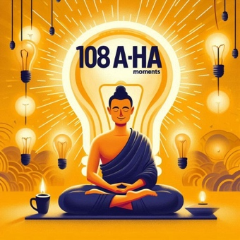

**www.108ahamoments.com**

**Verbal In Centre Announcement Discussion Points**

**Summary**

* Viryamuni from the Sydney Buddhist Centre is working on a project, ***to collect personal insights from Buddhist practitioners from around the world. 'Aha' moments of realisation that have shifted their understanding from the head to a KNOWING in the heart, and profoundly changed the way they live their lives for the better***
* The project is called **'108 Aha Moments'**
* He hopes he can get submissions from Triratna Order members, Mitras and Friends (Non Mitras).
* He asks for your submissions, and if he gets enough, he aims to publish a selection of these insights in a book and across digital platforms
* For more information including examples and the submission form, head over to **www.108ahamoments.com**
* We have received **a call for help** from Viryamuni of the Sydney Buddhist Centre in Australia;
* Viryamuni is working on a project called **'108 Aha Moments'** and hopes to collect **personal insights from Buddhist practitioners** from around the world.
* He aims to **publish this collection of insights in a book and across digital platforms**
* We learn from the Buddha's many 'Aha' moments, and now Viryamuni asks you: **Has something happened to you that has made these insights personal, in a way that you get it and went 'Aha!’?**

For example, when Viryamuni was undergoing cancer treatment a few years ago, he found it almost impossible to meditate. It made him realise: ***Just as it's easier to repair a leaking boat in calm weather, it's best to repair your mind and meditate when times are good – this helps me to sail through future storms that come.***

* Would you be willing to share your insight with the world to help their practice?
* At this stage, he is asking for submissions from those involved with Triratna including - **Order Members; Mitras AND Non Mitras**
* If you are interested, please head over to **www.108ahamoments.com** for:
  + More information on the project;
  + Examples of Aha moments ;
  + The submission form to submit your Aha moment or moment(s)
* **What is an Aha moment?** Perhaps they are:
  + Moments of insight in your life that has **shifted your understanding from the head to a KNOWING in your heart**;
  + An insight that has profoundly **changed the way you live your life for the better**;
  + Moments of insight that have brought joy, expansion and understanding of the Dharma;
  + Perhaps, the insight relates to your understanding about the nature of reality or ways of living or about your meditative practice;
  + Something **on reflection which may have strengthened your Sraddha (Faith).**