5 KEAN STREET – SUITE A, WEST BABYLON, NY 11704
PHONE (631) 649-4114 * FAX (631) 649-4115
EMAIL: INFO@IRONSIDESTEEL.COM * WEBSITE: WWW.IRONSIDESTEEL.COM

COMMERCIAL - RESIDENTIAL
DIVISON 5 STEEL - FABRICATION – ALUMINUM – GALVANIZED – STAINLESS – WROUGHT IRON

We Specialize In
Balconies * Cat Walks * Handrails* Marine Applications * Porch & Deck Rails Seismic Clips * Ship Ladders * Stairs * Structural Steel Window Guards * Steel Dunnage

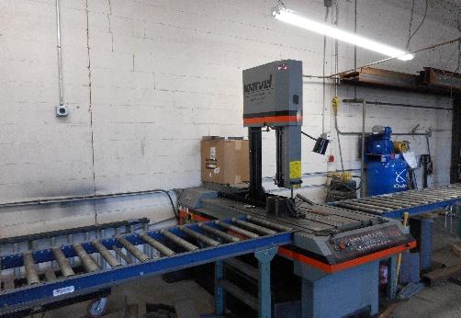
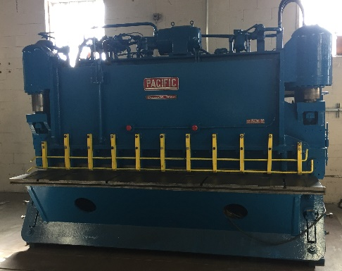
SHEAR – PRESS BRAKE – SAW – PIPE BENDER - BRIDGEPORT
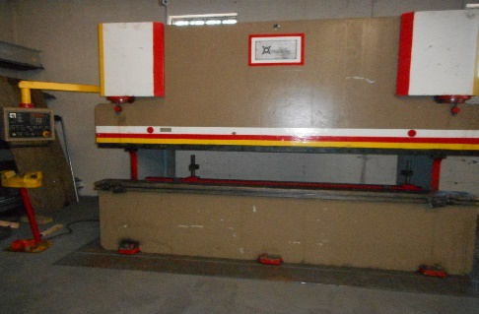

WE ARE CERTIFIED IN THE FOLLOWING
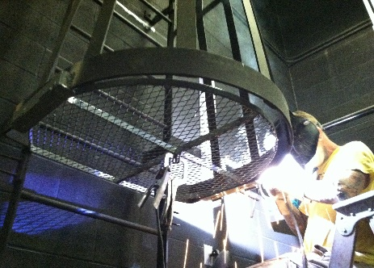
TIG – MIG – STICK - FLUXCORE – D1.5 -BRIDGE WELDING
ALL STAGES OF PRODUCT DEVELOPMENT
SHOP DRAWINGS
B.I.M
FABRICATIONS TO YOUR SPECIFICATIONS
ON TIME DELIVERY
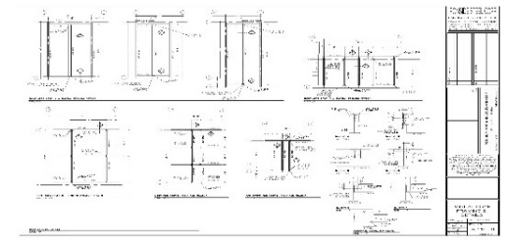

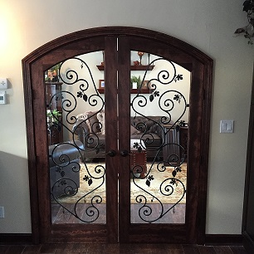

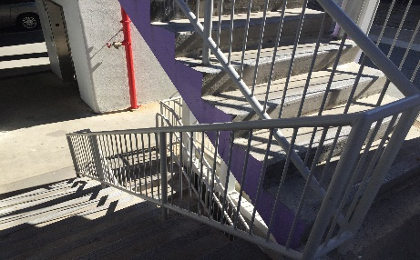
REASONABLE RATES
PROMPT REALIABLE SERVICE
QUALITY WORKMANSHIP

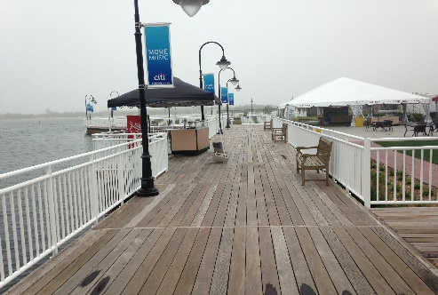

CONTACT US AT (631) 649-4114 OR AT INFO@IRONSIDESTEEL.COM TO SET UP A CONSULTATION
OUR #1 GOAL IS CUSTOMER SERVICE

