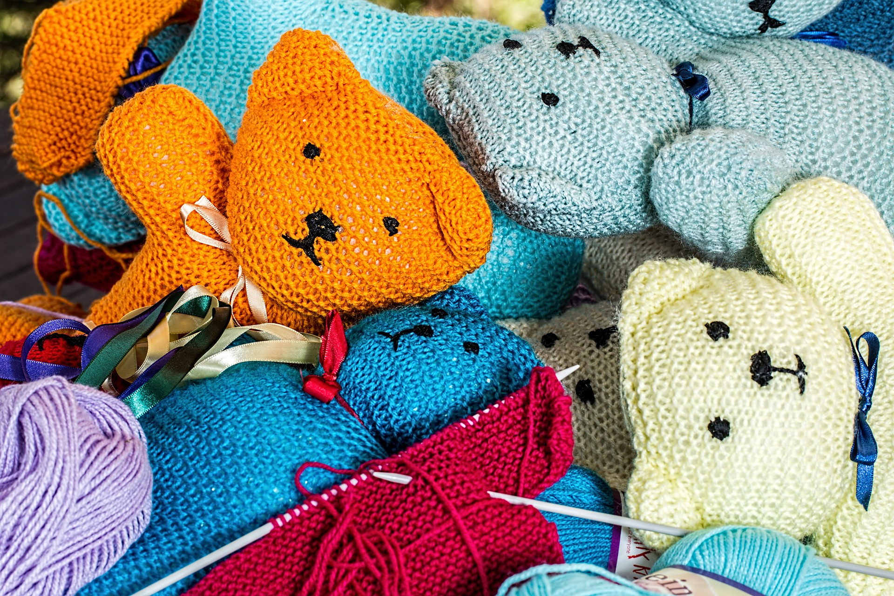Your Starter Kit For A Craft Show On A Budget

If you’re an artist or a maker of any kind, a craft show is an incredible opportunity to make a profit off of your hard-earned skills. However, if you don’t plan properly, it’s easy to wind up spending [more than you make](http://craftshowmoneymakers.com/reports/5%20Huge%20Mistakes%20Craft%20Show%20Vendors%20Make.pdf) at your first craft show. Remember, it may take a while to get a sense of how to attract customers and make your sales goals. The less you throw down on your first show, the more likely you are to see a return on investment early.

Here are a few ways first-time craft showers can perfect their display, nail their marketing, and attract both impulse and long-term customers without spending a ton of money.

*Need inspiration or wish to browse my selection of unique, handcrafted gourds? Head over to* [*DRW Designs and 1 of A Kind Gourds*](https://drwdesignsand1ofakindgourds.com/)*!*

**Know the Required Costs**

There are certain costs associated with any craft show, and some shows have more expenses than others. Reach out to a coordinator at your craft show to make sure you understand all the [costs](https://katersacres.com/buildyourbrand/craft-show-profitability/) you should expect. For example, you probably already know about your table fee, but do you have to also pay for a chair? If so, can you bring your own instead? Is this an area where you also need to get any kind of seller’s license? What percentage of profits, if any, does the craft fair collect?

Getting this info ahead of time will save you from unexpected costs or hiccups the day-of. Plus, it will help you figure out how to set pricing for your items.

Keep in mind that you’ll also want to be able to easily process various types of payments, as some customers won’t have cash on hand. Look for a [mobile card reader](https://www.creditkarma.com/credit-cards/i/mobile-credit-card-reader/) that won’t charge outrageous fees for processing credit cards; there are several on the market these days.

**Nailing Your Price Point**

The [right price point](https://feltmagnet.com/crafts/How-to-Price-Homemade-Craft-Products-to-Sell-Formulas-Retail-Wholesale) will make or break your profits. Too low, and you won’t make back what you’ve spent. Too high, and you’ll scare customers away. Get a feel for what similar items go for by hitting up other craft shows and farmers markets, and browsing online stores. This will give you a sense for the market that you can use as a starting point.

Though you may eventually decide you’re not interested in haggling, [keep an open mind](https://blog.hubspot.com/sales/essential-negotiation-skills-for-salespeople) during your first few shows. Remember, the odds are good that it may take you several craft shows to figure out how much everything should cost. Be sure to [keep track](https://www.template.net/business/tracking-templates/sales-tracking/) of your prices and sales and make a note if you sell anything for less so you can adjust in the future.

**DIY Marketing Tools**

Keep in mind, a craft show is not just a chance to make a sale; it’s also an opportunity to build up a [consistent customer base](https://blog.scalingretail.com/how-to-build-a-local-loyal-customer-base-for-your-brand/). There may be plenty of people who aren’t ready to buy your work that day, but may consider you later on. That’s why it’s so important to have marketing material ready to hand out, as well as an opportunity for people to jot down their info for your mailing list.

Purchasing business cards or postcards can wind up costing you a fair amount of money. Save professional stationary for down the road and focus on a DIY option in the meantime. You can use online design apps to create a [simple, functional card](https://www.creativebloq.com/graphic-design/how-design-business-card-10-top-tips-9134291) to hand out. Make sure it includes your name, website, and social media sites. Print it at home or through a local printing service on full-size card stock and cut them out yourself – use a paper cutter to get a neat, clean line. They may not be perfect, but they’ll do the trick!

**Tax Concerns**

As you get ready to sell your art, don’t brush off the important administrative tasks that all self-employed people have to attend to. Don’t forget that self-employed artists do have to pay taxes, even if selling their art is a part-time source of income! You can set up a savings account to prepare and create a folder for your receipts and invoices.

What else can you do to get ready for tax season? Establishing your business as a [Pennsylvania LLC](https://www.zenbusiness.com/pennsylvania-llc/) is a smart choice! This will give you plenty of flexibility as a business owner, as well as tax breaks and asset protection. To save time, you can file through an online formation service, which is easier than filing on your own and cheaper than working with a lawyer!

Making the most of your first craft show doesn’t mean spending a ton. Use your resources wisely, and you’ll be able to make a good impression, build up profits, and invest in upgrades down the line. Remember, this is only the beginning of your journey, and you have plenty of room to grow. Learn on a smaller budget so you can expand wisely.

Photo Credit: [Pixabay](https://pixabay.com/photos/knitting-handwork-hobby-handmade-1614283/)