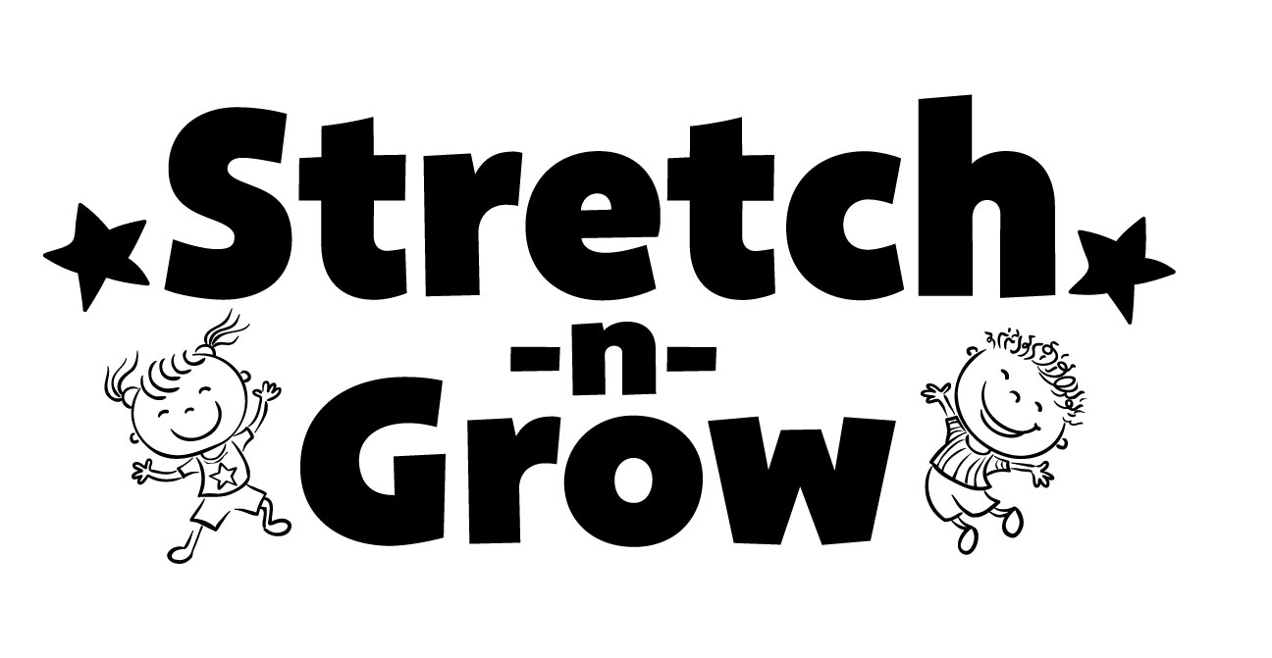
Credit Card Payment

Authorization Form
Of the East Valley

Please initial the box below and complete the bottom of the form. The original with your signature must be emailed to sngeastvalley@gmail.com
This form will be kept on file at Say That, LLC dba Stretch-n-Grow of the East Valley.
- I hereby authorize Stretch-n-Grow (SNG) to initiate a charge to my credit card for the payment of my program participation fees. In the amount of ____/month. Please see your child’s enrollment brochure for pricing.

General Provisions applying to all Credit Card payment authorizations:
This authorization is to remain in effect until the balance of the SNG Class session has been paid in full. I have the right to stop payment of the charge by notifying SNG in writing or by phone. I understand that there will be a $10 service charge each time my credit card is denied without previous written notification to SNG.

Any erroneous or incorrect charge will be corrected upon notification to SNG. If corrections in the charged amount are necessary, I understand that it may involve a credit or charge to my account.

PLEASE PRINT CLEARLY THE FOLLOWING:
Credit Card (circle one): VISA MASTERCARD

Name (as it appears on the card):

Billing address (this must match the address on file for the card)
_______________________________ ___________________________________________________________

Card Number: ________________
Expiration Date: Verification Code*:

*A Card Verification Code is required for Visa and MasterCard. The Card Verification Code is an added security feature to help protect you against online fraud. For Visa and MasterCard, the three digit code can be found on the back of your card following your card number printed in the signature bar.

Signature Date

Child’s name Name of School/Center & name of Teacher

Name of program Day and time of class

