SAFETY RULES

IBEW LOCAL 66

Rev 6
06/16/2022

SAFETY
No job is ever so
urgent or important
that it can’t be done
SAFELY

- Education

General Foremen & Foremen shall make certain that all employees are instructed and advised of all applicable rules and their application.

- Knowledge

Each employee shall be required to know and understand all applicable rules which apply to the work being performed.

- Enforcement

  - Employees acting in a supervisory position shall require all employees working under their direction to comply with all applicable safety instructions, safe practices and safety rules.
  - Any safety device, tool or equipment which upon inspection is found unsafe or defective shall be removed from service.

- Emergencies

In the event of an emergency which may result in a serious personal injury, a supervisor, foreman or employee in charge may temporarily modify or suspend any rule as they may consider necessary to permit proper handling of the emergency.

- First Aid

  - All employees should be trained and certified in First Aid/CPR. Employees should be responsible to carry their certifications and that they are up to date and maintained. The employee should also notify their employer prior to the expiration of their certifications so they can be renewed.
  - Every injured or ill person shall be given first aid as soon as possible.
  - Properly equipped and approved first aid kits shall be maintained on trucks, in attended plants or stations and such other locations as may be considered advisable.
  - Employees in charge shall be responsible to know emergency procedures in case the need arises. (Examples: radio procedure to call for help, phone numbers of who to call in case of an accident, location of the job and nearest location to receive emergency services, etc.) They should also make sure others on the crew are knowledgeable as well.

- Tools

  - Employees shall use proper tools suitable for the job. Only those tools in good repair shall be used. Defective tools shall be tagged and removed from service.
  - Climbing tools shall be inspected for damage and wear prior to use. Employees shall be trained in the proper use of and care for as well as the proper way to sharpen the hooks.

- Tailboards

  - A Tailboard or Job Briefing SHALL be done prior to the start of any job. A sheet/form shall be filled out for every tailboard.
  - All employees, who are going to be working on the site of the job, shall be present and take an active role in the tailboard. Knowing what work is to take place and what all employees on the job are going to be doing, will not only make the job more productive, but much safer as well. When employees are engaged in and take an active role in the tailboard, employees are sometimes able to identify dangers prior to getting into a position where accidents happen.
  - Safe work practices should be discussed and questions answered at each tailboard.
  - All PPE, safety gear, tools and equipment that is planned on being used shall be discussed and noted during the tailboard.
  - The tailboard shall also note the location of the job, nearest cross streets, circuit and/or substation the crew is working on and the direction of the feed in case of an emergency.
  - If the job changes, all employees on the site, shall be notified and understand the reason for the change.
  - If an employee who was not available on the job during the tailboard, such employee shall be brought up to speed prior to working on the job.

ENERGIZED WORK

- High Voltage Work in Aerial Device

  - When work is to be done on energized conductors over 600 volts, there shall be 2 Journeymen or 1 Journeyman and 1 hot apprentice. When 1 Journeyman and 1 hot apprentice are working together in the air, there shall be at least 1 Journeyman on the ground. (Foreman is included in the number of Journeymen needed.)
  - The definition of 2 men is 2 men in the same piece of equipment, either a single bucket designed for 2 people or a double bucket. (Note: 1 in 1 bucket truck and 1 in a different bucket truck working on the same pole or structure does not meet the rule of 2 men working and is not allowed.)
  - Whenever employees are working on energized conductors or apparatuses, there shall be a qualified employee on the ground acting primarily as an observer to help prevent accidents and to render immediate assistance in the event of an accident.
  - When employees are working on poles with energized primary, only 1 Journeyman Lineman will be required in bucket, to open and close disconnects, install or remove high sides and/or install or remove hard cover, with approved hot sticks. When apprentices are performing this work, a Journeyman Lineman shall be required in the bucket, with him.
  - When men are working on, near or above energized conductors or apparatuses, they shall not work on different potentials.
  - Qualified Employee is defined as Journeyman or Hot Apprentice (having completed the SWLCAT Observer Course).
  - Rubber gloving voltages.
      - In Appendage A, voltages up to 15,000 volts phase to phase is allowed. Voltages above 15,000 volts phase to phase shall be worked with hot sticks only.
      - In Appendage B, voltages up to 34,500 volts may be rubber gloved when the 2 men doing the work feel it is safe to do so.
  - When working on, near or above energized conductors or apparatuses, employees shall use the proper cover rated for the voltage the employee is working and shall use enough cover protect against accidental contact with a different potential.

  - Working distances shall be those defined by OSHA, the Customer or the Employer. The OSHA regulations shall be a minimum.

  - Hand line shall be placed on every structure, pole or aerial work platform where line work is being performed.

  - Before work of the day begins, there shall be at least three (3) signatures for operation of a non-fixed Manlift. (Foreman, Operator & Highest Classification entering the lift).

- High Voltage Work from the Pole or Structure

  - When work is to be done on energized conductors over 600 volts, there shall be 2 Journeymen or 1 Journeyman and 1 hot apprentice. When 1 Journeyman and 1 hot apprentice are working together in the air, there shall be at qualified observer, which is defined as a Journeyman Lineman or Hot Apprentice that has completed the SWLCAT Observer Course. (Foreman is included in the number of Journeymen needed.)
  - The definition of 2 men is 2 men on the same structure, either a pole, tower or rack.
  - Whenever employees are working on energized conductors or apparatuses, there shall be a qualified employee on the ground acting primarily as an observer to help prevent accidents and to render immediate assistance in the event of an accident.
  - When employees are working on poles with energized primary, only 1 Journeyman Lineman will be required on the pole or structure, to open and close disconnects, install or remove high sides and/or install or remove hard cover, with approved hot sticks. When apprentices are performing this work, a Journeyman Lineman shall be required on the pole or structure, with him.
  - When men are working on, near or above energized conductors or apparatuses, they shall not work on different potentials.
  - Qualified Employee/Observer is defined as Journeyman or Hot Apprentice (that has completed the SWLCAT Observer Course).
  - Rubber gloving voltages from a pole or structure. In Appendage A and Appendage B, voltages up to 4,160 volts phase to phase is allowed. Voltages above 4,160 volts phase to phase shall be worked with hot sticks only.
  - When working on, near or above energized conductors or apparatuses, employees shall use the proper cover rated for the voltage the employee is working and shall use enough cover protect against accidental contact with a different potential.
  - Working distances shall be those defined by OSHA, the Customer or the Employer. The OSHA regulations shall be a minimum.
  - Hand line shall be placed on every structure, pole or aerial work platform where line work is being performed.
  - When working from pole or structure, rescue set of tools shall be readily available in immediate area where work being performed
  - Rubber gloves that are used for energized work shall not be used for climbing poles or structure.

- Low Voltage Work from the Pole, Structure or Aerial Device

  - Journeymen and or 4th Period and above Apprentices may work on voltages below 600 volts by themselves on the structure. 3rd Period Apprentices may work on voltages below 600 volts under the direct supervision of a Journeyman. Direct supervision is defined as on the same pole, structure, tower or rack, or in the same aerial device.
  - Rubber gloves shall be worn when working energized conductors and or apparatuses.
  - Before work of the day begins, there shall be at least three (3) signatures for operation of a non-fixed Manlift. (Foreman, Operator & Highest Classification entering the lift).

- Live Line Work

  - Hot Sticks shall be used whenever:

1.Opening or closing disconnects

2. Energizing or de-energizing electrical equipment (i.e.: transformers, capacitors, lightening arresters, etc.)

3. Installing or removing grounds.

4. Whenever the employee involved or the employee doing the work feel that it would be safer than by the use of rubber gloves.
  - Electrical equipment (i.e.: transformers, capacitors, disconnects, pot heads) shall be de-energized before being transferred from 1 pole to another.
  - All protective cover, live line tools and equipment shall be:

1.Kept clean and as dry as possible.

2.Blankets and line hose shall be checked for holes, cuts and checking.

3.Protective covering shall be tested regularly according to OSHA regulations or the CBA, whichever is more stringent.

4. It is not permitted to lay protective cover or live line tools directly on the ground.

5. Care should be taken when storing not to cut or puncture all protecting equipment.

6. Any protective equipment found damaged shall be marked and taken out of service immediately.

7. Care shall be taken when storing live line tools and equipment (i.e., hot sticks, isolators, mechanical jumpers and grounding sets)

- Transmission

  - Live-Line Tools
- Before any live-line tool can be used for live-line work, it shall display a current test date.
- All conductors or apparatuses above 15,000 volts, in Appendage A and 34,500 volts in Appendage B or C shall be worked with approved live-line tools only. (Except when bare handing)
- All live-line tools, when not in use, shall be kept in live-line tool bags or weather proof boxes and kept as clean and dry as possible.
- Live-line tools and plastic cover shall never be laid directly on the ground or against sharp objects.
- All live-line tools and plastic cover shall be visually inspected before use each day. Tools and cover to be used shall be wiped clean and if any hazardous defects are indicated, these tools or cover shall be removed from service.
- Minimum approach distances should be visibly marked on any live-line tool. Care in applying these marks so not to create a dielectric issue shall be taken.
  - When work is to be done on energized transmission conductors, there shall be 2 Journeymen or 1 Journeyman and 1 hot apprentice. When 1 Journeyman and 1 hot apprentice are working together in the air, there shall be at least 1 Journeyman or Hot Apprentice (that has completed the SWLCAT Observer course) on the ground, whose primary responsibility is to act as an observer to help prevent accidents and to render immediate assistance in the event of an accident. (Foreman is included in the number of Journeymen needed.)
  - The definition of 2 men is 2 men on the same structure, either a pole, tower or rack.
  - Whenever employees are working on, near or above energized conductors or apparatuses, they shall not work on different potentials.
  - Qualified Employee/Observer is defined as Journeyman or Hot Apprentice (having completed SWLCAT observer course).
  - When working on, near or above energized conductors or apparatuses, employees shall use the proper cover rated for the voltage the employee is working and shall use enough cover protect against accidental contact with a different potential.
  - Working distances shall be those defined by OSHA, the Customer or the Employer. The OSHA regulations shall be a minimum.
  - Bare-Hand Live-Line Work
- A certification approving an employee to work bare-hand transmission work is required by each Journeyman Lineman working on energized transmission lines by the bare hand method.
- Crew size required is 2 certified Journeymen doing the work and 1 certified Journeyman whose ONLY responsibility is to act as an observer to help prevent accidents and to render immediate assistance in the event of an accident. (Foreman is included in the number of Journeymen needed, if certified.)
- The use of live-line tools while bare-handing:
  - shall be marked with minimum approach distances,
  - shall be used whenever measurements are needed, while in the MAD and
  - whenever installing jumpers or macs.

4. Apprentices are not allowed to do bare-hand work.

i. Apprentices on transmission work.

1. De-energized Work

a. can be done by any level apprentice,

b. care shall be taken when considering an apprentices experience level when sending an apprentice into difficult or close conditions, and

c. apprentices need to be educated on induction on de-energized transmission lines.
- Energized work:
      - 4th Step or higher is required to do any energized transmission work.
      - a Journeyman Lineman is required to be in control of any work done by an apprentice
      - an apprentice is not allowed to do any bare-hand live-line transmission work.
  - Transmission Technicians
  - Transmission Technicians 1-6 are not allowed to work ANY energized conductors.
  - Transmission Technician and Transmission Technician 7 are allowed to work ANY energized transmission conductors including, testing for hot and putting on any set of grounds, with a Journeyman Lineman in control of the work.
  - Transmission Technicians shall not be within reaching or falling distances of any exposed energized conductors.
  - Transmission Technicians shall not be allowed to direct the work of any apprentice while working energized transmission work.
  - Before work of the day begins, there shall be at least three (3) signatures for operation of a non-fixed Manlift. (Foreman, Operator & Highest Classification entering the lift).

- Underground and URD

  - When opening an energized or ungrounded underground transformer, or when an energized or ungrounded transformer is open, there is to be at least 2 qualified men.
  - PPE Shall be worn whenever within reach or falling distance of energized conductors.
  - Lower-level apprentices and helpers may work around the transformer while it is closed. Once opened and there are energized conductors, they need to back away.
  - If the transformers are de-energized and the conductors are grounded, lower-level apprentices and helpers may work inside the transformer.
  - Installing and/or removing standoff bushings and/or grounds and plugging or pulling elbows shall be done with approved hot sticks.
  - Before grounding any conductor, they shall be tested for hot using proper test equipment. If unable to test for sure or dont trust the test equipment, before any cable is pulled stood off or grounded, employees shall open the terminal poles and do all the switching and grounding de-energized.

- Grounding
  - Grounds shall be used prior to working on de-energized conductors or apparatuses, unless the grounded conductor or apparatus would create a safety hazard.
  - Grounds shall be:

1.Inspected prior to each use

2. Tested and tagged with the date tested

3. Have the proper connectors for where they are to be used (i.e., connecting to a conductor, buss or steel)
- Be the proper size for the available fault current.
  - Conductors or apparatuses to be grounded shall be tested to ensure they are de-energized prior to grounding.
  - There shall be a minimum of 1 ground on the conductor or apparatus being worked on.
- Between the place where the work is being done and any possible source of voltage, or
- A grounded equipotential zone created at each work location, or
- Bracket grounded with an equipotential zone.

  - As an additional safety measure, any time employees are working behind open disconnects:
- High sides shall be lifted
- fuse barrels removed and
- switch shall be tagged out.
f. All equipment (i.e., trucks, trailers, pulling rigs etc.) shall be grounded to at least a 5' screw ground rod, with the proper connectors.

Distribution Primary

- Grounds shall be used anytime employees are working on conductors where there is a possibility of accidentally becoming energized. Work on these conductors shall be done between grounds only.

- Equipotential grounding is the preferred method for grounding conductors.

- Grounds shall be sized for the available fault current possible at the location they are to be installed. Grounding jumpers are not to be used as mechanical jumpers. If they are ever energized, by way of a fault, they shall be retested to ensure their integrity.

- Grounding clamps shall be the proper type for the available fault current and kept clean from corrosion.

- Ground jumpers shall be tagged with the date last tested and the connection to the ground clamp shall be a pressed ferrule end, rated for the available fault current.

- Proper installation:
  - The connection to the ground shall be the first connection made and the last one removed.
  - There should be a flag attached to one of the jumpers, preferably the one attached to the ground connection and is attached to the first primary conductor, in a location for the best visibility.
  - Installation to the conductors shall be made with approved hot sticks only. Care should be taken and proper use to the hot stick so not to allow the jumper to make contact with the employees installing them. Once the connection is made to the first primary conductor, a grounding conductor shall be attached to that conductor and then to another conductor if needed then from that conductor to the third conductor if needed.

Transmission Grounding

- Equipotential grounding has been accepted by the Best Practice Committee within the OSHA Partners. (OSHA, IBEW, NECA and EEI) The local utility prefers to use bracket grounding on Transmission. CNP is in the process of determining for their employees and contractors that work on their property, what process they will use.

- It is generally accepted that on Transmission, 4/0 copper is the minimum and 350 MCM will probably be the minimum within the Substations. It is being talked about right now and the regulation requires the Utility to do a study on their system to identify the available fault current and duration so the employees can properly size their grounding conductors. Contractor employees need to check with the local utility for proper sizes. Work on transmission lines operated by CNP, the Contract Coordinator assigned to the job will be able to retrieve the proper sizes needed from the CNP intranet.

Circuit Grounding Preparation:

Prior to physically attaching grounds to a circuit, the following must be completed in order:

  - Contact the Contract Coordinator assigned to the job, to identify the ground size necessary (4/0 copper or 350 MCM copper) for the available fault current on the circuit where grounds will be applied.
  - Contact the Contract Coordinator assigned to the job, to verify the location of the structure and the location of the circuit on the structure.
  - Perform detailed Tailboard that discusses circuit number, grounding structure location, circuit location on structure, ground size, job assignments, and all other required tailboard information
  - Inspect the structure to ensure ground components are in good shape, if not, repair as needed before installing protective grounding.
  - Inspect grounds for damage, clamp function, test label, and ferrule tightness. Verify that test label on ground indicates impedance testing was performed within two years of current dates.
  - Test the approved Hot-Line Indicator for function as required by the manufacturers recommended specifications.
  - Test the circuit where grounds will be applied using the Hot-Line Indicator to verify de-energized state.
  - Test the Hot-Line Indicator for functionality per the manufacturers recommended specifications.
  - Refer to the Safety Manual for information on protective grounding prior to applying jumpers.

Electrical Grounding Operations:

Once the preparatory steps have been completed, the crew will now begin grounding the circuit. The following describes the approved method for grounding Transmission Circuits with the requirement for 4/0, and 350 MCM grounds:2 full sets of bracket grounds will be installed on the circuit within 1 mile, either side, of where the work is to be performed. (1 set on either side):

- When employing 350 MCM jumpers, a grounding stud shall be bolted to earth ground source to provide round connection point.
- The phase to ground/earth potential ground shall be connected first to ground below the linemans feet prior to installing the ground on a phase.
- Slack in the grounding cables become a hazard if the circuit becomes energized. To restrict movement, grounding cables shall be secured to minimize slack, or away from the work zone.

Towers

To properly ground transmission Towers with Vertical Suspension Circuit arrangements, follow these steps:
- Start by wire brushing the phase, with approved hot sticks and cleaning off paint or contaminants on leg or earth location to make a good electrical contact. Ground to phase grounding cables shall be installed from earth or ground potential (with earth end below your feet) to each of the first ungrounded phase conductors encountered by the lineman.
- Phase to Phase grounding cables shall be installed from each conductor of the grounded phase to each conductor of the next ungrounded phase until all phases are grounded.
- If the circuit has multiple conductors per phase, conductor to conductor cable shall installed from the grounded conductor to the ungrounded conductor on every phase. Jumpers, that are three-foot conductor length, shall be used to bond the bundled conductors together.
- To remove grounds, perform the above in reverse order. The last phase grounded is removed first. The last ground removed shall be the ground from earth to phase.

If working on a dead-end structure or a suspension structure where the wire will be cut, a set of grounds shall be applied on both sides of where the wire is to be cut. An additional set shall also be applied across the cut wire to remove induced difference. The initial set of grounds up to one mile away from the work site remains unchanged.

To ground a Delta Circuit Configuration Tower, follow these steps:

- Start by wire brushing the phase, with an approved hot stick and cleaning off paint or contaminants on leg, arm or earth location to make a good electrical contact. Ground to phase grounding cables shall be installed to the leg, arm or earth potential location (with earth end below your feet).
- The next step would be to install the ground from the leg, arm or earth potential location to the first ungrounded phase conductor(s) closest to the tower, encountered by the lineman after all phases have been checked with the Hot -line indicator.
- The next ground will be installed from the same leg or arm and then to the upper ungrounded conductor.
- The next ground will be installed from the same leg or arm as the other 2 and then to the outside conductor.
- If the circuit has multiple conductors per phase, conductor to conductor cable shall installed from the grounded conductor to the ungrounded conductor on every phase. Jumpers, that are three-foot conductor length, shall be used to bond the bundled conductors together.
- Removal of the grounds would go in reverse order where the last phase grounded is removed first and then removed from next grounded phase all the way back to taking the ground from the earth to phase ground off last.

Wood and Concrete Structures

When grounding poles or H-frames where the conductivity of the structure itself cannot be relied on for worker protection, like wood or concrete poles, the following steps are required:

- During de-energized work on these structures, the bond wire will not be used as a source of earth or ground potential unless approved by the Customers Contract Coordinator over the job. In some situations where jumpers on the circuit can be cut, the bond wire could be used depending on the magnitude of available fault current. If the bond wire cannot be used, a temporary screw ground will be installed into the ground and a proper length 4/0 cable will be attached to the screw ground and sent up the pole to a cluster rack mounted on the pole.
- Ground to phase grounding cables shall be installed from earth or ground potential at the cluster rack (with earth end below your feet) to each of the first ungrounded phase conductors encountered by the lineman.
- Phase to Phase grounding cables shall be installed from each conductor of the grounded phase to each conductor of the next ungrounded phase until all phases are grounded.
- If the circuit has multiple conductors per phase, conductor to conductor cable shall be installed from the grounded conductor to the ungrounded conductor on every phase. Jumpers, that are three-foot conductor length, shall be used to bond the bundled conductors together.
- Removal of the grounds would go in reverse order where the last phase grounded is removed and then removed from next grounded phase all the way back to taking the ground from the phase to earth ground off last.
- Remove the ground or grounds from the last phase.
- Remove the ground coming up the pole from the screw ground.
- Remove cluster rack and remove the end of the ground attached to the screw ground.
- Remove temporary screw ground.

The Transmission Grounding Procedures are to help protect the worker from the available fault current. The revised information is to be used to best protect the worker from induced voltages and accidentally becoming energized with the revised grounding size requirements. This document is a guide and is no means a document that will fit all circumstances that may arise. In those cases, you will have to consult with the Contract Coordinator from the customer assigned to your job for clarification and direction.

Secondary

- When working on de-energized secondary conductors, they should be grounded.
- When work is to be done above the de-energized secondary conductors, secondary grounds shall be used to prevent back feed.

Equipment Grounding

Whenever equipment, including easement machines, trucks, trailers, wire reels, tensioner and pulling rigs that are attached to a truck and their extended reach is within the minimum approach of any energized conductors, the equipment Shall be grounded.

- 2/0 copper welding cable is the minimum size conductor with a ferule end.
- Screw ground rod, screwed into the ground with no more than 18" sticking out.
- Screw ground should be placed as far away from the work zone as possible to protect against step potential.
- It is preferred to have at least 25' grounding cable attached to the equipment.
- Grounding clamps shall be the proper type for the available fault current and kept clean from corrosion.
- Grounding Clamps shall have the proper connectors for where they are to be used (i.e., connecting to a conductor, buss or steel).
- Trailers, wire reels, tensioner and pulling rigs when attached to truck need to have their own ground on a separate ground rod, unless they are electrically bonded together either from the truck to the trailer or the truck and the trailer to the same ground rod. If separated from the truck they need their own ground rod unless the trailer is not being used and does not have the potential of becoming energized from the equipment working within the MAD.
- Rolling grounds need to be used any time pulling wire with a potential to become energized including induction.
- Rolling grounds shall use a minimum of 2/0 copper welding cable to its own ground rod.
- Inside substations, it is allowed to ground equipment to the grounding conductors attached to the substation ground grid.

15. Substation

- Conductors and devices shall be tested and grounded only after proper clearances have been issued as specified in the facility owners Clearance/Switching Procedures.
- Depending on work location, lines and equipment shall be connected to ground using the following sources in descending priority:
  - Substation Ground Grid
  - Multi-Grounded Primary Neutral (When the Primary neutral is used as a ground source, the circuit shall be grounded to an additional ground structure)
  - Grounded Steel Structure
  - Existing Anchor Rod
- Only approved temporary protective grounding equipment shall be used when grounding lines and equipment. Table 1, listed below, specifies the size of grounding cable that shall be used for each system voltage.

Table 1

Source Voltage  (Note 3) | MAX Fault  Current Duty (A)  (Note 4) | Quantity of Grounds  per Phase | Size of  Copper Grounds  (AWG) | MAX Length  Of Grounds  In Feet
2.4 – 55kV | 30,000 | 1 | 4/0 | 20
2.4 – 55kV | 18,000 | 1 | 4/0 | 20
2.4 – 55kV | 9,000 | 1 | 2/0 (See Note 1) | 20
66 – 161kV | 38,000 | 1 | 4/0 | 20
66 – 161kV | 24,000 | 1 | 4/0 | 20
220 – 500 kV | 63,000 | 2 | 4/0 | 30
220 – 500 kV | 37,000 | 2 | 4/0 | 30
Note 1: The use of 4/0 grounds, except when they are to be applied on #4 solid conductor or smaller. In those situations, 2/0 grounds shall be used.

16. Protective Grounding in Substations

Personal Protective Grounds of a Substation Bus.

- Disconnect switches, power circuit breakers & transformers
- Obtain a clearance as specified in Facility owner’s Clearance and Switching Procedures
- Test the bus to be sure it is de-energized using an approved voltage detector.
- Ensure the personal protective grounds are installed as close to the worksite as possible.
- Install properly-sized grounding jumpers of correct length to the ground mat. Install the other ends of the grounding jumpers to each bus using hot-line tools.
- After the work is complete, remove grounding jumpers in reverse order.

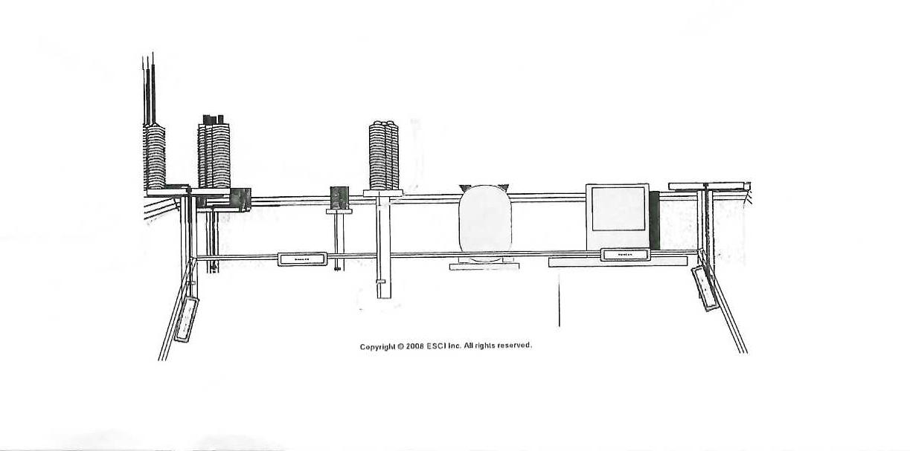

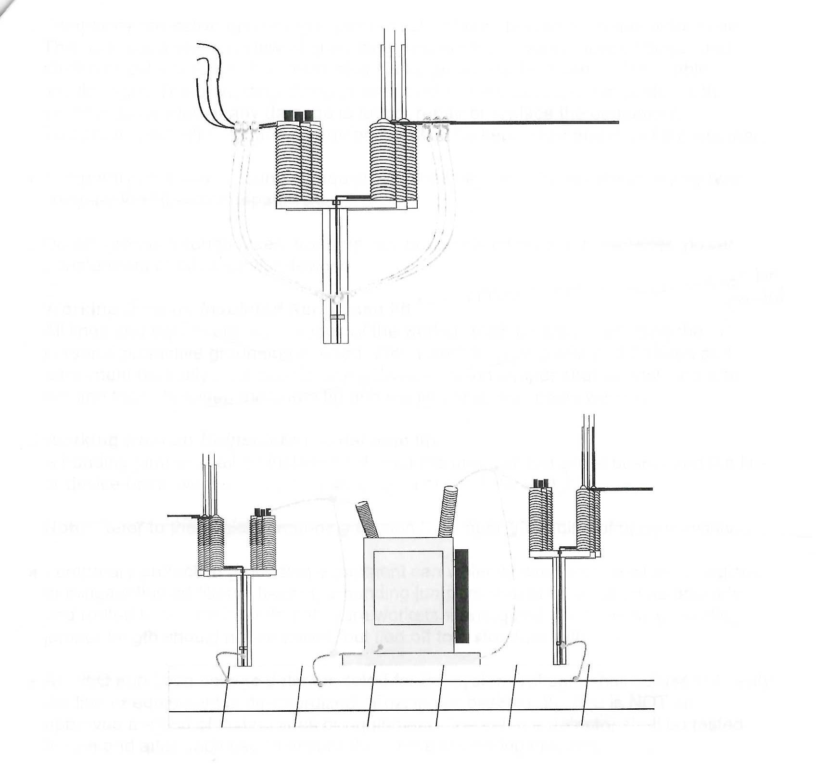

- Protective grounding equipment may be removed temporarily during testing. The use of test equipment may require removal of grounds, and can charge conductors and equipment. After testing, grounds shall be reapplied before coming in contact with the conductors or equipment.
- Temporary protective grounding equipment shall be inspected each day before use. This includes a visual review of grounding jumpers for broken or loose fittings, and chafed or cut insulation. The grounding clamp jaws shall be clean and the cable ferrules tight. The grounding clamp jaws should be wire brushed and coated with inhibitor as needed. If any damage is found, repair or replace the equipment. Temporary protective grounding equipment shall be kept clean and out of the weather.
- Temporary protective grounding equipment shall be tested for resistance every year.
- Do not ground through fuses, transrupters, power circuit breakers, power transformers or other similar devices.

Working From an Uninsulated Aerial Man Lift

- A bonding jumper shall be installed between the un-insulated aerial basket and the line or device being worked. (Break-away Personal Ground)
- Temporary protective grounding equipment can violently whip around when energized, to mitigate this additional hazard, grounding jumpers should be as short as possible and routed to ensure they do not injure workers if energized. Any excess grounding jumper length should not be coiled, but tied off to a structure with rope.
- An approved voltage detector, rated for the system voltage, shall be used to verify the line or equipment is de-energized. “Fuzzing or buzzing” the line is NOT an approved method of testing lines or equipment. The voltage detector shall be tested before and after each use to endure the device is working properly.

When grounding inside a Substation, the Substation Tech shall ground with a JY Lineman in the control of the work and another JY Lineman as a qualified observer.

Stop Work Authority

- Are you willing to save a life?

- Are you willing to do what it takes?
- Do you have the guts?
- Do you possess the leadership mentality?

- Would you intervene on someones behalf to stop them from making a serious mistake?

YOU ARE YOUR BROTHERS KEEPER

