Race Registration Form
www.gregsruntownsend.com

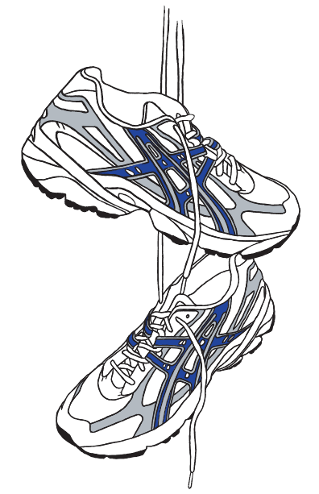

18th Annual Greg’s Run

Date: October 8, 2022

4.6 Mile Run/Walk: 10:30 a.m.

(Registration begins 9:00 a.m.)

Kiddie Race: 10:00 a.m.

Location: 3 Brookline Street, Townsend, MA 01469

Townsend Common

USA Track & Field Sanctioned
Make checks payable to:  Gregory E. Reeves Memorial Scholarship Fund | Mail entry form to:  Greg’s Run  8 Barker Hill Road  Townsend, MA 01469

Name:
Address:
City, State, Zip:
Daytime phone:
Email:
Date of birth:
Age on race date:
Circle your gender: | MALE FEMALE
Circle your event: | 4.6 Mile Run $30.00 through October 1; $35.00 October 2 through Race Day  4.6 Mile Walk $30.00 through October 1; $35.00 October 2 through Race Day  Kiddie Race (ages 2-7) $5.00 through Race Day
Circle t-shirt size: | ADULT: S M L XL 2XL  YOUTH: XS S M L XL  Pre-registered entrants by mail or online before 10/2. First 200 entries receive free T-shirt. T-shirt to all Kiddy Race participants!
THANK YOU SPONSORS
Murphy Insurance Agency, West Coast Dragonflies, Townsend House Restaurant
Evans on the Common, Rollstone Bank & Trust, Workers Credit Union

Apple Meadow Hardware, Attorney John B. Barrett, Attorney Thomas C Gustafson, Friends of Greg, Joseph’s Barber Styling,
McNabb Pharmacy, National Computer Direct, S. S. Tocci Excavating, Sheldon Portable Toilets,, T&W Custom Builders, Townsend Fire/EMS Department, Worcester Polytechnic Institute

Anderson Family Funeral Homes, Bailey’s Bar and Grille, Baro Enterprises, Cherry Hill Too, The Shifrin Family

Waiver must be read and signed before mailing:
I know that running is a potentially hazardous activity. I should not enter or run this event unless I am medically able and properly trained. I agree to abide by any decision of a race official relative to my ability to safely complete the run. I assume all risks associated with running in this race including, but not limited to, falls, contact with other participants, the effects of weather, including high heat and/or humidity, the conditions of the road and traffic on the course, all such risks being known and appreciated by me. Having read this waiver and knowing these facts, and in consideration of your acceptance of my application, I, for myself and anyone entitled to act on my behalf, waive and release the event, and all sponsors, their representatives and successors from all claims or liabilities of any kind arising out of my participation in this event even though that liability may arise out of negligence or carelessness on the part of the persons named in this waiver. All fees are nonrefundable.
_______________________________ ________________ ____________________________________
Signature Date Parent's Signature if under 18


