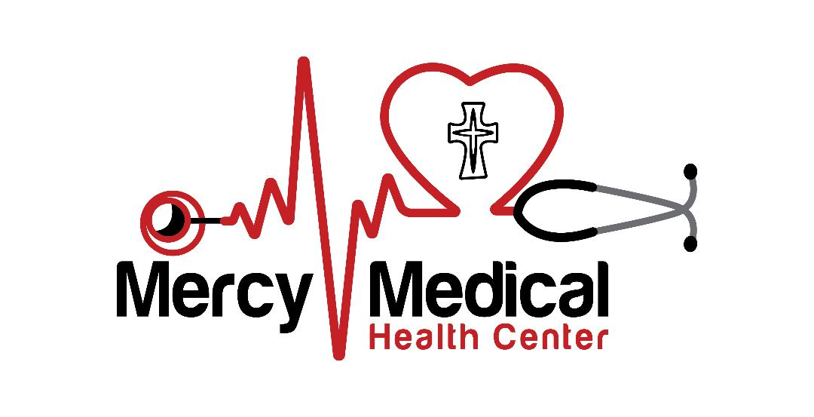
2026 Federal Poverty Guidelines 2026
Size of Household | 100% | 125% | 150% | 175% | 200% | >200%
1 | $15,960 | $19,950 | $23,940 | $27,930 | $31,920 | >$31,920
2 | $21,640 | $27,050 | $32,460 | $37,870 | $43,280 | >$43,280
3 | $27,320 | $34,150 | $40,980 | $47,810 | $54,640 | >$54,640
4 | $33,000 | $41,250 | $49,500 | $57,750 | $66,000 | >$66,000
5 | $38,680 | $48,350 | $58,020 | $67,690 | $77,360 | >$77,360
6 | $44,360 | $55,450 | $66,540 | $77,630 | $88,720 | >$88,720
7 | $50,040 | $62,550 | $75,060 | $87,570 | $100,080 | >$100,080
8 | $55,720 | $69,650 | $83,580 | $97,510 | $111,440 | >$111,440
*For households >8, add $5,680 for each additional person
FPL% | up to 100% | up to 125% | up to 150% | up to 175% | up to 200% | >200%
Medical fee at time of visit | $10 | $22 | $34 | $46 | $58 | 100% of cost
*Over 200% FPG, patient pays full non-discounted price.

