# FHLA NEWSLETTER 2022

| President-Manny Silva, Vice President- Liz Cope, Treasurer-Janet Swift, Secretary-Krenare Osmani, At Large-RoseAnne Nagle, At Large-Ellen Burns |
| --- |

**President’s Letter**

Dear Neighbor and Friend, Greetings!

On behalf of the FHLA board, I wish to thank you for your continued financial support by asking you to renew your membership for the upcoming year or if you recently moved to our beautiful community, join our association as a new member. Rest assured that we have lots of ideas in the pipeline to improve our lake neighborhood. No project would be possible without your participation and support. On Sunday, Sept. 11, we’ll have our annual BBQ, **“Come Meet Your Old and New Neighbors.”**

Our Board of Directors and I are once again upon a new and challenging season, but because of the measures we’ve taken last year, we have high hopes that early lake treatment for the year 2022 will produce better lake conditions than what we faced last year.

Fox Hill Lake Association, has entered into an agreement with Pond and Lake Connection for two treatments as follows: first application was done on May 19 and second application will be done in August 2022. The agreement covers treatment for ten acres of aquatic invasive vegetation, such as: lily pads, milfoil, coontail, quillwort, chara and as well as the green algae that shows up as soon as the good weather arrives.

Each one of us has the mission to preserve our beautiful lake, especially lake front homeowners.You can do basic things that have a very positive impact on the good health of our lake such as: have septic system pumped out regularly, prevent leaves from going into the lake waters, use a detergent low in phosphorus and if anyone sees a stick, a tree branch in the lake, please if you can, retrieve it and think twice before you fertilize your lawn. These organic materials are the biggest source of algae in our waters and in addition, make our lake shallower.

I’m sure that you and I would like to see an improvement in our neighborhood. What do you think about the  **FOX HILL LAKE WALK PATH idea?**

I hope that with your support, sometime soon, we’ll be able to take a walk around our beautiful lake and beyond without fear of being run over by a speeding car or even worse a truck. I have seen people taking their kids on strollers for a morning walk, dog owners walking their dogs and cars zipping by, way over an adequate speed. I urge you to visit our Facebook page at **“Fox Hill Lake Community” and sign the petition**, so we can take it to the powers that be at Town Hall. Every member of your household can sign this petition and in addition, for the sake of our safety, invite your friends and family to sign it, too. Provided they are Ridgefield residents.

**THANK YOU!**

Manny Silva – FHLA President

P.S – There is lots of good info at our web page “[Foxhilllake.com”](https://foxhilllake.com/), it’s time well spent.

**Please Be a Good Neighbor!**

**Dogs**-Pet waste should be picked up and put in your trash bins.

**Beaches**-Please clean up after each use and be sure to dispose of all refuse in your trash bins.

**Dumping**-Please do not litter in the lake. Leaves should not be dumped in the lake during fall or spring clean-ups. Properly dispose of all refuse.

**Boat Racks-**In order to keep your boat, canoe and/or kayak properly registered, when returning your membership form let us know which beach it’s stored at and the rack number. Ex: “B 10” for Bennett’s Farm Beach or “R 5” for Rita Beach – the number is to indicate the space on the rack. For easier access and to avoid injury, we suggest that heavier vessels be placed on lower racks. If you keep your vessel at home, you still need a boat sticker ! We need to prevent boats that have been used in other water bodies from bringing invasive plants into the lake.

**Please Note**: For proper maintenance of our beaches’ grounds; boats, canoes and kayaks must be placed on racks and not on the ground.

**Important: All boats stored on our racks must be claimed and tagged by the owner.Boats that are unclaimed and have no FHLA sticker will be auctioned by the association.**

**Fertilizers**-If you need to fertilize please remember to buy **phosphorus-free fertilizer**. Phosphorus gets into our lake and it causes algae growth which reduces oxygen for our fish population. **Check the label on the bags, it should say 0 for the middle number (phosphorus).**

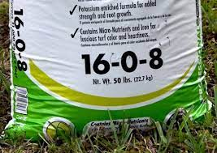

**Pump your Septic**-Septic tanks should be pumped every two to three years. Maintained tanks keep nutrients such as phosphorus that cause algal blooms out of our lake. Don’t wait and make that appointment **TODAY!**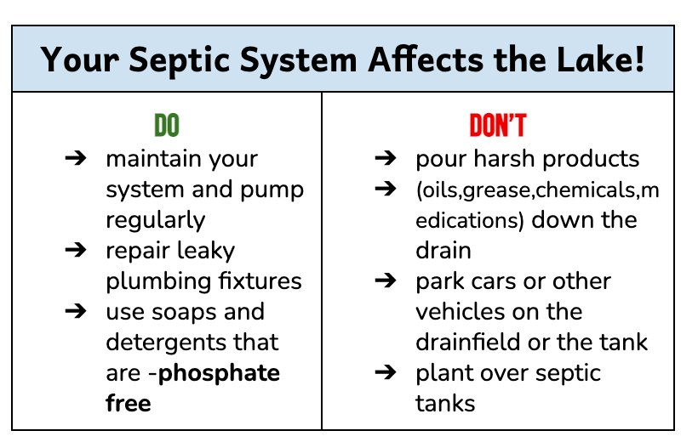

| **Boat Stickers** -**All boat owners must display a boat sticker**. Boat stickers are free for the first boat, and any additional boats are $15. **Indicate how many boat stickers you need on the membership form.** | **Mark your Calendars!**  **Community Tag Sale**-  Sat.July 16 at 10AM-10 Shady Lane. Rain Date-July 17  **Annual BBQ**-  Sun. September 11 at 1PM-4PM at Rita Rd. Beach  **Annual Membership Meeting-**  October, exact date TBD.  **Check out the Events Calendar on Facebook!** | **Stay in Touch!**  1.Join our Facebook page-search for [Fox Hill Lake Community](https://www.facebook.com/groups/382437330339474/) to follow all events, activities and picture posts of our lake.  2.Be sure to provide your **email address** on the membership form. It’s how we mainly communicate important information about our lake throughout the year.  3.Check our website regularly for updates and other pertinent info. relating to our lake [Foxhilllake.com](https://foxhilllake.com/) |
| --- | --- | --- |

**WE NEED VOLUNTEERS!**

Our association is volunteer based. We are looking for community members to donate their time and/or talents in a few important areas to help foster community and maintain our lake environment. If you are willing to help, please indicate that on the membership form or send an email to [fhlainfo@gmail.com](mailto:fhlainfo@gmail.com). Once we have interested members then we can create a committee for each project to ensure that tasks are completed.

**Events**-We have lots of community events planned! (See “Mark your Calendars!”).We organized a fun and well-attended Easter Egg hunt for the first time this year, and we’re open to other ideas in addition to the ones we already have planned. We also need help – these social events are a great way to meet your neighbors, new and old. Please email us if you have some ideas or would like to help.

**Beach Maintenance**-Weed removal, grass cutting, removal of geese droppings. *Thank you to those members that have done this and continue to help out with beach maintenance.*

**New Neighbor Welcome**-This was successfully done in the past but we need to bring it back! The idea is to put together a small welcome basket as a way to introduce our new neighbors to Fox Hill lake.

**Dam Repair-**The south dam needs a few repairs as it has been leaking for some time now. It is a task that can be completed with a few volunteers in one day.The water needs to be low in order to make repairs. Currently, the water is too high and it’s running abundantly over the spillway. Please let us know if you are willing to volunteer for this crucial task.

**Fireworks**

With the 4 th of July holiday almost upon us, the use of fireworks on lake association

property was discussed at the May 18 Board meeting. The consensus was to prohibit their

use on the beach areas, the dams, or in the lakes due to liability issues as well as the

negative effect on the lake and its wildlife. We appreciate your cooperation and

understanding.We encourage everyone to enjoy the holiday by attending the town’s annual fireworks display. If using fireworks in your own yard, please be considerate of your neighbors and their pets – dogs (and some cats) are particularly distressed by the noise of fireworks!

**Highlights from the Treasurer's Report**

Venmo is now available for easy payment of your membership dues and contributions! Our PayPal account was closed due to difficulties in transferring funds to our Fairfield County Bank checking account. The Paypal balance of $6,937.25 was deposited in our checking account, which has a current balance of $12,108.80. We hope to surpass last year’s count of 77 members!

It has been necessary to increase dues in two membership categories after many years of no increases (lake front is now $250, and lake view is $150). The General membership dues remain at $50.00. To help mitigate the increases, all memberships now include one boat sticker at no charge. Additional stickers are $15 each.

Inflation has affected everyone, including the lake association – the costs of many recurring expenses are increasing. FHLA has committed to weed control treatments by Pond and Lake Connection totaling $7,738, including the $400 CT DEEP permit. Directors and Officers liability insurance went up for the first time in four years to $1,829. Our town property taxes were $1,196 for the 2021-2022 fiscal year, and will increase slightly in the coming year. Generous donations made a $1,010 fall phragmites treatment possible.

Looking forward, more grass carp for enhanced weed control may be purchased and ongoing dam maintenance will be costly. Please come to our July community tag sale and buy!

Last year the tag sale, (with the added attraction of cupcakes and lemonade) netted us $401.

We need your support – please fill out your membership form today, and make your payment for membership dues (and additional contribution if possible) today!

**Phragmites Treatment**

**​​**Last fall, the association contracted with Pond & Lake Connection to do a trial treatment of the phragmites near the lake along Bennett’s Farm Road, from the dam towards the beach area. Phragmites australis (Common Reed) has spread around the lake and has crowded out native plant species. Phragmites are a non-native plant which aggressively spreads and are now present in nearly all areas around the lake. The treatment involved the use of the herbicide “Clearcast'' and was successful in killing the plants that were treated. The association will again contract with P&L for this treatment in other areas of the lake, if our finances allow.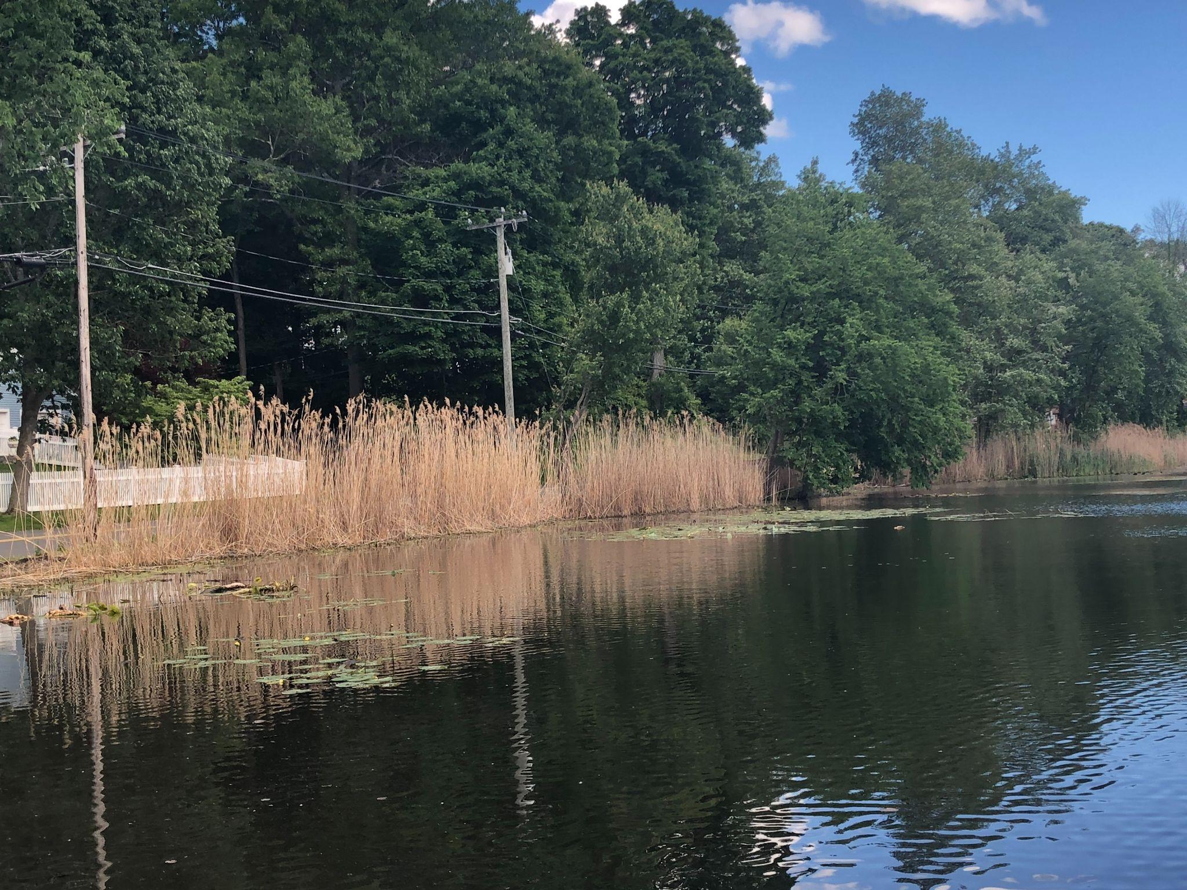



**A BIG SHOUTOUT TO SARAH PATTERSON FROM RITA RD. FOR GIFTING US WITH COPIES OF THE NEWSLETTER!**