Venner PneuX™ System
POINTS OF REFERENCE
This document is intended for quick guidance only –
Users should also refer to Quick Start Guide and IFU Manuals
SIZE:
Recommend Venner PneuX™ ETT/TT Size 8.0 ID Females/Size 9.0 ID Males
PRE-USE CUFF CHECK:
Inflate cuff with 15-20 mls of air to check for integrity, then deflate cuff
SUBGLOTTIC PORT PATENCY CHECK:
Flush the subglottic ports with sterile saline prior to use
INTUBATION LENGTH/TUBE POSITION:
Allow extra intubation length to account for flexible distal tube (approximately 2 cms)
Essential - Rigorous check in early phase of use to ensure cuff is mid-tracheal (not laryngeal or bronchial)- Chest X-Ray
FIXATION:
To avoid unplanned extubation – Ensure adequate and secure fixation to prevent tube movement
VENNER PNEUX TSM™ PRESSURE SETTING:
NB. Default tracheal wall pressure is 20 mmHg (27.2cmH2O) –
Increase to 30 mmHg if there is an audible air leak
Trans-laryngeal air leak – Check PEEP & peak intrathoracic pressure (if high – consider increase to 30 mmHg to match airway pressure)
Increase to 40 or 50 mmHg when performing subglottic irrigation
SUBGLOTTIC DRAINAGE:
Perform every 4 hrs or more often if required (with 10ml syringe)
SUBGLOTTIC IRRIGATION:
Perform every 12 hours/shift change or more often if required (with 60ml luer lock syringe)
Increase tracheal wall pressure to 40 or 50 mmHg for duration
DISCONNECTION/TRANSFER:
For disconnections of over 1-hour duration, cuff pressure should be monitored/controlled using a standard pressure inflator to ensure this is maintained at 80 cm H20.
ALARMS: See overleaf
Venner PneuX TSM™ - Tracheal Seal Monitor
ALARMS
Leak
Activates when there is a disconnection of the Venner PneuX™ Extension Tube, damage/fracture of the Venner PneuX™ Extension tube or cuff perforation.
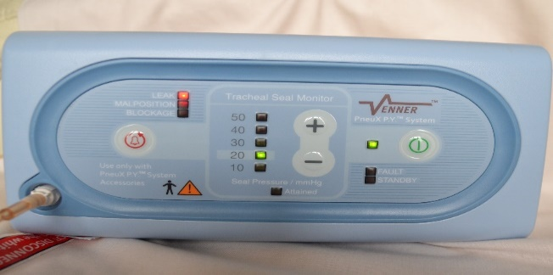
Malposition
Activates when a sudden requirement for inflation is detected by the Venner PneuX TSM™. This can indicate partial extubation or the unintentional withdrawal of the tube cuff into the stoma (TT).
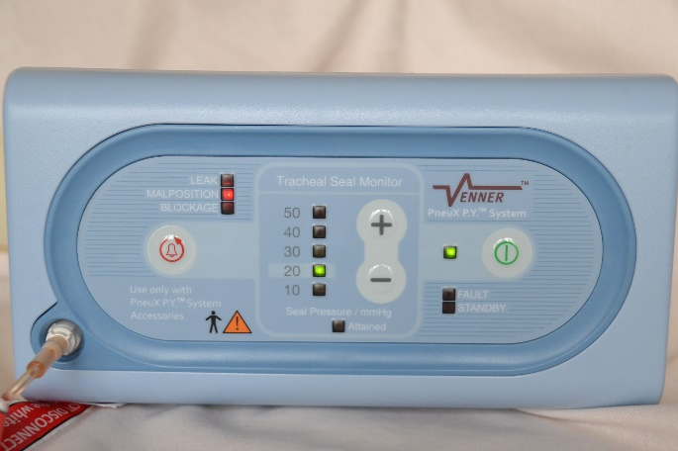
Blockage
Activates when the variability of cuff pressure with ventilation ceases. It indicates a possible cuff inflation system blockage. Activation may also occur with cessation of ventilation.

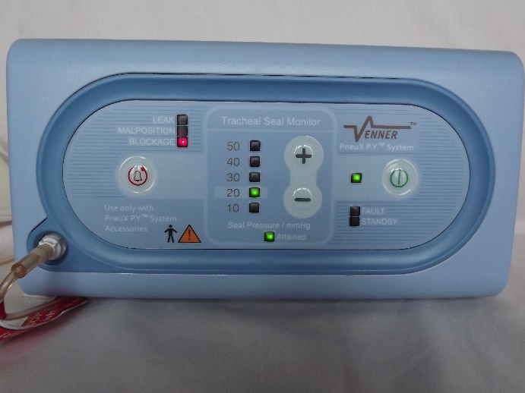
Should there be any doubt about the operation of the Venner PneuX TSM™, disconnect the Venner PneuX™ Extension Tube connector from the pilot valve and manually check/re-inflate the cuff EVERY HOUR, with a standard pressure inflator, to maintain pressure of 80 cmH2O

