
Broodmare Offering
Peyton’s College
(Violence-Honorable Cat)
Overview
It was a stroke of luck that we were able to find and secure Peyton’s College after her successful racing career. Her Sire Violence, a multiple Graded Stakes Winner, out of a Stakes Placed mare Honorable Cat provided her with all the opportunity to be not only a successful racehorse, but an outstanding Broodmare prospect as well. With a pedigree with the likes of Medaglia d’Oro, Gone West, Mr Prospector and Danzig she is sure to produce the caliber of racehorse we are striving to produce here at Double T Farm.
Peytons’s College
With 36 starts, 7 first-place finishes, 7 second-place finishes, and 8 third-place finishes, she had an amazing 61.1% in the money percentage and total earnings of $182,465.00. Peyton’s College has competed at various renowned racetracks such as Churchill Downs, Ellis Park, Turfway Park, Horseshoe Indianapolis and Parx Racing. Peyton’s College competed on the dirt, in distances from 6 Furlongs to over a mile receiving a speed rating of 79 in multiple races, this proves her adaptability as a racehorse and the athleticism she was bred with from such a deep family. She is a 7-year-old maiden mare, and we are excited to share this opportunity.
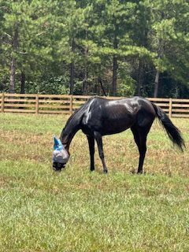
Mullion
TDN Rising-Star, only a 5 Year-old himself, his racing career was cut short due to an injury. The full brother to the none other Mandaloun, this Into Mischief offspring was described by trainer Brad Cox to be more talented than his Kentucky derby winning full brother. With two starts, 2nd as a two-year old, and at 3 winning his 2nd time out by an impressive 10 Lengths at Churchill Downshe was bred to go the classic distances. Entering stud in 2024 at the infamous Sequel Stallions New York his foals just started arriving in 2025 and we are excited to see what his weanlings look like in the very near future.
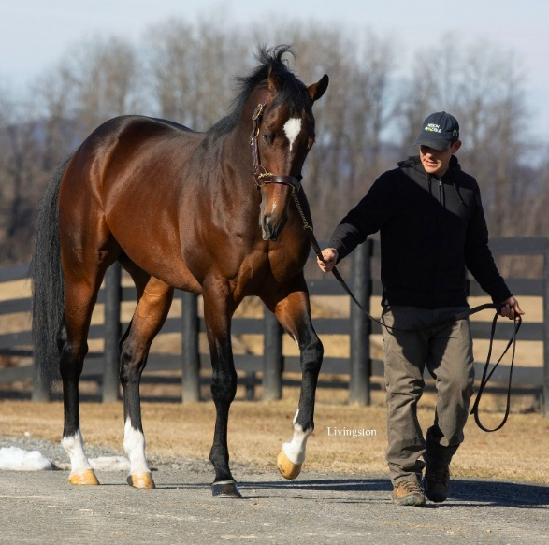
The Plan
Early in the breeding season of 2026 we will book Peyton’s College to be bred to Mullion in New York. She will then return home to Double T Farm to ensure the best care and opportunity to produce a top-quality foal. When the time is ready, she will return to the Great State of New York to Foal at Saratoga Glen Farm. At SGF Dan and his wife Kathy do an amazing job providing care for not only the foal, but the mare as well. Once we see what we have we will decide what steps are next in both the mare and foals’ interest in producing the best financial outcome. All partners will be involved in making the decision and have input. We expect this one should be a fun and exciting opportunity!
Valuation
The total 100% Valuation for Peyton’s College and Foal is $24,000.00. We currently have 66% available and will honor 11% increments with preference granted to larger commitments. All expenses will be billed quarterly at the owners’ percentage.
Ownership % | Total Value of horses | 1st Qtr Expenses | Total Payment
11% | $2640 | $300 | $2940
22% | $5280 | $600 | $5880
33% | $7920 | $900 | $8820

Contact: Terrence V Lambert 706-830-5361 with any questions and commitments

