
Broodmare Offering
Schumer
(Violence-La Titina)
In one of the last sales of the year we were able to acquire this mare by Violence. The Fasig-Tipton December Digital sale can be tricky seeing as how it’s the last sale of the year. We were very fortunate to have an opportunity to pick up a former Eclipse filly that was a $125k purchase as a two-year-old. Additionally, she is in foal to a Top 10 Stallion, Independence Hall who stands at the famous Winstar Farm.
Schumer
A Kentucky bred filly born and raised at Stonehaven Steadings in Versailles, KY. By Leah O’Meara, Schumer is by the most famous son of Medaglia D’Oro, Violence and out of La Titina by arguably one of the best Broodmare sires Distorted Humor. La Titina foals have brought anywhere from 125k to 625k in the sales ring. Schumer’s Half Sister Leslie’s Humor has won her last two starts at Belmont at the Big A with a 95-speed rating, training well for Chad Brown and LSU Stables. Schumer was bred on an early cover on April 3, 2025. We are excited to see her foal arriving in February.
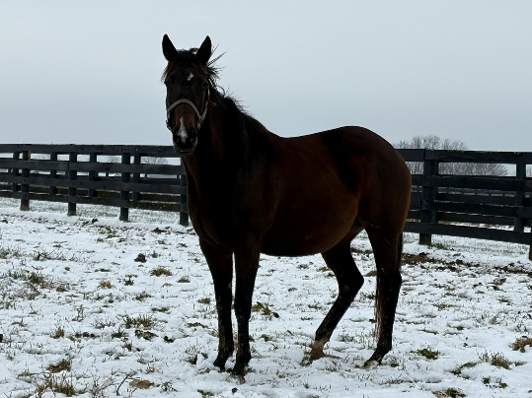

Independence Hall
The Son of the famous Constitution, Independence Hall was an undefeated Graded winning 2 YO & the fastest 2 YO of his crop w/ a 101&105 Beyer in the G2 Fayette. He entered stud in 2022 and has 5 Black Type Progeny already. Additionally, in 2025 his 2YO average was 119 and in 2024 his yearling average was 54k. He was a Top 10 Freshman Sire by Yearling average and his first crop 2yo sales sold for 1 mil, 700k, 400k, 290k, 285k, and a couple at 240k. He is currently standing at Winstar Farm in Versailles, Ky for $10,000.00
+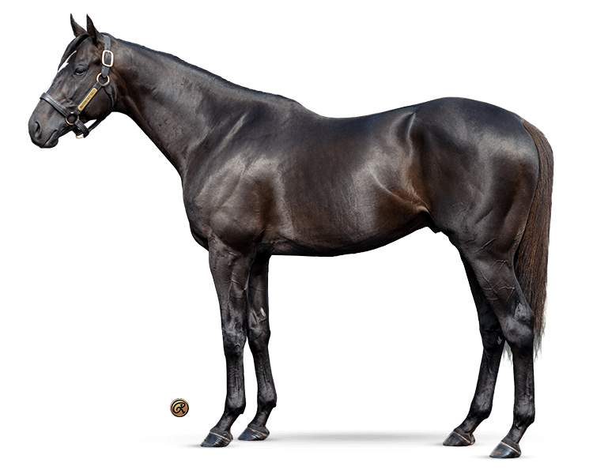
The Plan
Recently, Sean Tugel of ETP, introduced us to Jen at Zen Equine. With all the recent news and success they have had in the foaling world and the sales ring, it made perfect sense to plan to foal Schumer at their recently acquired farm (Millenium Farm near Lexington, KY). She should foal early to mid-March and will then be bred back to Goldencents sire of KY Derby Winner Mystic Dan. Once she is in foal, she will return to Double T Farm to raise her Foal and enjoy the comforts of home. 90 days prior to the September sale the foal will return to Zen Equine to be prepped for the sale.
Valuation
The total 100% Valuation for Schumer and Foal is $28,000.00. We currently have 33% available and will honor 11% increments with preference granted to larger commitments. All expenses will be billed quarterly at the owners’ percentage.
Ownership % | Total Value of Horses | 1St QTR Expenses | Total Payment
11% | $3080 | $600 | $3680
22% | $6160 | $1200 | $7360
33% | $9240 | $1800 | $11,040

Contact: Terrence V Lambert 706-830-5361 with any questions and commitments

