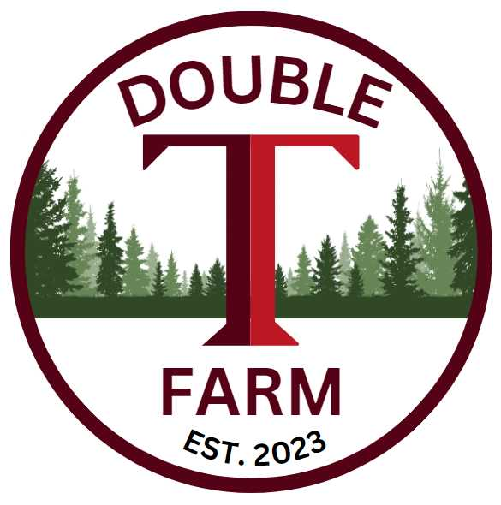
Broodmare Offering
Itsnotmyjob
(Half Ours-Izzie’s Gold)
Overview
This is one of those rare opportunities that only come around once in a lifetime! Although we are consistently looking for opportunities like this, they are RARE! We found this filly that had 53 starts and was still sound showing the durability of her bloodlines. Once we saw 4 generations back in her bottom side pedigree the “Queen of Pearl River”, Monique Rene, we new she was the one to get. So, let’s just say we have big plans for her and her offsprings future!
Itsnotmyjob
A winner of $198,485.00 from racetracks in the famed State of Louisiana such as Evangeline Downs, Delta Downs, and Louisiana Downs this 8yo Filly was as durable as they come. With her last win coming as recently as 4/11/25! She is a Beautiful Grey Filly with great bloodlines and outstanding Confirmation. Standing 15’2 with amazing powerful shoulders and hind quarters she will produce strong, stone-cold runners. Out of a Stakes Winning Black Type Dam Izzie’s Gold hailing from families from the likes of Mr Prospector, Yes Its True, Unbridled’s Song, and Storm Cat, she is sure to produce a high-quality foal with tons of upside. By Half Ours, who was the #3 Louisiana Stallion in 2022 and produced over 40 Stakes horses on the dirt and turf. He himself was by the infamous Unbridled’s Song out of a Storm Cat Mare, its no wonder this cross was so productive.
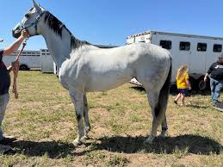

Coal Front
This 11yo beast of a Stallion was a Machine of a producer winning $1,825,280.00 himself. With wins such as the Godolphin Mile, Mr Prospector, Gallant Bob, and the Amsterdam he is by Stay Thirsty who is by none other than the Great Bernardini! Out of a Mineshaft Mare Miners Secret we knew that this cross was the perfect mix of Distance and Speed. Coal Front’s offspring has been doing an exceptional job in the sales ring, with his first OBS 2yo tagged for $150,000.00! In 2025 his son Coal Battle won the Smarty Jones, the Rebel Stakes, and ran 3rd in the Arkansas Derby and Qualified and participated in the Kentucky Derby. His progency continues to earn we are excited to continue watching his offspring flourish.
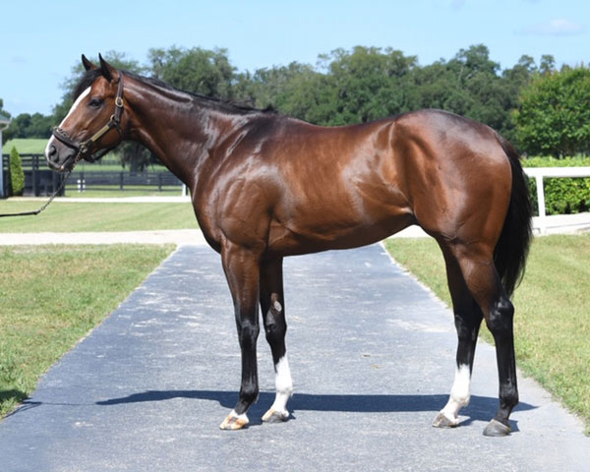
The Plan
Early in the breeding season of 2026 we will book Itsnotmyjob to be bred to Coal Front standing at Red River Farms in Louisiana. She will then return home to Double T Farm to ensure the best care and opportunity to produce a top-Quality Foal. When the time is ready, she will return to the Great State of Louisiana to Foal at Elite Thoroughbred Farm in Folsom, La to have her foal. At Elite they do a wonderful job of foaling, weaning, and Sale Prep. Once we see what we have we will decide what steps are next in both the mare and foals’ interest to produce the best financial outcome. All partners will be involved in making the decision and have input. Either way this one should be a fun and exciting opportunity!
Valuation
The total 100% Valuation for Itsnotmyjob and Foal is $17,500.00. We currently have 66% available and will honor 11% increments with preference granted to larger commitments. All expenses will be billed quarterly at the owners’ percentage.
Ownership % | Total Value of horses | 1st Qtr Expenses | Total Payment
11% | $1925 | $600 | $2525
22% | $3850 | $1200 | $5050
33% | $5775 | $1800 | $7575

Contact: Terrence V Lambert 706-830-5361 with any questions and commitments

