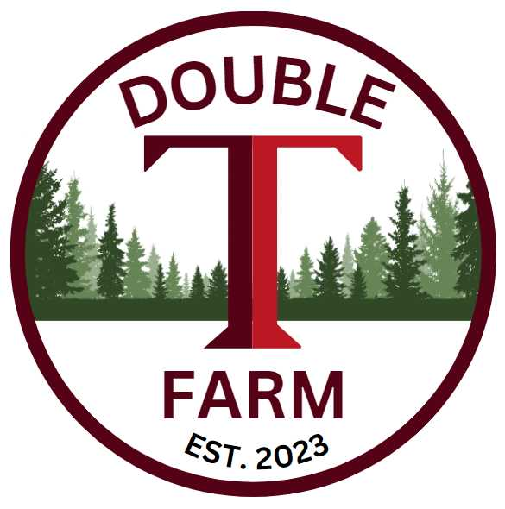
Broodmare Offering
Northway
(Bernardini-Shine Upon)
In 2025 this was one of our early purchases in the year. We were able to secure an early Breeding to a top Stallion Standing at Mills Ridge Farm in the prestigious Lexington, Kentucky. Aloha West, he needs no introduction as he was the Winner of the G1 Breeder’s Cup Sprint! Additionally, he was one of Eclipse Thoroughbred Partners’ top producers. From the Fappiano family, Speed and Confirmation from dam side, Speightstown daughter Island Bound. Northway is currently located in Nicholasville, Kentucky at Farview Farm all dappled out and enjoying the Green Grass and Sunshine.
Northway
A winner herself at racecourses in the great racing state of New York such as the famous Saratoga Racecourse, Aqueduct, Belmont Park and Finger Lakes this Young mare is by the Famous Broodmare Sire Bernardini. It’s very rare that we get an opportunity to own a horse with such great bloodlines as Northway. Additionally, out of a Black Type Stakes Winning Dam (Shine Upon) and 2nd Dam Stakes Placed (Look Upon). She is a Solid 16.3 Hand High Bernardini mare at the young age of 5 years old. She will have plenty of Future stars in the making going forward. She was Bred at the 8 am slot on Apr 11th and was a first-time cover on a maiden mare.
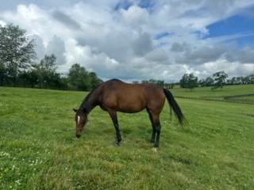

Aloha West
One of ETP’s Leading Producers, Aloha West won the prestigious Breeders Cup Sprint and a total Earnings of $1,507,290.00. He was sired by none other than the Durable son of Danzig, Hard Spun. Hard Spun has produced Fifteen Career G1 Winners and four stallion sons in Kentucky: G1 Met Mile Winner Silver State, G1 Breeders’ Cup Sprint hero Aloha West, G1 Breeders Cup Dirt Mile winner Spun to Run and Kentucky Derby runner up Two Phil’s. Aloha West physically resembles the Speightstown family with speed and his quality and presence. His pedigree blends from 3 of the most influential sire lines today: Danzig, Gone West, and AP Indy and traces back to Fappiano. Look no further, this Cross should produce an epic blend of Speed and Route of ground. He is currently standing at Mills Ridge Farm in Lexington, Ky for $8500 Live Foal.
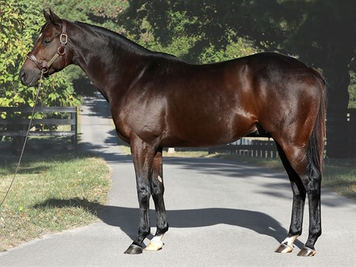
The Plan
Utilizing our resources the plan is to Foal Northway at Glencrest Farm in Midway, KY. Established in the Middle of the 20th Century, Glencrest Farm and the Greathouse family can trace the history of more than 120 Stakes Winners, including the winners of the Kentucky Derby, the Kentucky Oaks and Breeders Cup Champion, to their Bluegrass Fields. Once she has delivered the foal, we will decide who to breed her back to, we will confer with all partners prior to deciding. Once the foal is weaned the foal will stay at Glencrest Farm to continue to grow and be prepared to attend the Yearling sale when ready, we will be looking for any updates that come out prior to picking which sale to attend. Four Star Sales will be preparing and deciding which event will generate the most for our awesome edition.
Valuation
The total 100% Valuation for Northway and Foal is $28,000.00. We currently have 33% available and will honor 11% increments with preference granted to larger commitments. All expenses will be billed quarterly at the owners’ percentage.
Ownership % | Total Value of Horses | 1St QTR Expenses | Total Payment
11% | $3080 | $600 | $3680
22% | $6160 | $1200 | $7360
33% | $9240 | $1800 | $11,040

Contact: Terrence V Lambert 706-830-5361 with any questions and commitments

