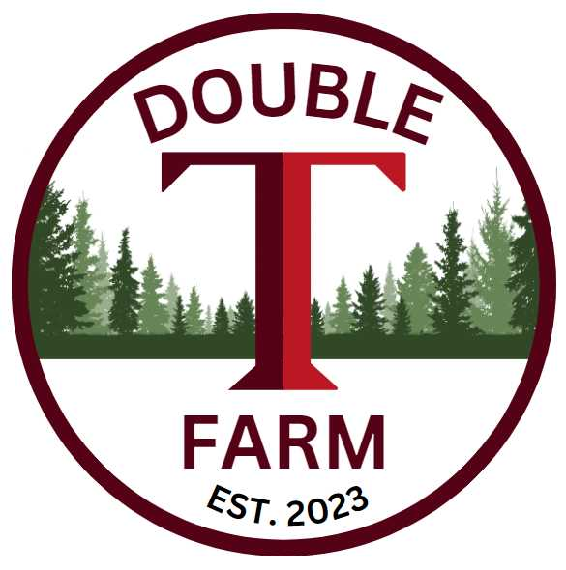
Pair of Filly’s Value
Partnership Opportunity
Of course, a week before Mardi Gras, Double T Farm was presented an interesting opportunity that seemed to give us a reason to “Laissez les bons temps Roulier”. Good racehorses can come from anywhere, these two were orphaned by their owner/breeder when she unfortunately died of a sudden heart attack. Her trainer was a longtime friend and came in to catch up. He mentioned the pair and now we own them. They will be ready to begin running at the end of August, as long as everything goes as expected. We will let them tell us respectfully.
Scarlet Star
By Coal Front out of Mockingbird Song
This young lady is full of spice and pizzazz! By Coal Front a Proven Sire who Double T Farm is familiar with. He recently had a son running in the 2025 KY Derby and has a pair of very nice fillies win close to $1million at the track! Her mother was a $145k Yearling purchase by Kenny McPeek. This is her first foal and from what we see here at Double T, we have a lot of upside.
Big Honey
By Big Mike out of Coolhandtrix
This filly is large and in-charge. Carrying the Danzig bloodline, she has a great mind and is much more reserved than her buddy Scarlet Star. That doesn’t mean she isn’t competitive or lacks any confidence. She is well balanced with a great shoulder and a hind end that holds all the pushing power. Her sire Big Mike was unraced by Belong to me by Danzig and out of an Atticus mare that was Stakes Placed. She was an exceptional value but based on her physicals she will have a lot to offer.
Training and Strategy
Both fillies were sent immediately to be broke in North Augusta. They will be with that trainer for 60 days and receive all the groundwork and initial training, they should be ready shortly after Masters week. They will then be sent to Double T Farm to begin their conditioning and get 120 days under them before shipping to Colonial Downs. Once there, they will get Gate Schooling and have at least 5 or 6 breezes before looking for a race.
Trainer/Conditioner
Kenny Huffman began his career racing Quarter horses in the early 80’s. He made the transition to the Thoroughbred side after realizing the opportunities were much greater. Having 2,062 Starts, 159 Wins (Multiple Stakes Winning Trainer), 218 Seconds and 261 Thirds, we know he knows how to get them there. They will join Kenny at Double T Farm in 60 days.
Valuation and Pricing
The pair will be offered as a package. We will offer our standard 11% ownership with a Valuation of $12,000.00. Expenses will be quarterly with the first 3 months estimated due at inception.
Ownership% | Total Value of Horses | 1st Qtr Est Expenses | Total Payment
11% | $1320.00 | $1023.00 | $2343.00
22% | $2640.00 | $2046.00 | $4686.00
33% | $3960.00 | $3069.00 | $7029.00
44% | $5280.00 | $4092.00 | $9372.00

Contact: Terrence V Lambert 706-830-5361 with any questions and commitments.

