



WOODBURY UNITED METHODIST CHURCH

4 Church Street

Woodbury, CT 06798

Website: [www.woodburyumc.net](http://www.woodburyumc.net)

Office: (203) 263-4775 • Fax: (203) 263-5867

Email: [www.woodburyumc.net](http://www.woodburyumc.net)

Find us on Facebook Clip Art/woodburyumcct & Instagram cliparts/woodburyumcct

Rev. J. Michael Cobb, Pastor

**Woodbury United Methodist Messenger**

Wednesday, March 10, 2022

**March 13th: Second Sunday in Lent**

**Guest Preacher: Garrett Walkup**

**Lectionary Reading: Genesis 17:1-9**

**Liturgist: Sarah-Kate Walkup**

**Communion Steward: Anna Walkup**

**Ushers & Greeters: Joann King, Barbara Etcheto, Jay Hockenberry**

**Audio Visual Technician: Theron Kissinger**

**Worship At 10:30 AM, Livestreaming Or In Person**

Join us in person of via livestream on YouTube or audio-only by telephone broadcast. Video recordings of services will also be available for later viewing. The options for accessing services electronically remain the same:

* **Video**: Go to [http://www.woodburyumc.net](http://www.woodburyumc.net/), scroll to the link for livestreaming near the top of our home page. A link is also provided for archived videos for later viewing.
* **Audio only by phone:** dial 425-436-6391, enter pin with hash sign 2431819#. Note that these numbers have changed from what was previously used. Please mute your phones to eliminate background noise.

**Schedule For This Week**

**Tuesday, March 15th** Lenten Lectionary Bible Study, 6:30 PM, via Zoom

**Wednesday, March 16th** Lenten Lectionary Bible Study, noon

Bell Choir Rehearsal, 6:00 PM, Sanctuary

Voice Choir Rehearsal, 7:15 PM, Sanctuary

**Thursday, March 17th** Trustees Meeting, 7 PM, Assembly Room

**COVID Response Team (CRT) Update**

We hope you have enjoyed the resumption of congregational singing two weeks ago. We are delighted to announce that we plan to resume Fellowship Hour this month on March 27th. We are also now allowing masks to be optional during small-group meetings held in Fellowship Hall, predicated on the fact that all participants are fully vaccinated/boosted, are asymptomatic, unanimously agree to removal of masks, and use either enhanced ventilation or the HEPA air filter boxes built by BOT.

The CRT is now considering the conditions under which masks can be made optional during worship services. We hope to be able to announce such a step toward normalcy in April, predicated on continued downward trends of COVID metrics and the ability to re-open windows and implement enhanced ventilation. In the meantime, we request that you continue to be patient.

The following is a reminder of how you can do your part to protect your church family at in-person worship:

1. Pre-register for the service on our website, [www.woodburyumc.net](http://www.woodburyumc.net).
2. Upgrade your mask to at least a surgical mask. We strongly encourage you to wear an N/KN 95 mask for increased protection. Both will be available to anyone who needs one at check-in.
3. If you or a family member is ill, please stay home and continue to enjoy the service online at our website, [www.woodburyumc.net](http://www.woodburyumc.net), or our YouTube channel at <http://www.youtube.com/channel/UCN-kkokTCbVE9urwgP_AEcw>.
4. Maintain your distance from other family units after briefly greeting one another.

You will find a chart on our website at <https://woodburyumc.net/covid-recovery%2Freopening> to help you determine when it is safe for you to return to in-person worship after being ill or having been in close contact with someone else who is ill.

**Support For The People Of Ukraine**

We have all likely gone through a variety of emotions as we have watched the suffering being inflicted on the people of Ukraine by a foreign invader. One question that has surely arisen is “What can we do?” The New York Annual Conference has shared that through The Advance, the donation platform of the UMC Board of Global Ministries, there are two ways that you can give support:

* **Advance #14053A: Eurasia In Mission Together -- Ukraine and Moldova.** Donations to this Advance account will be quickly transferred to the bank account of the UMC of Ukraine, which has a system in place to receive these donations, put them to immediate use, and provide reporting on the usage of these funds. To donate, go to: [Eurasia in Mission Together](https://ny-email.brtapp.com/!BUJbOIk1iSTUulXnzJy0sq02DA+MN5LKemqWndsR5skYcDmuWtD1QlpAX-q4wR2mg)
* **Advance #982450: UMCOR International Disaster Response.** Donations to this Advance account will be directed to UMCOR, which is already partnering with agencies on the ground in Eastern and Central Europe to assist those displaced by the fighting. Donations to this account should be designated "for Ukraine." To donate, go to: [UMCOR International Disaster Response](https://ny-email.brtapp.com/!JIdiRdcgSeitXhSG1tX0GZuSH9s090G4FygliEXsFrvv0vzq8CLHhG5k9615YlHQM)

In addition to these two ways to provide some material support to the people of Ukraine, please continue to provide your spiritual support through your ongoing prayers for protection for the most vulnerable and peace for their land.

**From Woodbury to Ecuador and Back Again – Love in Action**

In 2017 the WUMC began a relationship with the people and the Methodist Church in Ecuador through a connection with Sara Flores and her husband Dakin Cook, missionaries with the General Board of Global Ministries (GBGM). The church has supported ministry with the people of Ecuador through prayer, financial gifts to GBGM ministries (Advance Specials in Methodist lingo), sale of handcrafted items with proceeds going directly to Sara for discretionary use there or Advance Specials, and in 2018 a mission team of 12 (most of whom were from the WUMC) spent a week of service in churches in Atucucho and El Prado in Ecuador. But the love and service are not one way. In addition to the hospitality and the care our mission team received while in Ecuador, on several occasions over the past 5 years we have been the recipients of heartfelt prayer from the churches in Ecuador. The last time being on the 20th anniversary of September 11th.

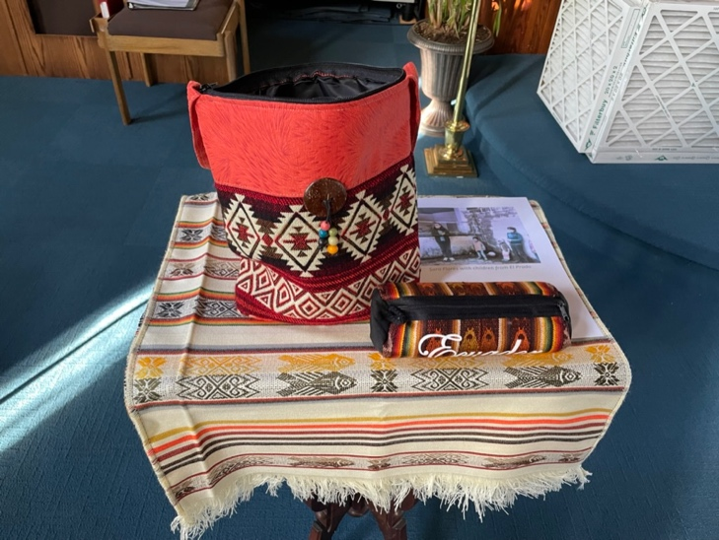With this ongoing mutual commitment to share the love of Christ between the one body in two locations in mind the **Mission & Outreach Committee will be receiving a special offering throughout the season of Lent** to provide continuing support of the ministries of Sara Flores and the Methodist Churches in Ecuador. While the needs in Ecuador are varied, which include programs for children, support for pastors, and just recently recovery from flood damage at the end of January, Sara has asked that the gifts we raise go towards the building of a church and community center for El Prado and surrounding communities. Sara writes, “To achieve this dream, we are in a campaign to promote funds for the purchase of land. The goal is to reach $20,000 U.S., and we have already saved $5,000. We pray, confident that we can achieve this goal in 2022.  We invite Woodbury UMC to be part of this dream.”

**Each Sunday in Lent there will be well-marked locations in the church for your gifts, such as one at the front of the church, pictured here. Gifts can also be mailed to the church or donations can be made through the church’s website. If a check is written please make it out to “WUMC” with “Ecuador” on the memo line.**

Lent is traditionally a time when people give something up. This Lent may we also take up this way of deepening our Methodist worldwide connection.

**Children & Youth Ministry News**

**FAMILY ACTIVITY**: Read Luke 13:31-35 together. In it, Jesus compares King Herod to a fox and himself to a mother hen. Jerusalem is his flock of chicks that keep running off. Despite danger from the fox (Herod), the mother hen (Jesus) continues to love and protect her chicks.

* If you were to compare God to an animal, what animal would you choose and why?
* Mother hens are soft and warm, but they are also fierce, chasing off predators. Who in your life feels safe like that?
* Have you ever wanted to do something on your own, without help or protection? Were the adults in your life still there for you after?

**Last weekend’s retreat was a lot of fun. We discussed the differences between prevenient, justifying and sanctifying grace, and did an exercise using clay to make the point.**

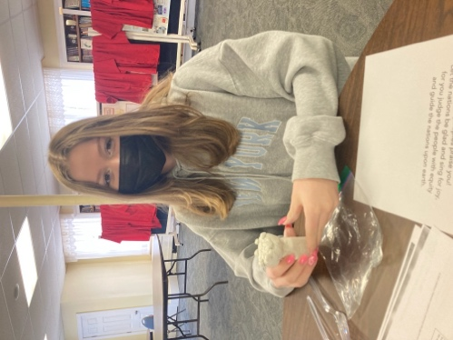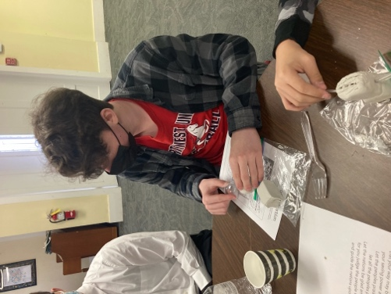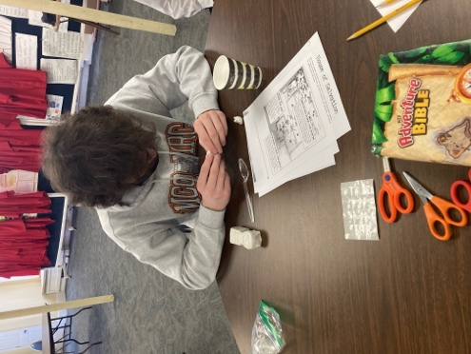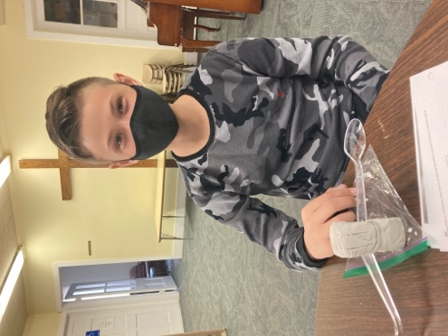

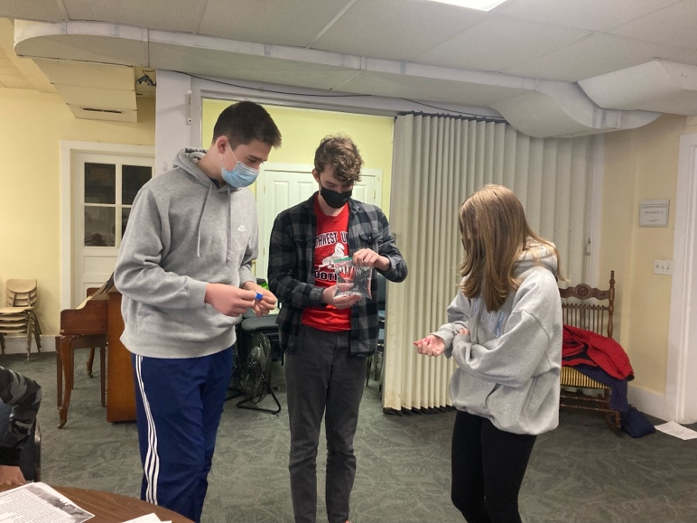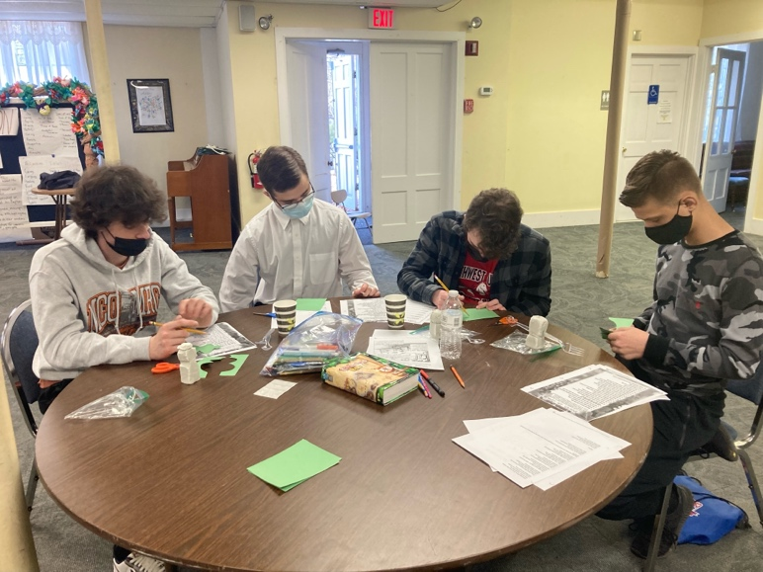

Our next **CONFIRMATION CLASS** meets next on **March 27** in Fellowship Hall from 4 to 6:30 PM to discuss Worship and Sacraments.

**Lenten Lectionary Bible Study!**

For the Lenten season, we are going to offer a Bible study focused on going deeper into the scripture that was just preached in Sunday’s sermon. You have two ways to participate: We are meeting via **Zoom on Tuesday evening**, and **in the Assembly Room at the church on Wednesday at noon** (bring your own lunch).Contact Pastor Michael for details.

**The Prayer Corner**

**During Lent, please join together all are invited to join together for a time of prayer prior to worship from 9:30 to 10 AM in the room off of Fellowship Hall.**

***In prayer, please remember: The People of Ukraine;***

***Our sisters and brothers in Christ, after recent mudslides in Ecuador;***

***The following individuals from the WUMC Congregation*:** *Michael Etcheto*, grandson of *Barbara Etcheto, Lou Calabrese* (husband of *Lynn Ramsden-Calabrese*); our homebound members, *Florence Brown and Linda Bailey;*

***Our Confirmands:*** *Annabelle Cloud*, *Cody & Zachary Cordova, James Levario, and Matthew Shupenis*

*To add individuals to the weekly prayer list, please reach out to Carolyn Shay, 203-518-3177 or 1jerseygirl52@gmail.com*

**Kudo Korner**

**Thanks to last Sunday’s worship leaders:** *Rynn Naylor, Communion Steward & Liturgist; Bud and Jo Ann Behlman, Greeters and Ushers; Theron Kissinger, Audio Visual Technician.*

**Altar Flowers**

The floral chart will be placed in the Narthex for your convenience if you would like to select a date further into 2022. REMEMBER: if you don’t have an occasion, you can donate and we will be sure to deliver them to one of our homebound people during that week. There has been an increase in floral pricing to **$35.00** for 2022 due to the increase of all supplies used for the arrangements. Call the office at (203) 263-4775 or email at [wumc@woodburyumc.net](mailto:wumc@woodburyumc.net).