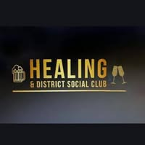
Healing & District Social Club – Events calendar 2026
Fri 6th February – Quiz
Sat 21st February – Pete & Sammie
Fri 6th March – Quiz
Fri 20th March – AGM
Sat 21st March – Jacqui
Fri 3rd April – Quiz
Sunday 5th April – BBQ/Karaoke (Easter Sunday)
Sat 18th April – JoJo
Fri 1st May – Quiz
Sun 3rd May – O’s house (Bank Holiday)
Sat 9th May – Chris Perry
Sat 16th May – Eurovision Party
Sun 25th May – BBQ/Karaoke (Bank Holiday)
Friday 5th June Quiz
Scan the QR code to go directly to our website !

Healing & District Social Club – Rookery Lane – Healing
New members welcome

