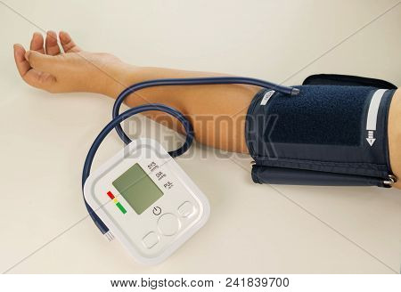

UNDERSTANDING YOUR
BLOOD PRESSURE READINGS
BLOOD PRESSURE  CATEGORY | SYSTOLIC mm Hg  (UPPER #) |  | DIASTOLIC mm Hg  (LOWER #)
NORMAL | Less than 120 | AND | Less than 80
ELEVATED | 120-129 | AND | Less than 80
HIGH BLOOD PRESSURE  (Hypertension Stage 1) | 130-139 | OR | 80-89
HIGH BLOOD PRESSURE  (Hypertension State 2) | 140 or Higher | OR | 90 or Higher
HYPERTENSIVE CRISIS  (Consult your PCP Immediately) | Higher than 180 | AND/OR | Higher than 120
SOURCE: AMERICAN HEART ASSOCIATION

