FOR INMEDIATE RELEASE

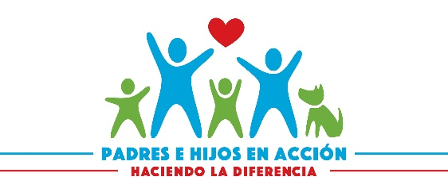

PADRES E HIJOS EN ACCIÓN Receives Grant to Support our Mission to serve Latino families with members with Special Healthcare needs.

Date:12/15/2022
Hector Portillo
Executive Director
Portillohm99@gmail.com
608 335-8779

Madison WI –December 15th, 2022, PADRES E HIJOS EN ACCIÓN has been awarded a Legacy Grant of $10.000 by the Wispact Foundation. This grant will allow us to continue to serve some of the most vulnerable in our community including Children with Special Care needs.

This support is vitally important especially now due to the rising cost of living. This funding will allow us to provide Shower Chair, Portable Hoyer Lift, Pads, Wheelchair, and more services to Latino families.

PADRES E HIJOS EN ACCCION is a grassroots organization of individuals with disabilities, their families, friends, and community members building fulfilling and community-centered lives for Latino children.
PADRES E HIJOS EN ACCION envision a world in which all people with disabilities can enhance their quality of life and strengthen the civic life of the community. By focusing on the assets of Latino Children with disabilities and their family members.

The Wispact Foundation was established in 2021 and provides grants to support the mission of client-centered organizations assisting Wisconsin residents. The Wispact Foundation is a wholly owned subsidiary of Wispact, Inc., a non-profit organization dedicated to improving the lives of persons with disabilities through pooled and community special needs trusts (SNT). Wispact was created in 2003 and is now one of the largest of its kind in the United States; and currently serves more than 4,000 beneficiaries throughout Wisconsin.

MORE
The following is a comprehensive list of Wispact Legacy Grant recipients.
Access to Independence
ALS Association WI Chapter
Arts for All
Audio &amp; Braille Literacy Enhancement
Autism Society of Greater &amp.
Southeastern WI
Autism Society of WI
Betty Brinn Childrens Museum
Beyond Vision
Black River Area Foundation
Bloom 360 Learning Center
Blue Lotus Farms
Bridge the Gap
Broadscope
Carmelite Ministry of St. Teresa
Cerebral Palsy Inc
Curative Care Network
Dogs in Vests
Door Tran
East Shore Industries
Eisenhower Center
Elsie Shaw
Ex Fabula
Families Matter
Family Voices
Fishing That Has No Boundaries
Friendship Circle
Gigi&#39;s Playhouse Madison, Fox Point &amp;
Weston WI
Goodwill Industries
InControl
Independence First
Islands of Brilliance
Journey 21
Journeys Lutheran School
LE Phillips
Logans Heart and Smiles
Lutheran Social Services of WI
MATC
MCFI
Mel’s Charities
Mequon Nature Preserve
Milwaukee Symphony Orchestra
Movin&#39; Out
Neighbor to Neighbor
Natures Edge
OccuPaws
One City Schools
Opportunities Development Inc
Padres e Hijos en Acción
Paralyzed Veterans of America
Pawtism Society
People First Wisconsin

