FOR INMEDIATE RELEASE

Legacy Grant

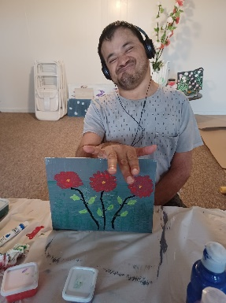
Thank you to the Wispact Foundation for awarding PADRES E HIJOS EN ACCIÓN one of 75 Wispact Legacy Grants! Our grant will be used for assisting Children with Special Care needs.

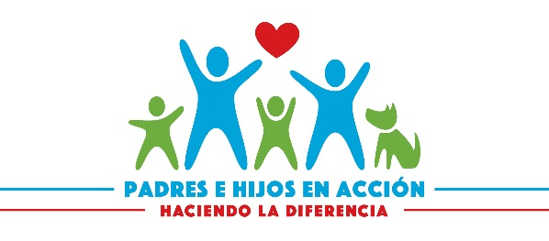
Please help us share the good news, PADRES E HIJOS EN ACCIÓN will be receiving a Wispact Legacy Grant in the amount of $10.000.00 Our grant will be used for Serving Latino Families with members with special needs.
Check this out, the Wispact Foundation has awarded us a Legacy Grant to fund support for to improve the quality of lives of persons with disabilities in 2023.

To enhance the lives of people with disabilities across Wisconsin, the Wispact Foundation will distribute $637,330.

The Wispact Foundation increased their support of Wisconsin non-profit organizations 275% over last year.

The mission of the Wispact Foundation is to improve the quality of lives of persons with disabilities through partnerships with the disability services community.

The Wispact Foundation was established in 2021 to provide a broader scope of service and create more opportunities to improve the lives of persons with disabilities across Wisconsin.

The Wispact Legacy Grant Program was established by Wispact Inc. and is managed by the Greater Milwaukee Foundation.

