Habit Reversal Training (HRT)

Stefania Dannacher, Psy. D.
Habit reversal training is a set of procedures that have been successfully used to treat trichotillomania (hair-pulling), excoriation (skin-picking), nail biting, and motor/vocal tics. With practice, triggers and reinforcers for the habit will weaken as healthy alternative habits are established. After your therapist has shown you the procedures in the office, use the following outline for your daily practice sessions at home.

Awareness Training (AT): Increase Your Awareness of the Habit
- First, identify factors that foster and maintain the habit: environmental, behavioral, emotional, cognitive, and sensory variables. (E.g., an individual may be more likely to engage in the habit when in the bathroom, when watching T.V., when bored, when thinking about their appearance, or when feeling a bump on their skin). Be aware that which of these variables are particularly triggering so be prepared for increased urges when entering these situations.
- Identify each time you have an urge or start the habit by using a predetermined signal. For example, you can raise your hand/finger when the habit occurs or you can say, "I’m having an urge" or “’I’m doing it” when the habit occurs. (Parents: If you see your child doing the habit and your child does not notice, signal them with a gesture or expression that you both have agreed to use).
Your signal is ________________________________________________.
- You can record each occurrence of the habit on an index card/notepad (using tallies). Keeping track of how often the habit occurs is a great way to tell when progress is being made and can be very rewarding to visualize.

Practice a Competing Response (CR) Regularly
- A competing response is an action you do in place of the habit. The muscles used to do the new action make it impossible to perform the old habit. For example, instead of doing an eye blink tic, you will very gently close your eyelids and hold them closed for 10 seconds.
Your competing response is ______________________________________.
- Practice your competing response each time you experience an urge or become aware that you are already engaging in the habit. (Parents: Encourage your child to use the competing response in situations where the child is likely to engage in the habit).
- Try to use the competing response for as long as it takes for the urge to come down or for 30 seconds to 1 minute after each time you become aware you are performing the habit.
- Stimulus Control:
- Sensory substitution/distraction techniques provide alternatives to soothe, invigorate, and provide pleasing sensations impacting the nervous system in ways that divert the individual from the habit. Fidget toys/stress balls can be used to keep hands occupied.
- It can help to move to different environments which are less triggering. For example, spending more time around others if you are less likely to engage in the habit around other people.
- Wearing gloves or putting Band-Aids around certain fingers may help in high-risk situations.

Exposure and Response Prevention (ERP)
- Bring on the urge to perform the habit on purpose (e.g., feel for bumps without picking/popping). Notice how the urge feels both physically and emotionally. Rate your level of anxiety/discomfort. (Parents: Help your child to become aware of how their body moves and what muscles are being used when they perform the habit).
- “Urge Surfing”
  - Mindfulness: take deep breaths as you experience an urge. Do not engage in a battle for control over these unpleasant feelings. Rather, notice them and let them go at their own pace. Imagine that tension is being released with each exhale. Notice what happens to the feelings/thoughts over time in an objective way. Try to let go of any judgement or criticism that arises.

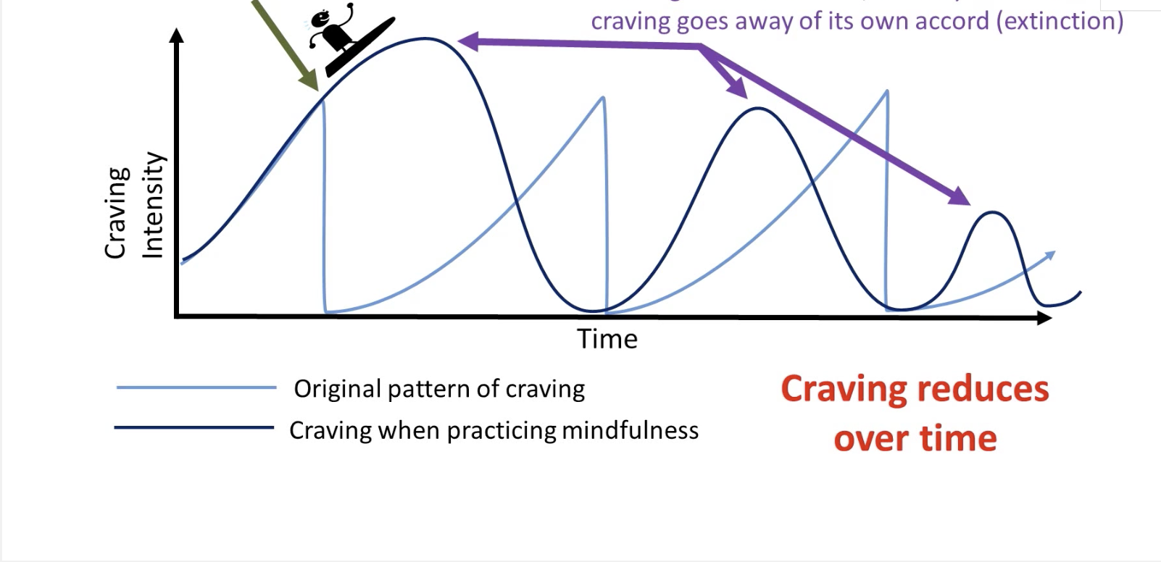

Parents: Help Your Child
- Feedback: Work with your child to help them be aware of the habit by using the signal to identify the habit when it occurs.
- Support and Encouragement: Encourage your child to use the competing response and praise them when they do. Praise your child when you notice the habit is starting to become less frequent or less severe.
- Effort: Remember, although many children and adolescents will notice a decrease in their habit within a couple of days, the greatest change from using these habit reversal procedures occurs during the second and third month. Don't give up after only a couple of days or weeks.

