**Graphs to demonstrate habituation through Exposure and Response Prevention (ERP)**

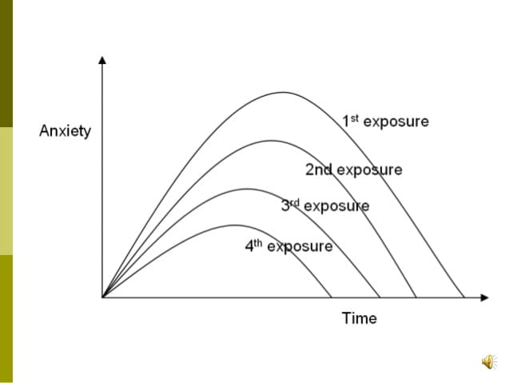

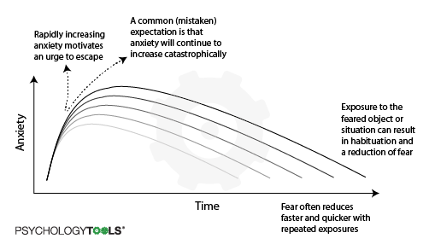

**“Urge Surfing”**

