INVITE FOR NON-PROFITS

Subject: Join Us for the 2026 Duck Derby Spring Festival – “Adopt a Duck” Fundraiser

2026 Duck Derby Spring Festival, hosted by the GFWC Wewahitchka Woman’s Club. Date: Saturday, March 28, 2026
Location: Lake Alice, Wewahitchka, FL

A huge THANK YOU to everyone who participated last year — your support made it unforgettable! This year, we’re adding a splash of excitement with our
Egg-stravagant Kids Zone, where children can play games, win eggs, and trade them in for candy and prizes. And pictures with the Easter Bunny!

Sign up today to be included in the first printing of our “Adopt a Duck” materials! First printing will be early January – The Duck Derby Spring Festival Squad will be setting up at the JSL Chili Cook-off on Jan. 31st in PSJ.

Duck Adoption Program:

- Ducks available for a $5.00 donation
- Sell 1–30 tickets and earn $2.00 per ticket
- Sell 30+ tickets and earn $3.00 per ticket

Volunteer Call: We need helpers at the Egg-stravagant Kids Zone game stations from
10:00 AM to 12:00 PM — a great way to get involved and support the fun!

Non-Profit Booth Opportunities: Your group is welcome to set up a booth to sell food, merchandise, recruit members, hand out giveaways, or showcase your organization.

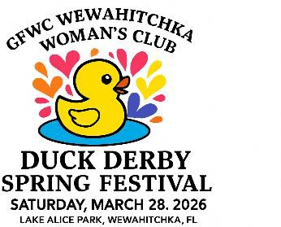
Let’s make this year’s Duck Derby Spring Festival the best one yet. We can’t wait to see your group there, feathers and all!

With gratitude,

The Duck Derby Spring Festival Team
GFWC Wewahitchka Woman’s Club

