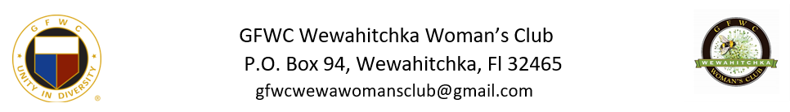
Dear [Community Member/Local Business/Prospective Sponsor],
We’re not ducking around! Prepare for feathers, fun, and a whole lot of quacking! The GFWC Wewahitchka Woman's Group is thrilled to introduce our first-ever Duck Derby Community Event on Saturday, March 9, 2024, at Lake Alice Park. We're counting on our amazing community to add some extra feathers and need your help to make it just Ducky!
What’s a Duck Derby? It is a fundraising event where rubber ducks will “race” across Lake Alice.
How does it work? Prior to the race, all ducks will have been tagged with a number corresponding to an individual who will have previously “adopted” the duck at the cost of $5. The lucky owners of the first ducks to cross the finish line will win one of our exciting prizes.
Sponsorships: We are seeking sponsors to help cover essential operating costs such as shirts, ducks, advertising, and we are also partnering with Wewa High School Cross Country Team which will hold a 5K “people” race to kick off the event and so much more. Your contribution will play a vital role in the success of our event.
- STRUTTIN’ DUCK - $500:
  - Exclusive recognition as a STRUTTIN’ DUCK.
  - Logo prominently displayed on the back of event shirts.
  - Acknowledgment in all promotional materials.
  - Special mention during the prize ceremony.
  - Our deepest gratitude for your generous support.
- SUPER DUCK - $250:
  - Logo placement on the back of event shirts.
  - Acknowledgment in promotional materials.
  - Recognition during the prize ceremony.
  - A heartfelt thank you for your significant contribution.
- QUACKER BACKER - $100:
  - Name listed on the back of event shirts.
  - Acknowledgment in promotional materials.
  - Recognition during the prize ceremony.
  - Appreciation for supporting our community event.

Big Prizes Needed: We are also seeking substantial prizes to add excitement to the Duck Derby. If you can donate or help secure prizes such as an overnight stay, a kayak, or other appealing items, we would greatly appreciate your assistance.
We are seeking volunteers to provide entertainment and photography services during the Duck Derby. If you have a talent for entertaining or capturing special moments, your support would be invaluable.
If have any questions on sponsoring, providing prizes, assisting with duck sales, or contributing in any other way, please contact Michele Gionet 610-334-1879 or Caroline Dean 850-247-2052 or email gfwcwewawomansclub@gmail.com. Involvement will make a significant impact on this community event.
Thank you for considering our request. We look forward to your support in making the GFWC Wewahitchka Woman's Club Duck Derby and Community Event a memorable and successful day for our community.
Quackily yours,
GFWC Wewahitchka Woman’s Club

