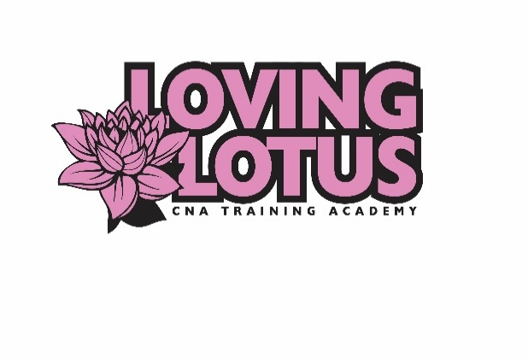
Loving Lotus CNA Training Academy, LLC
650 Brakke Drive
Hudson, WI 54016
Phone: 651-321-7500 Fax: 651-389-9147
Website: www.lovinglotuscna.com
Email: lovinglotuscna@gmail.com

APPLICATION, CONTRACT, AND BACKGROUND CHECK CONSENT FORM
(Please PRINT LEGIBLY and complete all sections)

Date of class to be enrolled __________________________________________
Full Legal Name______________________________________________________________________
Drivers License Number/ID_______________________ Social Security #________________________
Street Address: ___________________________________________________Apt No._____________
City, State, Zip Code: __________________________________________________________________
Phone: _____________________________________________________________________________
Email Address:_______________________________________________________________________
Date of Birth: ____________________Race___________________________Sex__________________
Maiden names or previously used names___________________________________________________
Emergency Contact:__________________________________ Relationship:______________________
Phone Number: ______________________________________________________________________
Please answer the following question:
Are you able to lift a minimum of 50 pounds? YES NO
Do you have any medical restrictions or conditions? YES NO
Are you a High School or GED recipient and can provide proof? YES NO
Have you ever been convicted of a felony or misdemeanor? YES NO
If so, please explain:
I consent to have a background check completed by the school and am aware that this background check must be clear to attend clinical sites. I authorize Loving Lotus CNA Training Academy, LLC and its employees to provide a copy of my background check to the clinical site.
_______________________________________________________________ __________________
Signature of Applicant Date
Loving Lotus CNA Training Academy, LLC
650 Brakke Drive
Hudson, WI 54016
Phone: 651-321-7500 Fax: 651-389-9147
Website: www.lovinglotuscna.com
Email: lovinglotuscna@gmail.com

APPLICATION, CONTRACT, AND BACKGROUND CHECK CONSENT FORM
(Please PRINT LEGIBLY and complete all sections)
Applicant’s tuition fee will be $1,400.00. A non-refundable deposit of $1,000 must be paid at time of registration to reserve a seat in the program. Tuition cost does not include the testing fee for your state exam. The balance is due at the pre-arranged date made with administration. To receive a certificate of completion, all fees must be paid and all equipment on loan from the school must be returned in satisfactory condition.
No refunds will be issued after activation of the online learning. Tuition payments may be refunded only if requested in writing within 3 business days from application and online link was not activated. Refunds will be issued within 30 days. There will be a $50 non-refundable fee deducted from balance. Student must appear in person to receive refund – they will not be mailed out per school policy. If student has logged in to the online learning portal and wishes to withdraw from class, no refund shall be issued regardless of time passed. If student does not pass the background check, student will receive full refund minus a $50 background check fee.
The student will provide program with a copy of their driver’s license or state-issued photo ID and the results of a negative TB skin test for approval of application. All information provided to the school shall be kept confidential.
________ I have received a copy of the school catalog and policies and procedures. (initials)
How did you hear about us? _____Internet _____Social Media ______Friend _____Workforce Center _____Newspaper ______Other: ________________________
I have read this contract and agree to the terms. I understand that clinical or supervised practical training dates and times are subject to the discretion of the clinical director and the facility at which clinical will take place.
Signature of Applicant Date
For Office Use Only (Do not write below this line)
Tuition Payment _____________________________Payment Date______________________________
Tuition Refund ______________________________Refund Date ________________________________
Drivers License______________________________Background Check____________________________
TB Skin Test________________________________ Processed On/By ____________________________

