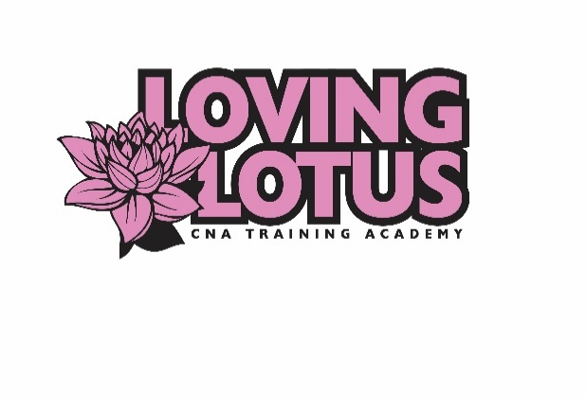

Loving Lotus CNA Training Academy
Phone: 651-321-7500 Fax: 651-389-9147
Website: www.lovinglotuscna.com
Email: lovinglotuscna@gmail.com

Mantoux/PPD Test Result Form
Student Name: _____________________
Student Date of birth: _________________
To be completed by the Physician/Nurse:
Name of Provider who read the exam (please print):
___________________________________
Date and time PPD test was administered: _____________
Date and time PPD test result was read: _______________
Result of Test: ______Positive _____Induration ______Negative
Does Patient need to have a chest x-ray? _____Yes _____No
Signature of Provider/Nurse who read the exam:
____________________________________________
Date: ________________
Provider Address: ___________________________________

