Orchid expert and grower, Jeff Hutchings, talks about what to choose
and how to grow them in a garden or meadow.
Growing beautiful hardy orchids in your garden or meadow .....
I am constantly being told by gardeners that they did not realise that orchids can be grown in the garden despite the fact that there are 60 plus species growing wild in this country including over 20 in Cumbria. In this article I intend to outline the orchids available for you to grow in the garden, the way in which they grow and where they can be bought.
The most important aspect of growing orchids in a garden situation is to be aware of the needs of individual species. I have found that the best way to identify these cultural requirements is not to read books and “experts” cultural suggestions but to study photographs of each species growing in its wild habitat. A good example is the Bee Orchid Ophrys apifera. Books on British native orchids refer to this orchid as requiring dry alkaline/chalk soils. Earlier this year I stood in a very wet clay soil field full of Bee Orchids in Essex. Apart from the alkaline soil the conditions were completely opposite to what is expected.
The basic principles of hardy orchid cultivation are quite simple. The key is “killing with kindness”. Terrestrial orchids have adapted to enable them to withstand low nutrient regimes and periodic droughts. They have very specific dormancy periods in the same way as all perennials but this period may be in the summer or last for three-quarters of the year. Therefore, giving the plants good compost, constant watering, etc; is not what they actually want.
To cultivate a particular hardy orchid you need to know its requirements and how to recreate them, the hardiness of the species; particularly to our winter rain, whether it requires sunlight or shade, wet or dry, and the pH levels.
Before introducing you to the different garden worthy terrestrial species I want to dispel the myth concerning the requirement for fungus (mycorrhiza) in the soil before orchids can grow. The need for the mycorrhiza is at the germination stage. The seed is so small it has no food reserves and needs the symbiotic relationship with a specific fungus in order to enable the development of the protocorm. Some growers do not use mycorrhiza when they are growing orchids in flasks. Older orchids often retain some mycorrhiza in the tubers which is transferred each year.
Hardy orchids can be grown in many different garden situations and most relish poor low nutrient soil. Initially, it is sensible to purchase easy species and then progress onto more difficult species with experience.
To grow hardy orchids successfully, you need a basic understanding of your chosen species. All the hardy orchids grown outside in the United Kingdom are terrestrial and usually have a seasonal dormancy period within their annual growth cycle.
Terrestrial orchids can be divided into four specific groups depending on their root system. There are the rhizomatous group where the rhizome spreads out just under the surface and sends up leafy single shoots which may terminate in a flowering spike. This group includes cypripediums and epipactis and are winter dormant.
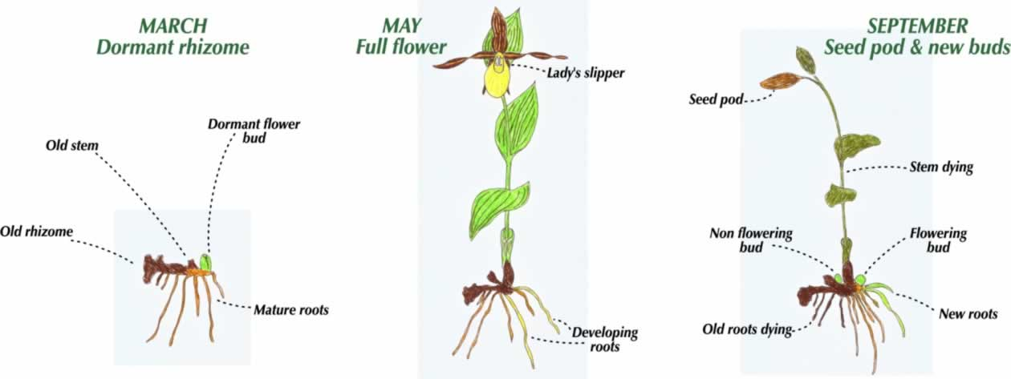
Cypripedium annual growing cycle
The next group have an annual root tuber (carrot or finger shaped) with a rosette of leaves being produced in the spring from which develops the flowering stem which has leaves up its length. Flowering is in late spring through into the summer. This group includes Dactylorhiza, Gymnadenia and Platanthera.
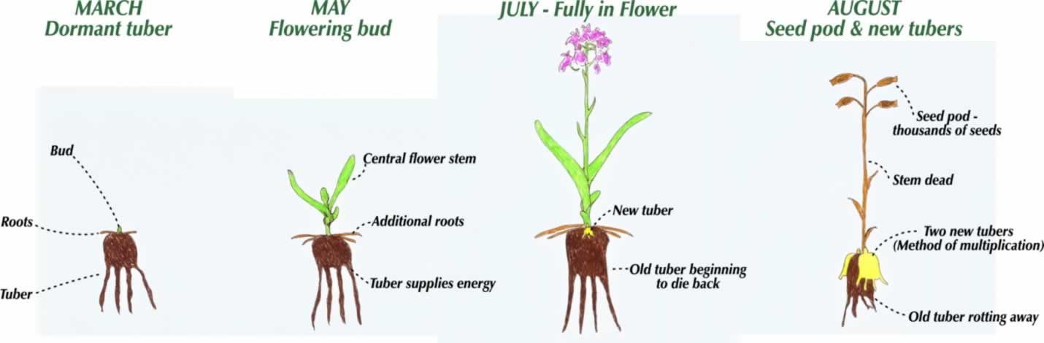
Annual cycle of the Dactylorhiza
Species with an oval annual root tuber forming a leaf rosette in the autumn and producing a flowering spike in the spring and early summer followed by a summer dormancy period include Orchis, Anacamptis and Ophrys.
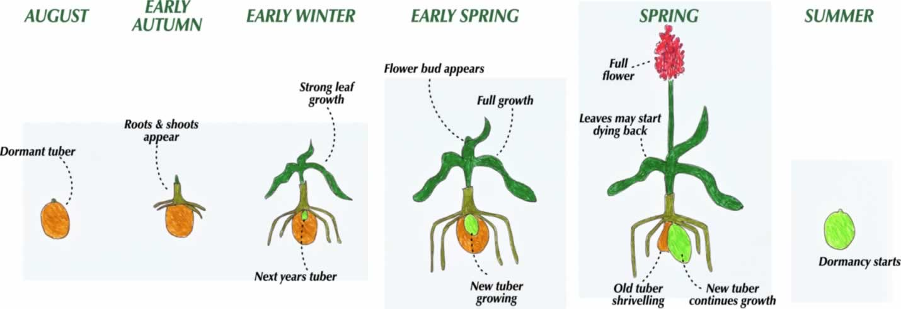
Annual cycle of the Anacamptis
The final group have pseudo-bulbs which spread across the surface with the new buds sprouting each spring on the edge of the clump and flowering in late spring and summer. These include the Bletillas and Calanthe.
Of the summer flowering species, Dactylorhiza, Epipactis and Platanthera are all good garden or lawn subjects. Most require a moist free draining soil which is neutral or slightly alkaline. Cypripediums are becoming increasingly available and a small number of species plus numerous hybrids grow well in cool semi-shade conditions.
The winter green species include both native and European species. The former grow well as they are adapted to British conditions but the latter are more used to much lower rainfalls. It is from this group that the species useful for lawns and meadows are found.
Terrestrial Calanthe are good subjects for damp shady areas where there is some protection from heavy frost. Finally, there are the Bletillas which grow in either semi-shade or full sun.
People often ask what conditions are required for hardy orchids. My response is to ask where they might like to grow the orchids and then I can outline which grow in those particular conditions.
Having outlined the annual growth cycles of the different groups I will now take you through the various genus and the particular species which make good garden subjects.
The easiest of all the terrestrial orchids are the Dactylorhizas. Most people have come across the Common Spotted, D fuchsii; which grows happily in many situations providing the soil is neutral to alkaline. Its one requirement if it is to thrive is the need for full sunlight. If grown in the shade whilst it does not die it most certainly will not multiply.D majalis is an ideal plant for very damp areas around ponds: having the ability to withstand very wet conditions. The best species for a garden border is D foliosa (the Madeiran Orchid) which grows to 60/80 cm and the main clone offered has deep purple flowers. For alkaline soils, D praetermissa (Southern Marsh) thrives, whilst in acidic area D purpurella (Northern Marsh) is the orchid of choice. Planting should take place either in the early autumn or spring before grow restarts. They should be planted with the growing tip about 2 cm below the surface.
Dactylorhiza also make good species for growing in large pots. Provided sufficient space is left for multiplication plants can be left to grow for several years without repotting. British native species make good subjects for wildflower meadows.
For wet areas, the two Epipactis species, the British native palustris and the American gigantea are ideal subjects. Palustris must have alkaline soil whilst gigantea will grow rapidly in many situations with the rhizomes rapidly spreading over a large area. E palustris can also be grown as part of an orchid meadow.
Bletillas can be grown in either semi-shade or full sun in the garden. Being pseudo-bulbs they require well drained soil which has a good organic content and the new growth develops outwards from the initial planting. The pink striata is the species often offered in a garden centre and known by most gardeners. There are however a number of species and Richard Evenden has produced a whole range of Penway hybrids which includes many with the yellow B ochracea as a parent. This produces multicolour flowers including plants such as Sunset and Harlequin. Plants should be planted with the pseudo-bulb just below the surface and unlike many other orchids division should take place in the summer after flowering. This enables the plant to grow well during the autumn producing new pseudo-bulbs for the next season.
A further genus from Japan are the hardy Calanthe which grow in woodland areas in its native habitat. In the garden it can be grown in the same situations as hostas and ferns. Again they are pseudo-bulbs which are semi evergreen. The old leaves should be removed in the spring. The flower spikes emerge before the leaves fully open. Most species are fully hardy in this country with tricarinata and discolour being the two hardiest. The largest flower (60 cm) is sieboldii but it is slightly less hardy than the others. There is also C reflexa which does not flower until the early autumn. These species also make very good pot plants where they can be given more protection during the winter and if keep in a cold greenhouse the flowers will remain for a number of weeks.
The next group are the famous slipper orchids; Cypripediums. The majority need free draining soil and situations which are cool in the summer and does not get midday sun. When the plant is happy, the rhizomes will spread over a good area and produce numerous flowers. Of the 60 plus species only a few can be categorised as easy garden subjects. C reginae is the easiest species. In the USA it grows in dam areas near streams with its buds held above the water table whilst its long roots will go down into the water. Two other American species c parviflorum mochison and c parviflorum pubescens are also good subjects as is c formosanum . When planting it is best to make up a gritty mix, dig out a planting pit to a depth that allows the root system to spread out naturally. The rhizome should be planted with the buds about two cm below the surface. Planting should take place when the rhizome is dormant and protection provided against winter rainfall. There are a number of commercially available hybrids which are ideal beginners plants. They combine the good points of the parents to provide hybrid vigour and consequently a better plant. The genus is also ideal for growing in pots either in a cold greenhouse or outside. The flowering period for the different species and hybrids is from April to July.
The final group are the wintergreen species. The British natives, such as Orchis mascula (Early Purple) Anacamptis morio (Green Winged) and Anacamptis pyramidalis (Pyramid) make good rockery or meadow orchids. Most require infertile soils which are neutral to alkaline which is easily replicated in a rockery or trough. When grown in a meadow it is important to consider the fertility of the area. If the grass grows well then it is likely to swamp the orchids thus reducing their viability. Tubers should be planted in early September when they are dormant. They will grow through the winter and flower in the late spring. The three identified will multiply through the division of the tuber during regeneration.
The native Bee orchid (Ophrys apifera always attracts attention but it does not always flower regularly. A far better option is to grow a hybrid between apifera and a continental type because these usually flower every year. These are only a few of the native species which can be grown in a garden situation.
As I wrote before there is a hardy terrestrial orchid for all situations in the garden and I would suggest if you are a keen gardener they make a good addition to any garden. Start with the easy subjects and when you succeed with them move on to some of the more exotic. Beware, growing hardy orchids is addictive.
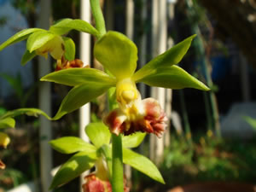 | 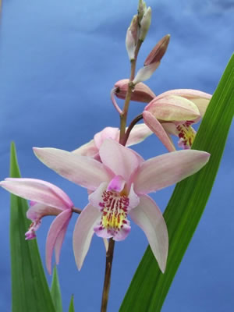 | 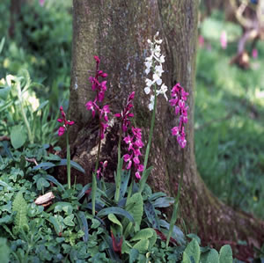
Calanthe tricarinata | Bletilla Penway Harlequin | Orchis mascula
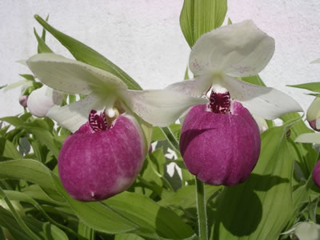 | 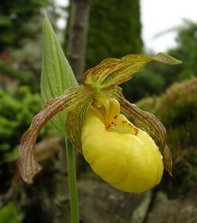 | 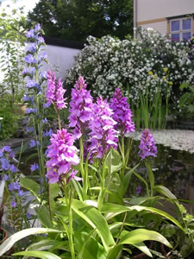
Cypripedium reginae | Cypripedium parviflorum pubescens | Dactylorhiza foliosa
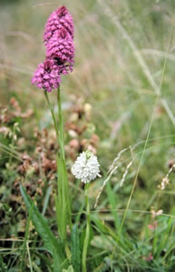 | 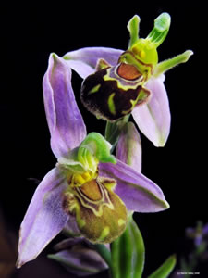 | 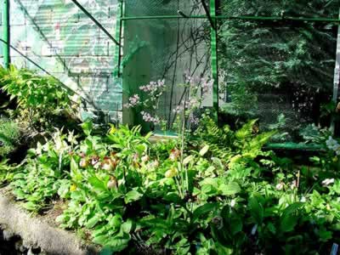
Anacamptis pyramidalis | Ophrys apifera | Cypripediums in a garden

