Cultivation of Pleione - Part 1
1. Where in the world can they be grown?
Pleiones can be grown wherever conditions sufficiently mimic their natural habitat. They come from areas with distinct seasons of Spring, Summer, Autumn and Winter and grow best wherever the average summer temperatures dos not exceed 25 centigrade (though a few odd days up to 30 centigrade is tolerated). In winter, while they are dormant, they need to be kept cold but just frost-free. A range between 1 and 5 centigrade is ideal. If need be, small numbers can be kept in a fridge if your winters are usually too warm (you can un-pot them and keep them in the fridge in a paper bag). Within these restraints they may be grown on a windowsill, in a glasshouse or cold frame and may be put outside for those months that are frost-free. In areas with few and gentle frosts they can even be planted in the garden. But most people grow them as pot plants.
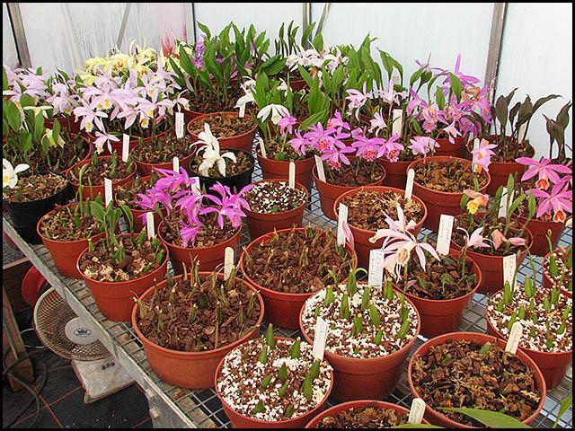
A Pleione collection grown in a glasshouse

2. What kind of containers can be used?
Clay or plastic pots can be used and both have their devotees. Clay pots may need watering more frequently but the evaporation from their surface helps to keep the roots cool and provides humidity around the plants. Plastic pots need less frequent watering, are easier to clean and lighter to use. Many growers use half pots, pans or seed trays, as pleiones are shallow rooting in the wild. In a pot the roots can go much deeper and will easily fill a deep pot but, despite this, my experience is that are still happier in a shallower container. It is probably wise to thoroughly clean and disinfect pots before use.

3. What kind of potting compost can be used?
Pleiones will grow in a variety of compost mixes, the main requisites being that the mix should be very "open" and free draining. I have used various different mixes in the past, but now I always use a mix of 3 parts bark and 2 parts moss (All "parts" are by volume). The bark can be small to medium grade orchid bark or even a good quality mulching bark. Here in the U.K. I use a product called Melcourt Potting Bark, which is similar to (though not quite as good as) orchid bark in quality. This is what it looks like:
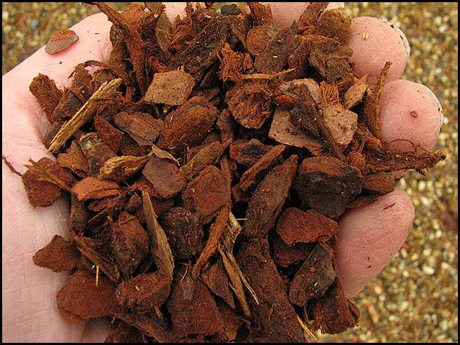
Melcourt potting bark
The moss used can be wood moss or Sphagnum moss (which may be live or dead). I buy bales of dried Sphagnum moss which look like this:
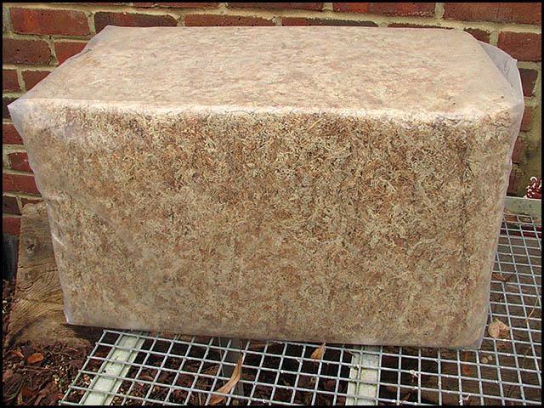
Bale of dried Sphagnum moss
The bales are compressed and need breaking up before use. I find the long strands of moss do not mix easily into the bark and are best cut into shorter lengths of roughly 5 to 7 cm . It is easier to do this if the moss is dampened first. Small amounts can be cut using scissors. A serrated bread knife works well if used on a dampened, compressed handful. Cutting up large quantities by hand takes far too long but putting dampened moss through a garden shredder works quite well and quickly too - an entire bale can be done in about an hour. When ready for use it looks like this:
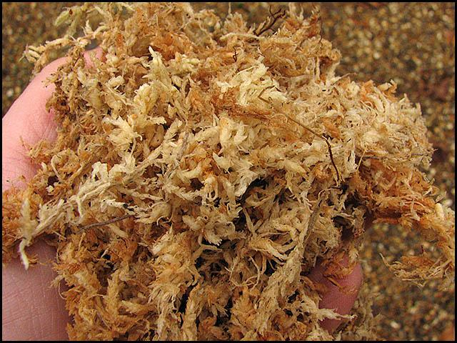
Dampened Sphagnum moss cut into shorter lengths
When the 3 parts bark and 2 parts moss are mixed together to give the final potting mix, it looks like this:
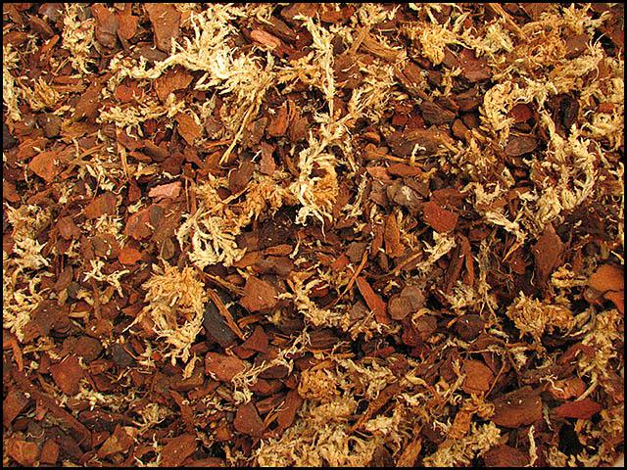
Pleione potting mix ready to use
Many other mixes are suitable - you can use pure wood moss or pure sphagnum, or a mix containing these along with such ingredients as bark, pine needles, leafmould, coarse peat, perlite and others - the main aim is to get a "scrunchy" or spongy, open and free-draining mix. There are as many recipes for mixes as there are growers!

Cultivation of Pleione - Part 2
4. When & how to pot Pleione
Pleiones can be potted or re-potted anytime while they are dormant. I believe it is best to re-pot them every year. (Note - all my timing advice applies to the northern hemisphere, you will need to adjust this by about 6 months if you are growing in the southern hemisphere). I usually do mine in two parts - I un-pot them in November and pot them again in January (except for the autumn & winter flowering types which I repot all in one go either just before or immediately after flowering).
First, the un-potting:
When you remove them from the pot you hope to see that they made lots of good root growth like this:
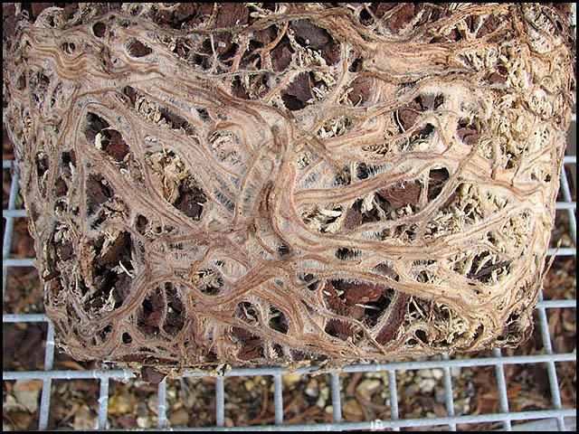
Old Pleione roots at re-potting time
Pull apart the root ball, removing the old compost and most of the dead root. (Pleione roots are annual so die at the end of each growing season). Rather than remove the old roots entirely, trim them back but leave a length of 3 to 4 cm. This will help to anchor the pseudobulb in the new compost when potting. Here are a couple of pictures to show before and after trimming:
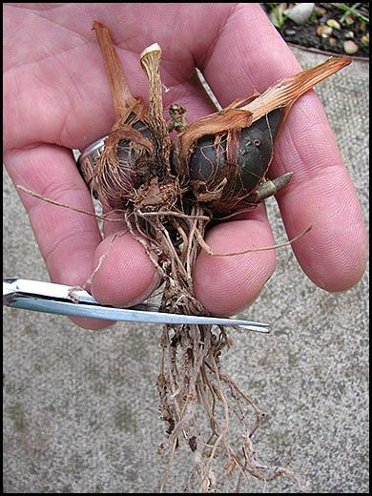  Trimming off old Pleione roots | 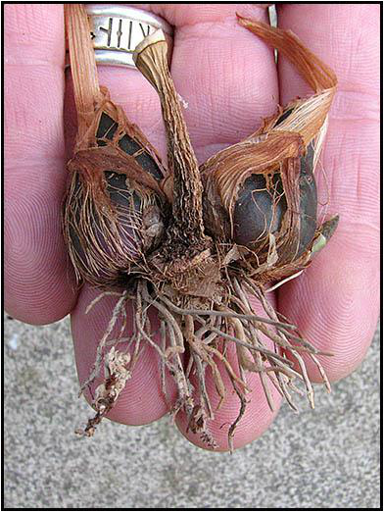  Pleione roots after trimmimg
You will notice in the pictures above that there is an old, shriveled pseudobulb in between the two new pseudobulbs. Like the roots, the pseudobulbs are annual and towards the end of the growing season they shrivel and die. The old pseudobulbs should be removed and thrown away:
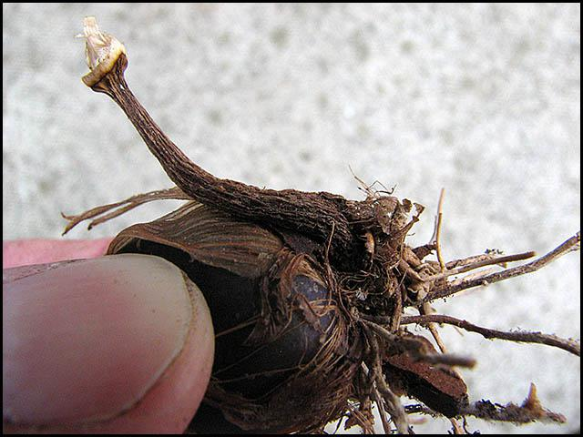  Old, shrivelled pseudobulb still attached to new pseudobulb | 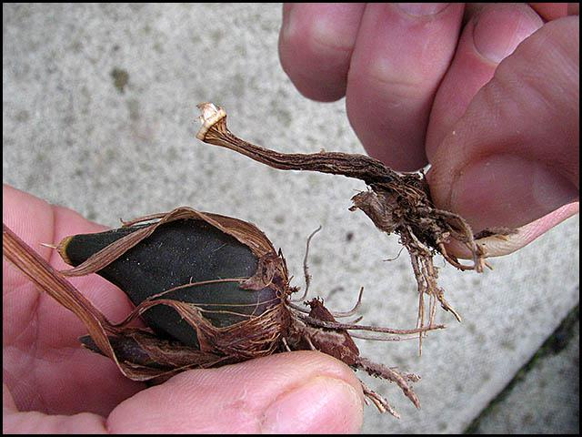  Old pseudobulb removed
Once they have been un-potted, the old compost removed, roots trimmed and old pseudobulbs removed, I store the new pseudobulbs in paper bags in trays until I am ready to pot them up again:
Pleiones stored in bags awaiting potting up
Stored like this they take up much less room - which means I only have to heat a smaller space through the winter. It also gives me chance to give the glasshouses and benches a thorough clean - I always like to start each new season as clean as possible. Good husbandry always helps towards healthier plants.
Secondly, potting up again:
The pseudobulbs should be planted with approximately one third their depth sticking out above the compost and spaced about 2 cm apart. I first put some compost in the pot then stand the pseudobulbs on it. I then add a topdressing of just bark:
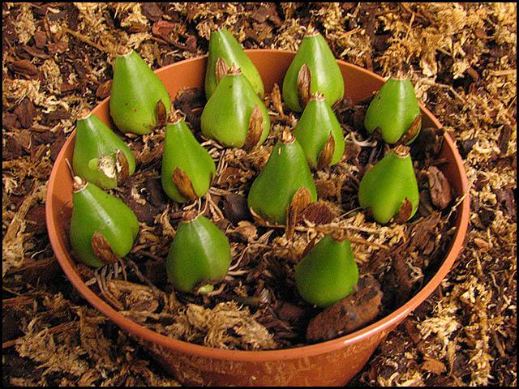  Potting Pleiones | 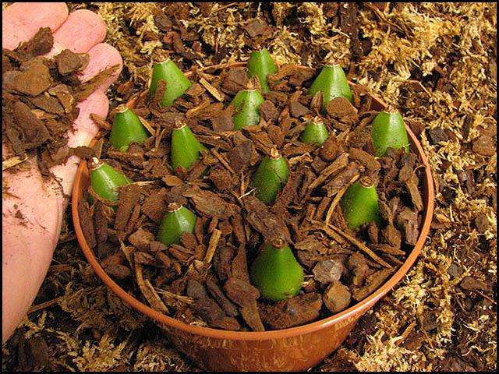  Adding bark topdressing
If you have a lot of one variety, whether adult size or smaller bulbils, you can use a seed tray instead:
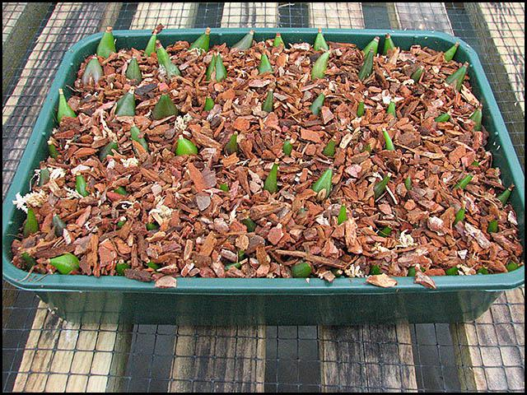
Planting in a seed tray
Note that in the photos above I think I should have planted them a bit deeper i.e. not sticking out quite so much!

Pleione Cultivation - Part 3
5. Watering Pleione
Pleiones are watered from spring through summer to autumn and then kept totally dry while dormant in the winter. The critical time is early in the season. The roots usually start to grow more or less as the flowers fade and at this time it is important to give only a little water - the aim is to keep the compost only-just damp and make the newly-emerging roots go searching for moisture. If the mix is too wet at this time there is a danger the new roots will rot. Once however the roots are well established (often evidenced by rapid leaf growth) watering can be increased substantially. Pleiones come from areas which get the summer monsoon. As long as your mix is very free draining, it is difficult to give them too much water once they are actively growing.
It is best to use rain water, soft tap water or water produced by reverse-osmosis, but this is not so critical for Pleione as for many other orchids and they will tolerate hard tap water. If possible, keep them open to the weather in summer so they can be rained on. They love it! While I still had a small collection I used to take the roof glass out of the glasshouse during summer so the rain could fall on them. It also kept them cooler.
As days shorten in the autumn and growth slows, reduce watering. When the leaves start to go yellow it is time to stop watering altogether and allow them to completely dry out. The leaves will go brown and finally fall off and the pseudobulbs enter their dormant phase.
6. Feeding
Pleiones need to be fertilised to build up the pseudobulbs for flowering the following year. They like regular but weak feeds with a liquid fertiliser. Feeding should start once the leaves start to grow quickly - often late May with me, and continue until the autumn. I have used various feeding regimes and many different brands of fertilisers over the years. I don't think it makes too much difference as long as you do feed them regularly. In my current regime I use the "Miracle-Gro" brand of fertiliser:
Miracle-Gro fertiliser
This has an N - P - K analysis of 24 - 8 - 16 plus trace elements. I give this once a fortnight at about one third to one half of full strength. In the alternate weeks that they don't get this, I give them some liquid seaweed extract ("Maxicrop") again at one third to one half of full strength:
Maxicrop Seaweed Extract
For measuring fertiliser strength accurately, a conductivity meter is a very useful instrument:
Conductivity meter | Orchid growers often invest in such an instrument because many orchids are very sensitive to being over-fed. Measuring the strength of your fertiliser solution accurately helps to avoid this possibility. These meters may measure in units of "parts per million" or "microsiemens". I am most familiar with the latter. Whenever I make up a fertiliser solution for the pleiones I aim to make it produce a reading of 600 to 800 microsiemens on the meter. For comparison, a full strength solution may read 2000 to 2500 microsiemens
7. Light, Air & Temperature
When grown under glass, pleiones need to be shaded from direct, bright sunshine. A shade cloth giving about 50% shade is ideal, or the glass can be painted with a traditional style whitewash. They also enjoy fresh air, so provide plenty of ventilation - a fan is very useful to give some air movement. They prefer cool temperatures, preferably below 25 centigrade though they will tolerate higher temperatures for a while. Outside, they can tolerate full sun but it is more usual and advisable to provide somewhere semi-shaded, for example in the shade of a tree providing dappled light. You may also need to think about some protection from birds and other wildlife, (not to mention the footballs coming over the fence from the neighbours' kids!); growing inside a fruit cage would be ideal. Outside they are also more vulnerable to slugs & snails which love pleiones!
8. Exceptions - species that require different treatment
The treatment outlined so far applies to the vast majority of both species and hybrids. But a few require something different. Pleione maculata, Pleione praecox and their hybrid P. x lagenaria are autumn flowering. These, along with many autumn & winter flowering hybrids, have a rather shorter rest period and need to be kept warmer during this time - a minimum of 10 centigrade for P. maculata though P. praecox can go colder than this. They barely have a dormancy and start to grow new leaves very early - often before the end of the year - and new roots too. Despite this new growth, do not be tempted to give a lot of water - keep them a little moist - perhaps mist them occasionally and perhaps stand the pot in a few millimetres of water for a few minutes to give some moisture at the bottom of the pot for the new roots to go heading for. Don't start regular watering until you are sure the new roots are well down the pot. P. maculata in particular also likes to be kept warmer in the summer with plenty of humidity too.
Pleione saxicola is another autumn flowerer recently introduced to cultivation. It grows a lot of new root very early in the autumn, before even the flowers die down. It is probably better to keep it moist throughout so these roots don't die - though I have tried treating it like any other normal species and it grew OK.
Pleione coronaria, P. hookeriana and P. scopulorum all have a longer, cold winter and a shorter growing season than other species. These species do better if kept cold for longer in the winter, using a fridge if necessary. I suggest keeping P. coronaria and P. scopulorum in the fridge until around early March and P. hookeriana until late March. Keep an eye on them though and take them out if they threaten to flower earlier than this. Also, P. scopulorum unlike other Pleiones must not be allowed to dry out completely during dormancy or it will shrivel and die.
Pleione forrestii also I believe benefits from a long, cold dormancy and should be kept cold until early March if possible. However, this one more than the others has a tendency to flower early and if the buds are clearly developing quickly, remove it from the fridge. It might be worth noting that while cold may delay flowering it will not necessarily prevent it altogether - plants can achieve full flower in the fridge in the dark!
Finally it must be said that some of the species, particularly all those mentioned above, are not easy to grow and we still have much to learn.

