Greater Akron Orchid Society

An Affiliate of the American Orchid Society & the Mid-American Orchid Congress

#### September 2019

## 

**Upcoming Business**

-------

## Next Meeting

The next meeting of the GAOS will be Monday, Sept 9, 2019. Doors open 6:30 pm, Beginner's Corner 6:45 pm and meeting starts 7:15 pm. Portage Lakes Kiwanis Center, 725 Portage Lakes Dr., Akron, Ohio 44319.

Program: **2nd Member Plant Auction /**

**Orchid Diseases Part 1**

Speaker:  Jane Bush

We will hold our 2nd Member Plant Auction of the year. Bring plants and orchid related items to sell to society members. We all have purchased plants that don’t do well in our environment or refuse to bloom for us, bring them to the auction and hopefully you can find something new and exciting to take home with you.

Plants are priced and auctioned. The seller takes home 75% of the final price and the society receives 25%. Please do your best to remove all pests before being auctioned, thank you.

----------------------------------------------------------------------------

Jane will discuss different orchid diseases, their prevention and remedies in this 2-part series.

----------------------------------------------------------------------------

Each meeting will have a show table in which everyone is invited to bring in their blooming orchids to show off. This is a great way to see what other members are growing and how they do so.

New members and visitors are also invited to bring any plants they wish to show or have questions about.

----------------------------------------------------------------------------

## Minutes of Aug 2019 Meeting

## 

The August meeting was a fun one with orchid jeopardy.

Dave announced that he is helping to sell Paul’s light setup which consists of a track and moving light rack system. Contact him for price and details.

As Donzell’s is closing, our Orchid Society needed to find a new location for our annual show. The Show Location Search Committee has visited ten different places in the Akron area and is recommending Rohr's Nursery and Garden Center. <http://rohrsnursery.com/>  
Rohr’s came to our attention as they host a bonsai show. They are very happy to work with us and will supply the tables. We only need to pay the cost to heat the greenhouse to keep the orchids happy.  
  
Paul’s orchids were offered for sale in hopes that they would find loving homes.

***Website:***[*www.thegaos.com*](http://www.thegaos.com)

***Facebook:***[*www.facebook.com/theGAOS*](http://www.facebook.com/theGAOS)

|  |  |
| --- | --- |
|  | **Photo of the Month:** Laelia lundii. Beautiful specimen of this miniature species from Brazil. San Diego County Orchid Society, photo by Orchidées de Prestige |



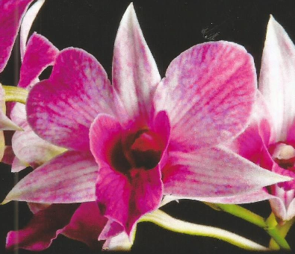

**President’s Corner**

By Jane Bush

Greetings!

It’s September already and those of us who have our orchids outside are treating for bugs and watching the weather forecast to determine when the plants must be brought back inside.

Another item that September brings is the need for GOAS officers. Barbara Ford agreed to be vice president for just one year. We need a vice president for 2020. If you are interested in being an GAOS officer, especially vice [resident, please speck to any current board member.

In addition, we are in the process of planning our programs for 2020. If you have any ideas or suggestions for what you would like to do at our meetings, please share them with me or Dave or Barb.

The September meeting is our annual fall member auction. If you have any orchids or orchid supplies that you want to sell, bring them to the meeting. Please be sure plants you bring are bug free. GAOS gets 25% of each sale and you keep 75%. So, you are helping the club as well as helping yourself when you participate in the auction.

TIDBIT: Safer Soap is an insect killing while Safer 3 in 1 Soap kills insects and controls leaf spotting fungus.

**Meeting Schedule**

GAOS meets the second Monday of each month (except December) Beginner’s Corner starts at 6:45pm and the meeting at 7:15pm, at the Portage Lakes Kiwanis Center, 725 Portage Lakes Dr., Akron, Ohio 44319

Members are encouraged to bring orchids from their collection for exhibit.

**All are welcome; you do not have to be a member to attend.**

Sept 9 2nd Member Plant Auction

“Orchid Diseases Part 1” Jane Bush

Oct 14 “Orchid Diseases Part 2” Jane Bush

Nov 11 Holiday Banquet / Elections

Dec 9 ***No Meeting***

Your local supermarket may appear to be very brightly lit when, in fact, the actual light level is less than 500 foot-candles (*Phalenopsis* need at least 2-3 times that level for adequate growth and flowering) and your office environment is typically about 1/5 of that level. While the most accurate way to measure light levels is to purchase a light meter you can get a pretty good estimate using just your hand. On a clear day, position yourself so that your hand is between your plants and the light source and about 12 inches from the leaves and observe the shadow, if any, your hand casts. If you can see no shadow, you probably do not have enough light for any orchids with the exception of the jewel orchids which are grown more for their leaves than flowers. If the shadow is fuzzy and faint to moderate your light level should be sufficient for *Phalaenopsis* and *Paphiopedilum* which require less light than most orchids. If the shadow you see is sharp, you most likely have sufficient light for all but the highest light-requiring orchids like cymbidiums, vandas and ascocendas.

Don't let anyone tell you that you can't grow a mixed collection of orchids. Hobbyists do it all the time. They just take advantage of the variation in conditions throughout their growing areas. As far as light levels are concerned, direct sunlight entering an unshaded window can be as high as 4,000 to 8,000 footcandles measured directly at the glass while it may only be as low as 500 footcandles just inside the shade off to the side of the same window. Lower light plants like *Paphiopedilum* and *Phalaenopsis* can be staged in these shady areas while higher light plants like oncidiums and cattleyas can be arranged closer to the center and nearer the glass. It just takes a little experimentation.

**Quality versus Quantity**

Plants need red and blue light and they reflect green. Light from the red end of the spectrum is critical for flowering while that from the blue end is used in growth. This is usually not a problem when plants are grown out-of-doors or in a greenhouse unless the greenhouse skin is very old and has yellowed to the point that the spectral quality is poor. However, for plants grown under lights, this can be an important factor and is the reason that many books recommend a mixture of 50:50 cool-white and warm-white fluorescent tubes in the light rack. Spectral quality can also be an issue if you are growing your plants in a sunroom glazed with bronze or other colored glass since these glazing materials may filter out much of the spectrum used by plants.

**Light, the Key to Successful Blooming**

By: American Orchid Society

While there are many factors that can trigger blooming in orchids; a drop in night temperature, increase or decrease in day length and even sharp restriction in water availability, none of these will be successful unless your orchids have been grown with adequate light. For most hobbyists, this factor is almost always at the heart of the question "Why won't my orchids rebloom?" You can't work magic or miracles and without adequate light during the growing season, no amount of cajoling with decreased nitrogen, abusive cold nights, dehydration or similar abuse will result in flowering. If you have noticed a general decline in the number of your plants that flower, it's highly likely that the amount of light you have reaching your growing area has decreased. Don't forget that trees and landscaping grow as well and can eventually shade windows. I was once asked at a basic orchid culture class why one of the attendee's vandas no longer flowered. She explained to me that the first year she had amazing results, somewhat less the following year, last season only those on the outside edges bloomed and in the present season virtually none had flowered. My answer was she didn't have enough light. This prompted her to re-ask the question and insist there was plenty of light as the arbor had been especially constructed for her vandas. The second time she rejected my answer I asked if she'd trimmed the vines growing on the arbor. When she asked me how I knew she had planted vines, I said "you don't have enough light."

So what is adequate light? While the actual levels vary with the genus, in general orchid foliage should be a light yellow-green rather than a lush sort of grass green. In addition, the leaves of your plants should be firm and stand upright. Even *Phalaenopsis* which need relatively low light will, depending on the genetic background of the plant, hold their foliage horizontally or somewhat upright and plants that produce very long, floppy leaves are being grown under insufficient light. Think of the leaves being the plant-equivalent of solar collectors. The lower the light, the bigger the leaves need to be to gather the same amount of light; the heavier the leaves the harder it will be to hold them firm and upright.

There are several ways to gauge the light your plants are receiving and you can't really trust your eyes. Our eyes are designed to effectively adjust to the light they receive.

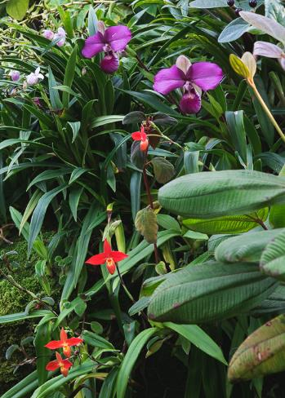

**Orchids in Art: John Day's Scrapbooks**

By: Gawler Orchids

John Day (1824–1888) was an English orchid-grower and collector and is noted for producing some 4000 illustrations of orchid species in 53 scrapbooks over a period of 15 years. These scrapbooks were donated to The Royal Botanic Gardens, Kew in 1902 by his sister, Emma Wolstenholme.

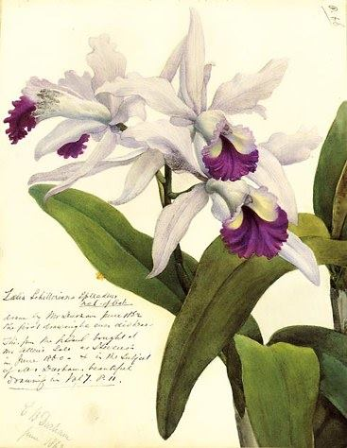

**Duration**

Longer is not always better. First, plants need a night just as we do. They are adapted to the daily cycle of the sun and different parts of their metabolic cycle are accomplished during light and dark periods. In addition, many orchids, especially species, are adapted to changes in day length. This is called photoperiodicity. Fall-blooming cattleyas flower as day length shortens while spring-blooming ones as day length increases. If these plants are grown under conditions of constant day length they may never flower. The old cattleya cut-flower growers used this knowledge to time flowering for important holidays and it's used today by Poinsettia growers for the Christmas market. Why is this important to the hobby grower? It's really quite simple. While a street light outside your greenhouse or living room window will produce such little light that being on all night won't matter that's not the case for lights in your growing area. If your only choice for a growing area is one that is lit late into the night, it would be best to concentrate on those plants like Phalaenopsis that flower without regard to day length.

**Too Much Light**

Unlike too little light whose effects are often insidious, the opposite can be true of too much light. Too much light, especially if it's a sudden change usually results in dramatic damage (sunburn) in very little time. The first sign of too much light is often yellow foliage. If left alone, this yellow foliage will eventually turn white and then dark brown and dry as the sunburned area dries out. Plants chronically exposed to too much light but not enough to cause sunburn will be stunted with yellow, hard foliage. If the problem is caught before the chlorophyll has been completely destroyed it is often possible to reverse the damage. Once white spots or sunken areas have appeared, the damage is irreversible and the best thing one can do is stop further progression with more shade.

This is one area of orchid culture where you want to make changes SLOWLY. Orchids are easily sunburned if light levels rise too fast. When moving plants around, especially when bringing them outdoors after winter, err on the side of excess shade. Make changes when you are going to be home and can watch the plants. Feel the leaves. The palm of your hand is about 93F. If they are hot to the touch, the leaf temperature is well about 95F and serious damage can occur in very little time.



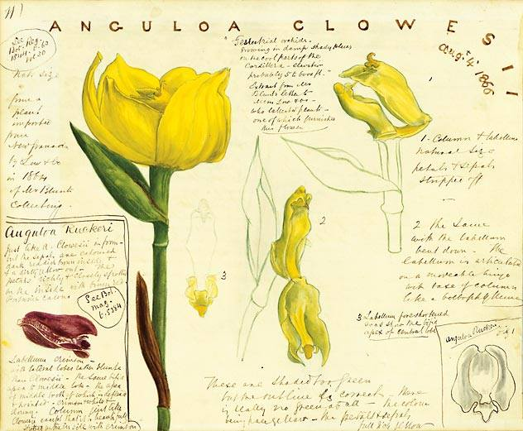

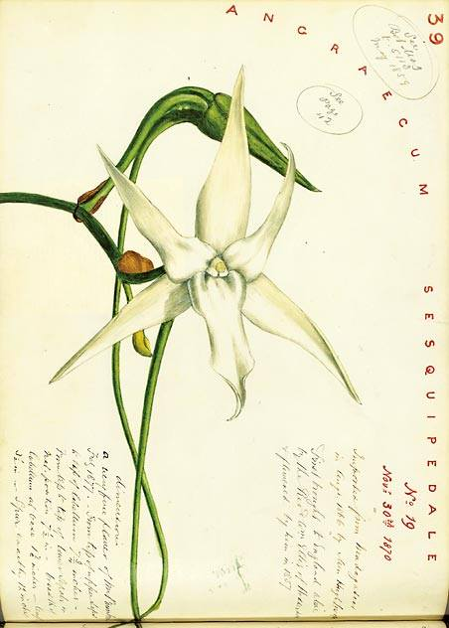

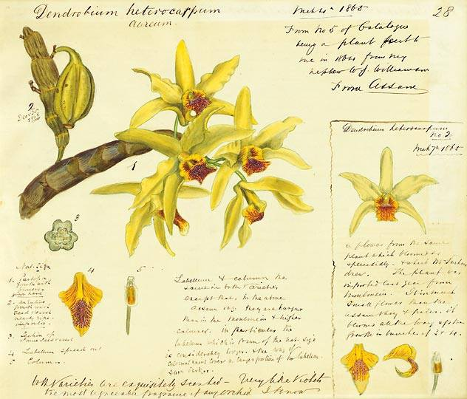

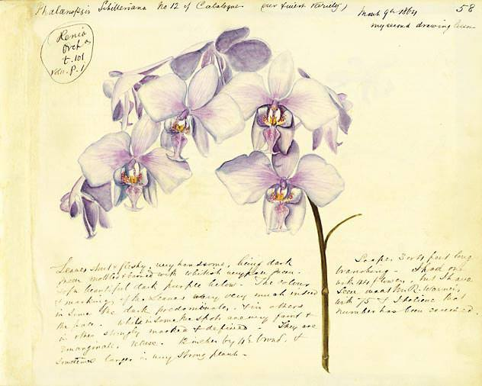



**Reliable Bloomers Wanted**

By Pam Everett

At the May meeting, Pam had an idea, for those who wish to participate, to send Pam a list of two or three of their orchids that are regular bloomers and have been easy to grow.  This may help, especially newcomers, to be on the lookout for plants which they can be successful in growing as they begin their journey into the orchid world.  It may also give some of the more seasoned members ideas for plants they haven't yet thought to cultivate.

The main idea, though, is to give each member one additional way of participating in GAOS activities.

To participate provide simple info on the following growing requirements:

1. Orchid Name
2. Light and Air
3. Humidity and Temp
4. Media
5. Repotting
6. Fertilizer
7. Side Notes

Send to Pam at [pjoeverett@aol.com](mailto:pjoeverett@aol.com) where she will start a database for us.

[Sobralia dicotoma](https://www.facebook.com/hashtag/sobraliadicotoma?source=feed_text&epa=HASHTAG&__xts__%5B0%5D=68.ARAF9H0SPIIQTVHS_m0siWj9D8R35-x4l10azFGOKxuMy7KiQYkeCIph8vAMJNdAO_Q3ypabmMecrJvE0op64lq-rs7dPRnTLSfcSSQ5bR1J6RQbuKPEbPrbLTisSanF2ytMqjTxgxXgtJmOzzcQQ6tF1iYXzDiFDsE3NlqI0KSwMxClkWvy44NFrBkSHm2PN8JR5dBT7-dHVB9o7ARuodgbhvCHLdlVxo1_35J-r6wWuNx3YvNKRFCCvkk7UQ8OLrGJ_74YMYc-jJisCTaQ3xtcJkt5CMQBp4SYrIV2GkMC6WmLsg8HjzjsnXho5PKIFMcZa_ziaZVOOAmhR4ekPrpYwg&__tn__=%2ANK-R) from Colombia. 7 foot tall plant with 4 inch flowers grown outside in full sun in coastal California at our nursery in Encinitas, California. By, Andy’s Orchids

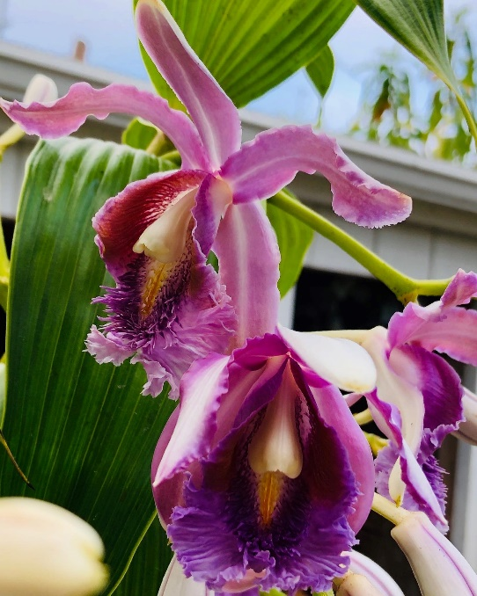

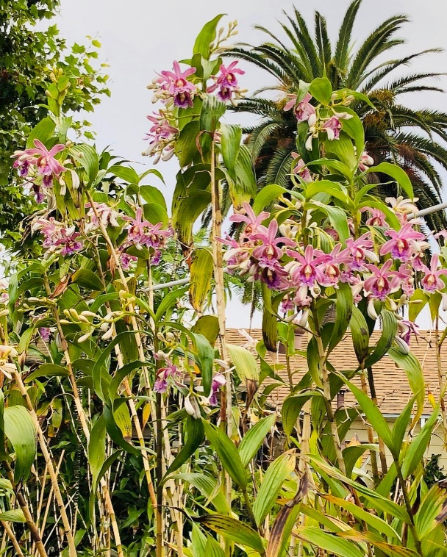



**Upcoming Orchid Events**

‘Orchids Under the Dome’

Presented by Niagara Frontier Orchid Society

November 9-10, 2019

Buffalo & Erie County Botanical Gardens

2655 South Park Ave, Buffalo NY

|  |  |  |  |
| --- | --- | --- | --- |
| **Photo Gallery**  **Aug 2019 Meeting** | Habenarias Edgar Stehli | Habenarias Edgar Stehli | Habenarias Edgar Stehli |
| NoID Onc Edgar Stehli | NoID Onc Edgar Stehli | Paph glaucophyllum x roths Wayne Roberts | Diacattleya Pam Everett |
| Phal cornu-cervi Wayne Roberts | Phal cornu-cervi Wayne Roberts | C Bob Crowder x harrisoniae Wayne Roberts | Paph spicerianum Dave Miller |
| Mtssa Estrelita Pam Everett | Prosthechea cochleata Pam Everett | Encyclia alata x tampensis Pam Everett | Phal Jiaho Blueberry Dave Miller |
| Asco christensonianum Pam Everett | Milt Morris Chestnut Jane Bush | Lc Dorothy Werna Jane Bush | Pros Green Hornet Jane Bush |
| Dtps Long Pride Shadow Jane Bush | Vanda Paki Mary Bell | Phrag Sorcerer’s Apprentice Mary Bell | Vanda Hybrid Mary Bell |
| Den Yellow Song Mary Bell | Den Micro Chip Lore Yu | Oberonia rufilabris Mandy Brooks | Encyclia bractescens Mandy Brooks |
| NoID Phal Kurt Nestel | Mtssa Estrelita Bernie Skalak | NoID Cattleya Frank Skalak | Den Fairy Moon Sweetie Bernie Skalak |
| Den Red Emperor Bernie Skalak | Den Love Memory Fizz Bernie Skalak | Blc George King Frank Skalak | Blc George King Frank Skalak |
| Coel speciosa Dave Miller | Coel speciosa Dave Miller | NoID Cattleya Frank Skalak |  |