Rutherford Irish

American Association

**2nd Annual Pub Night Fundraiser!**

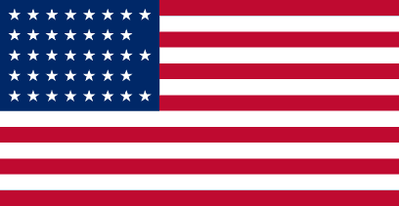 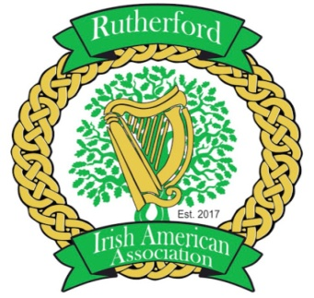 

Friday, October 19th, 2018

Elks Lodge

48 Ames Avenue, Rutherford

7pm-11pm

21 Years and older

$40 pp member

$45 pp non-member

Ticket includes beer, wine and soda!!

Bring your own snacks!!!

Featuring Band: Ridgemont High

***CHECKS ONLY!! PLEASE MAKE PAYABLE TO “RIAA”***

***TICKETS ARE LIMITED!!!***

**Seating is on a first come basis!**

**Please Print Clearly**

Name: ___________________________________ Phone: _______________________

Email: ________________________________

Number of tickets per member: _________ Number of tickets per non-member: ________­_

Total _______________ Check number ___________

**Monies due by October 12th**

Please mail form with payment to PO Box 233 Rutherford, NJ 07070

Contact Debbie O'Neill with any questions @ [yanks11fan@aol.com](mailto:yanks11fan@aol.com) (201-424-3830)