Complete this form following the OSCT CEU Guidelines and CEU Standards documents. Include all supporting documentation with your submission.
Due December 31, 2025 by 11:59 PM.
How to use this form:
If you need more rows in any of the sections, right click on an empty cell and select:  “Insert > Row Above or Row Below” from the drop-down menu | 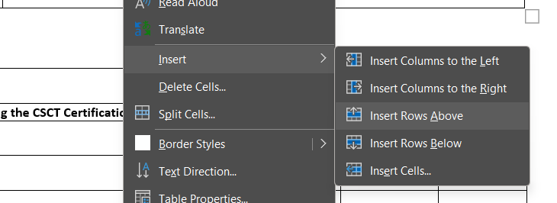
If you need to remove extra rows in any of the sections, highlight the row(s) and right-click. From the drop-down menu, select:  “Delete > Delete Row” | 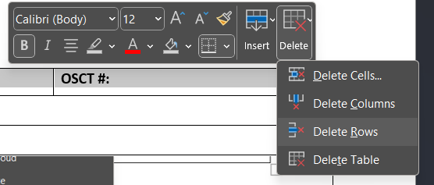

Full Name: |  | OSCT #:
Phone #: | Email:

 | Section 1: Academic Training
Section |  | Criteria | Max potential CEUs | Carryover value | OFFICE USE ONLY
1a |  | Successfully completing the CSCT Certification Exam or CCI | Year 1: 10  Year 2: 20  Year 3: 30 | Year 1: 0  Year 2: 5  Yar 3:10
Date of completion: |  |  | CEUs expected:
1b |  | Successfully completing other cardiac related exams (i.e. IBHRE, ARDMS, CARDUP, etc.) | 15 CEUs | 5
Date and times of completion: |  | Name of Exam: | CEUs expected:
1c |  | Formal education/courses from an accredited cardiology program | 5 per course  max 30 per triennium | 5
Date and times of completion: |  | Name of Course: | CEUs expected:
1d |  | Formal education/courses from an accredited non-cardiology health sciences program | 6 | 0
Date and times of completion: |  | Name of Course: | CEUs expected:
Section 2: Continuing Education & Training
2a | Primary author of a published cardiology paper, article, abstract | 25 | 5 | OFFICE USE ONLY
Date of completion: | Name of Project, Publisher: | CEUs expected:
2b | Co-author of a published cardiology paper, article, abstract | 20 | 5
Date of completion: | Name of Project, Publisher: | CEUs expected:
2c | Clinical Preceptors | 1 per 7.5 hours  max 5 per year | 0
Date and times of completion: | Name and Location of program: | CEUs expected:
2d | OSCT Education Day | 1 per topic  5 per day | 0
Date and times of completion: | Name and Location of program: | CEUs expected:
2e | Cardiology related media (i.e., journal articles, webinars, in-services, lunch and learn, etc.) | 1 per hour | 0
Date and times of completion: | Type of Learning, Name and Location: | CEUs expected:
2f | Other health sciences media (i.e., journal articles, webinars, in-services, lunch and learn, etc.) | 1 per hour  max 2 per year | 0
Date and times of completion: | Type of Learning, Name and Location: | CEUs expected:
2g | Conferences or seminars | 1 per hour  max 5 per day | 0
Date and times of completion: | Name and Location Program: | CEUs expected:
2h | Cardiology rounds | 1 per hour  max 15 per triennium | 0
Date and times of completion: | Name, Location, and Host: | CEUs expected:
2i | Formal presentation to colleagues, students, or the public. | 1 per hour  max 5 per year | 0
Date and times of completion: | Name and Location Program: | CEUs expected:
2j | Formulating Case studies (i.e., from interesting cases in the workplace, submissions to OSCT for regulation, presentation at workplace) | 1 per study | 0
Date and times of completion: | Supplementary information: | CEUs expected:
2k | CPR, BCLS, First Aid, BLS | 1 | 0
Date and times of completion: | Name and Location Program: | CEUs expected:
2L | ACLS, HCP, AED, PALS, NRP | 1 per hour  max 5 per year | 0
Date and times of completion: | Name and Location Program: | CEUs expected:
2L-2 | Recertification of 2k and 2L training  Proof of hours must be provided and signed by instructor/manager/supervisor. | 1 per hour  max 2 per year | 0
Date and times of completion: | Name and Location Program: | CEUs expected:
Section 3: Professional Services
3a | OSCT Board of Directors membership and/or meetings | 5 per year | 0 | OFFICE USE ONLY
Date and times of completion: | Name, location, and purpose of meeting: | CEUs expected:
3b | Provincial Committee membership and/or meetings | 1 per hour  max 5 per year | 0
Date and times of completion: | Name, location, and purpose of meeting: | CEUs expected:
3c | Attendance of Provincial (OSCT) AGM | 5 | 0
Date and times of completion: | Location and Name of Program: | CEUs expected:
3d | OSCT BOD conducted surveys, projects, etc. | indicated for each | 3
Date and times of completion: | Name of survey, project, etc.: | CEUs expected:
3e | Member submitted content for OSCT monthly newsletter | Up to 3 per year | 0
Date and times of completion: | Supplementary information: | CEUs expected:
 | TOTAL CEUS EXPECTED:

