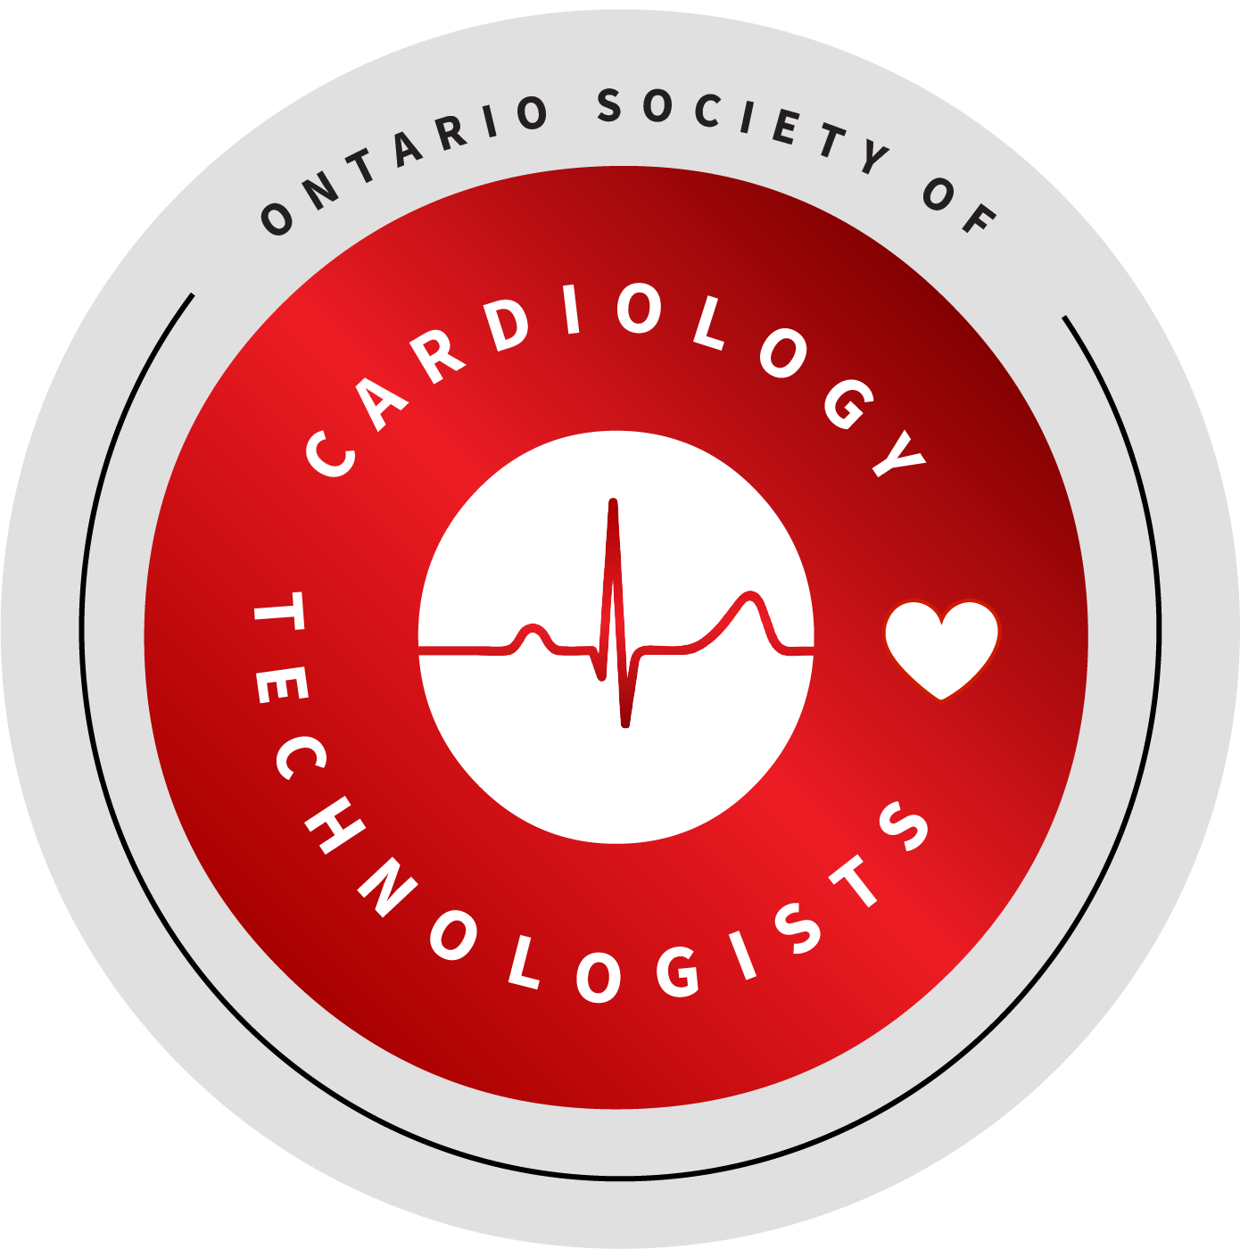
Cardiology technology involves the non-invasive testing and monitoring of the functioning of the human heart under various conditions, the provision of basic patient care during these procedures, and the assessment and programming of implantable cardiac devices.
Registered Cardiology Technologists (RCT):
- Record and analyse Electrocardiograms
- Operate and analyse Stress tests
- Analyse Ambulatory monitoring recordings
- Interrogate and program Implantable cardiac devices
RCT’s provide initial analysis and test results to physicians for use in the prevention, diagnosis and treatment of cardiac conditions.
Revised: February 2012
Approved by the CSCT Board of Directors, February 2010

