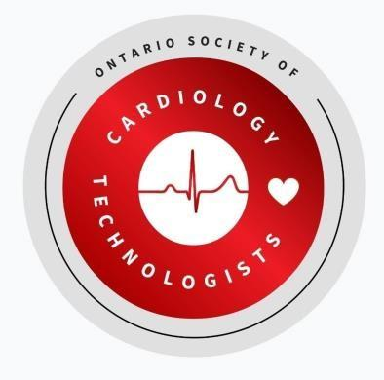

Ontario Society of Cardiology Technologists
Continuing Education Unit Guidelines 2026 – 2028 Triennium
- Every member is responsible for earning 30 Continuing Education Units (CEUs) per triennium. Members will be randomly audited within one week of the end of each triennium (between January 02 – 09 of the year following the triennium end date of December 31st, 2028). A notification email will be sent notifying the member of the audit and a request for specific documents (certificates of attendance, transcripts, etc.). The deadline to submit these documents will be 7 days from the date of the request. No extensions will be provided unless prior arrangements are made with the board before the end of the triennium.

- Trienniums are based on calendar years, not individualized based on when you pass the Canadian Society of Cardiology Technologists (CSCT) Certification Exam. You can find the current triennium information on the Ontario Society of Cardiology Technologists (OSCT) website (www.OSCT.ca).

- To document your CEUs earned, complete the CEU Submission Form. It is recommended to do this as you earn your CEUs, so that you do not forget any material.

- If you do not have a certificate that provides the details of the conference or seminar you attended (who spoke, how many hours, and the topic(s) of discussion). You must fill out a form providing all these details with a summary of the topic(s) and if available any other supporting documents showing you attended.

- Members are responsible for keeping originals of all documentation in case the OSCT BOD requests they be submitted upon a member being audited. At this time, CEUs will not be retained in member profiles or by the OSCT.

- Only CEUs accumulated and submitted during the current triennium will be accepted except indicated carry over activities. Carry over activities can only be carried over once to the next triennium. If any CEUs are obtained before the current triennium they will NOT be counted. As well as any CEUs earned in the new triennium will be subject to late CEU fee even if they are submitted within the 7 days allotted for audit request.

- Job requirements may not necessarily meet the criteria for CEUs (i.e. WHIMIS, code review, EMR software training, etc.). Activities involving cardiology equipment are eligible for CEUs, however, further information may be requested.

- In the event a member disagrees with an audit decision, they should fill out a CEU Appeal Request Form must be filled out and sent to education@osct.ca.

- Members who are on parental, medical leave, or facing extreme barriers to completing CEUs during the triennium must submit an accommodation request to the education director for review and approval by the OSCT board of directors prior to the end of the triennium.

- OSCT is it’s own board with no association with the CSCT. Due to this NO CSCT AGMs count for CEUs.

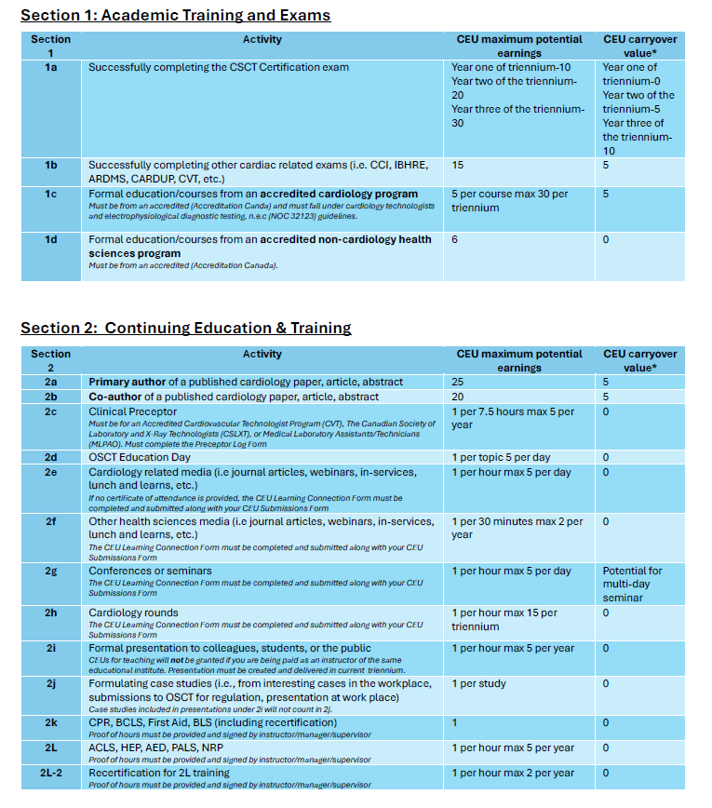
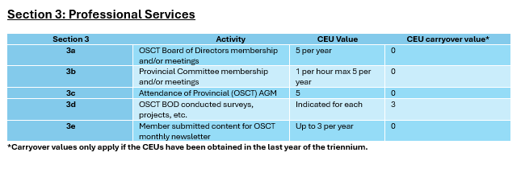

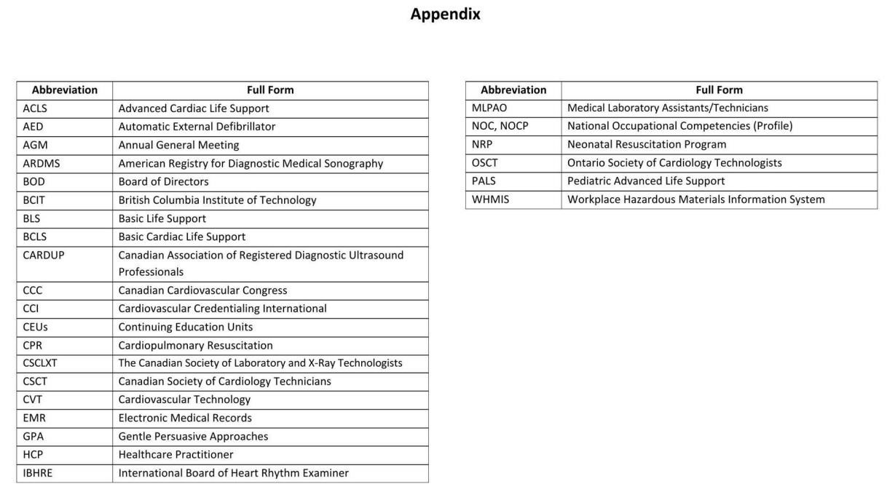

CEU Appeal Request Form

Complete this form if you do not agree with a decision regarding your CEU submissions. Send to education@OSCT.ca. In your email, include your completed CEU Submission Forms and any other supporting evidence.

Member information:

Full name:
OSCT #: | Email address:

Appeal information:

CEU Section: | Date of Completion: | Time spent on activity:
Name of Activity:

Explain why you do not agree with the decision regarding this CEU opportunity. Be as specific as possible.

