
Chico Jr. High School Cheer Club
Sponsorship Program

To whom it may concern,

The Chico Jr. High School Cheer Club is a newly established organization created for students of all grades and ages at Chico Jr. High School. Our mission is to teach student-athletes the value of hard work both in and outside of the classroom. We emphasize the importance of accountability and encourage our athletes to support and push one another to achieve their best.
Our athletes are expected to lead by example, as they represent not only themselves but also their community, school, teammates, coaches, and the Chico Jr. High Cheer Club. We strive to nurture not just outstanding athletes but also responsible individuals by instilling positive habits that extend beyond sports. Education remains our top priority, and all members are required to sign a contract acknowledging that participation in cheer is a privilege. Each athlete must maintain a minimum 2.0 grade point average with no F's and be able to provide regular grade checks to remain in good standing with the club.
We are reaching out to you, or your business, to invite you to participate in our sponsorship program. You have the option to sponsor a specific athlete in need or contribute to our general fund, which helps provide financial assistance to those who require support to participate and covers general program fees. Our goal is to raise $650 per athlete, which covers all fees for the season.
- I would like to sponsor one child in full in the amount of: $650.00
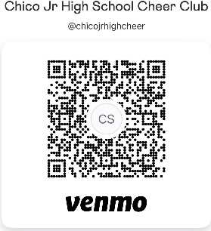
- I would like to donate in the amount of: $______
Please make checks payable to: Chico Jr. High School Cheer Club
When submitting your sponsorship or donation by check or Venmo, please be sure to include the athlete's name in the memo if you are sponsoring a specific athlete. This helps us ensure that your contribution is directed appropriately.
If you have any questions, please contact Tiffany @ 530-487-2597 or chicojrcheerclub@gmail.com
EIN – 33-3837956
On behalf of the Chico Jr. High School Cheer Club, we sincerely thank you in advance for your generous donation!

