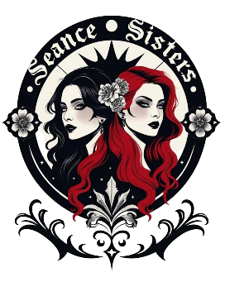
Sponsorship Opportunities
Restless Spirits of the Menard House – Galveston, TX
Date: October 11, 2025
Time: 2 PM – 3 AM
Location: The 1838 Menard House
1605 33rd Street, Galveston, TX

Join us for a 13-hour immersive Halloween experience featuring:
- Haunted property tours with Spooky Galveston
- Artisan vendors from Galveston Island Market: After Dark
- Psychics & mediums
- Paranormal investigations with Generation X Paranormal
- Seance Gallery with The Austin Seance
- Guest speakers
- Vampire Court of Houston
- Forgotten Dollhouse Museum
- Victorian Mourning Funeral
- Rocky Horror Picture Show screening with MarMo Innovations (Awaiting Screening Permit)
- Vampire Pageant Costume contest, food & drinks
This first-year event is expected to attract 500+ attendees, including families, pop culture fans, and paranormal enthusiasts.

Sponsorship Levels

Phantom Sponsor – $2,000 (Title Sponsor)
- Event presented “by [Your Brand]”
- Logo on all marketing materials (flyers, posters, social media, website)
- Recognition during the event
- Booth/activation space at a high-traffic location
- Radio airtime promotion leading up to the event
- Free tickets to the event

Specter Sponsor – $1,000 (Premier Sponsor)
- Logo on selected marketing materials and event signage
- Recognition during the event
- Social media mention
- Booth/activation space
- Radio airtime promotion leading up to the event
- Free tickets to the event

Poltergeist Sponsor – $500 (Supporting Sponsor)
- Logo on event signage
- Social media mention
- Inclusion in swag bags or promotional giveaways
- Free tickets to the event

Ghoul Sponsor – $250 (Community Sponsor)
- Logo on event signage
- Mention in social media posts
- Option to include a small promotional item in swag bags
- Free tickets to the event

Spirit Sponsor – $100 (Friend Sponsor)
- Logo or name featured on event signage
- Mention in social media posts

Deadline for inclusion in print materials: September 27, 2025

To become a sponsor or discuss a custom package, contact:
Seance Sisters – Gin Keel & Jennifer De Ranieri
Email: thegalvestonseancesisters@gmail.com
Phone: (713) 898-4488 or (409) 392-3695

