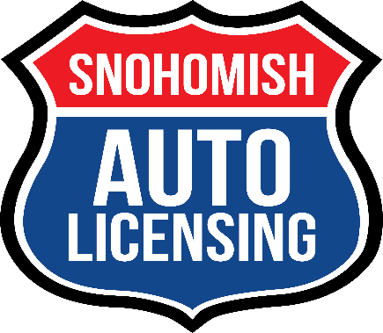
510 – 2nd Street Ste C, Snohomish, WA 98290
Telephone (360) 568-8836 * FAX (360) 568-5353 * Email snohomishautolicensing@gmail.com

___________________(Date)

I, _____________________________________ (Vehicle owner’s name)
Give ____________________________ (Buyer/Pick up customer name)
Permission to purchase/pick up the tabs for my ____________________
____________________________________________________________
(Year, Make, VIN # above)
___________________(License plate number)

_____________________________________(Vehicle Owner’s Signature)

