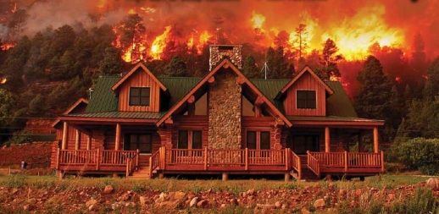
Firewise Landscaping
- Firewise landscaping can be aesthetically pleasing while reducing potential wildfire fuel.
- Plant choice, spacing and maintenance are critical.
- Your landscape, and the plants in it, must be maintained to retain their Firewise properties.
Creating a “defensible space” around your home is one of the most important and effective steps you can take to protect you, your family and your home from catastrophic wildfire. Defensible space is the area between a structure and an oncoming wildfire where nearby vegetation has been modified to reduce a wildfire’s intensity.
More fire resistant plants share characteristics. They often 1) have a higher moisture content in their leaves, 2) have little seasonal buildup of dead vegetation, 3) have low, compact growth form, 4) are high in soap or salt content, 5) have green stems and 6) are drought tolerant.

