Plants at Orton Botanical Garden in Twin Falls
that are especially noted to attract large quantities of pollinators
Prepared by LaMar Orton

Shrubs
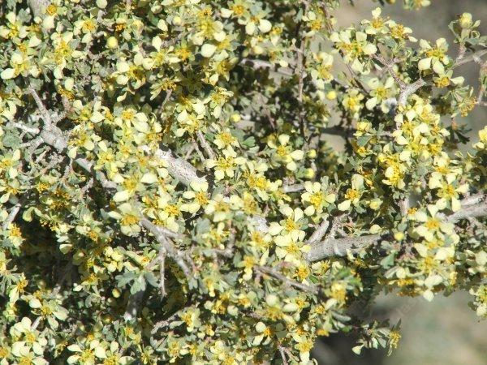
1. Bitter brush (Purshia tridentata) – Idaho native

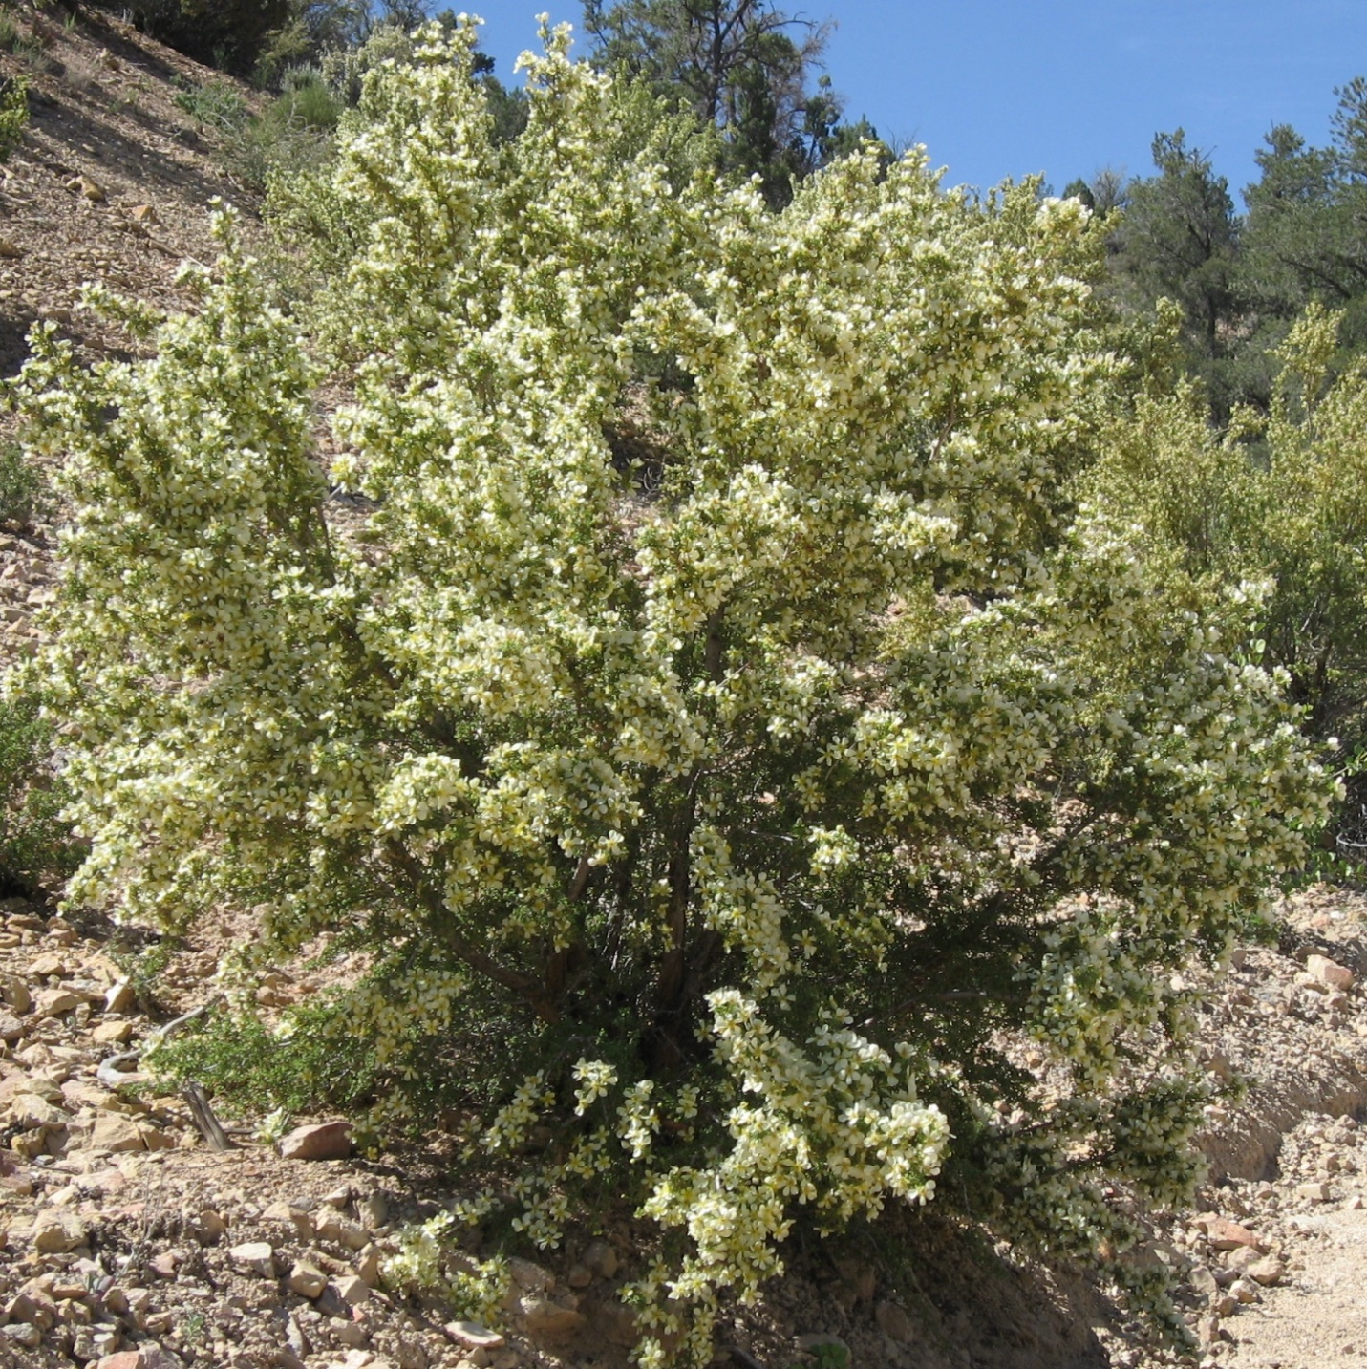
2. Mexican cliff rose (Purshia mexicana) – blooms in May, a large relative of bitter brush.

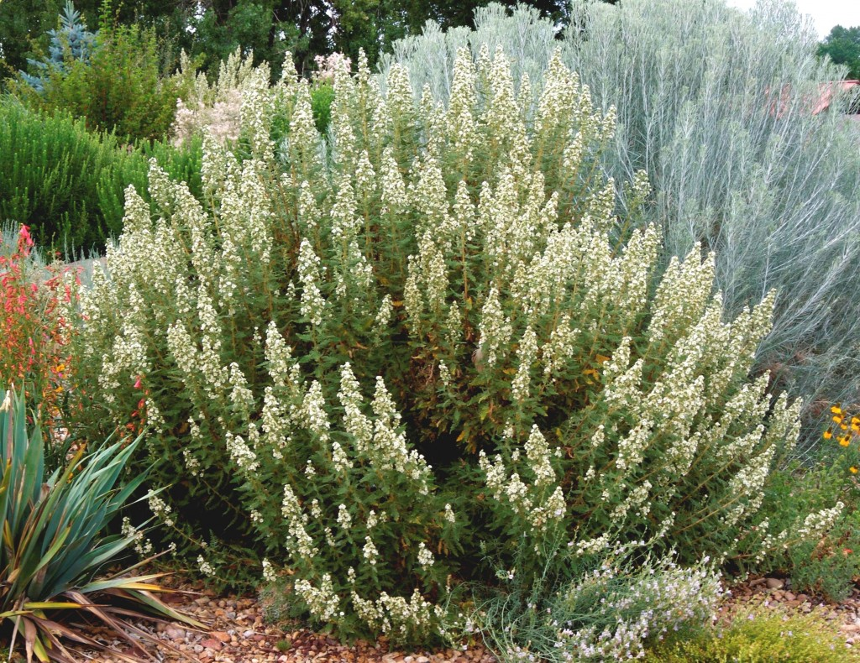
3. Fern bush (Chamaebatiaria millefolium) – Idaho native, blooms in July/August. Every garden should have these plants. When in full bloom, they attract honey bees and native pollinators by the hundreds.

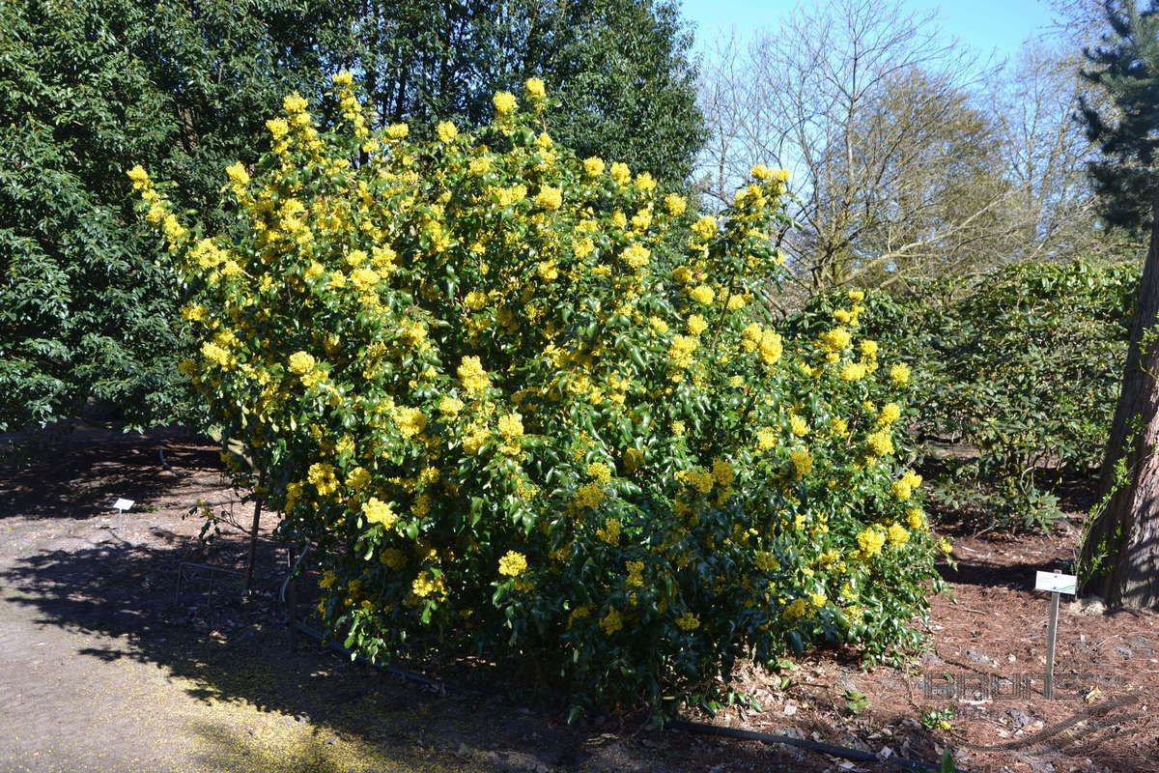
4. Oregon grape (Mahonia aquifolium) – upright to 10 ft high, Idaho native, blooms in April, evergreen.

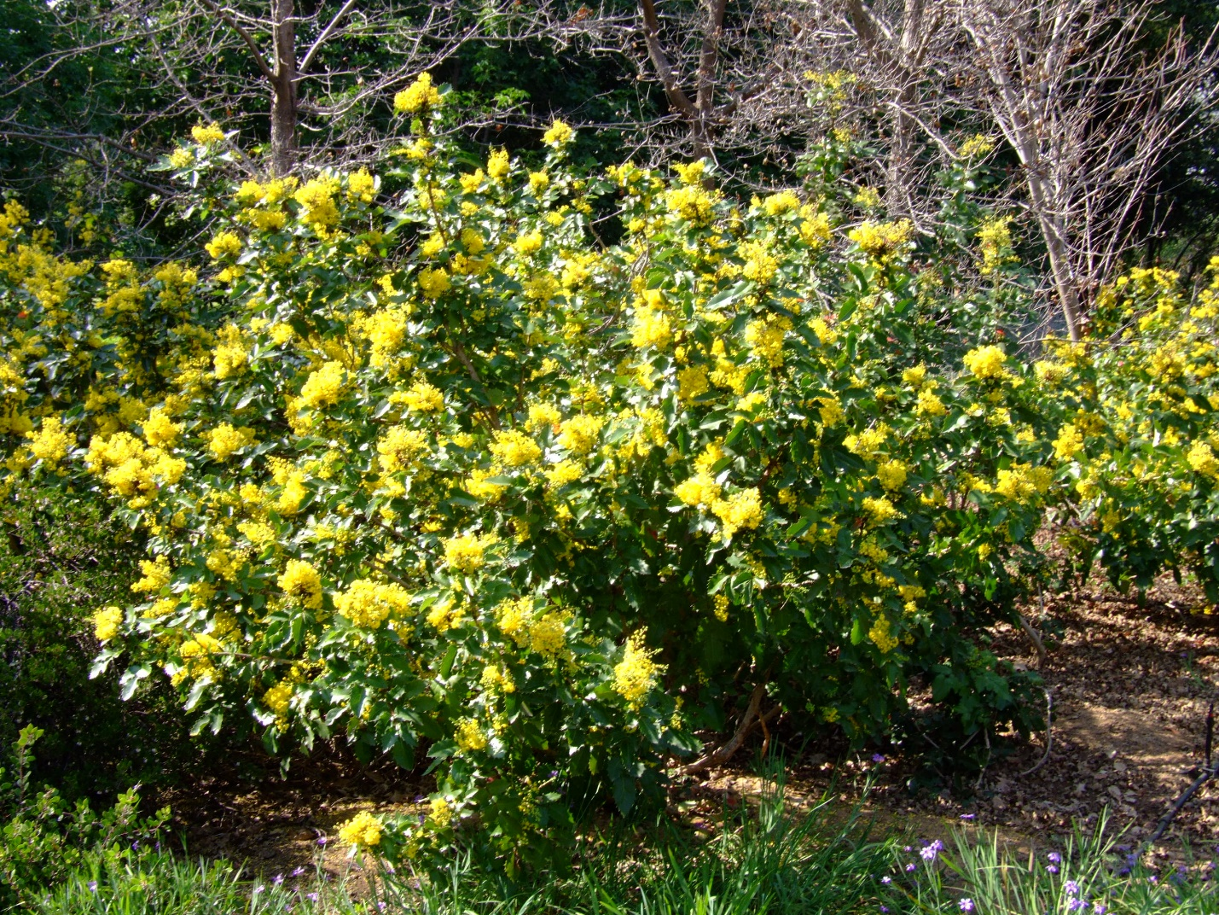
5. Creeping Oregon grape (Mahonia repens) – low grower, good for shade, Idaho native, blooms in April, evergreen.
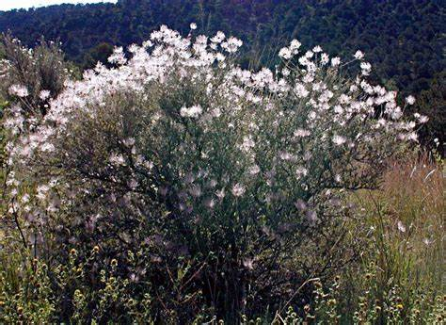
6. Apache plume (Fallugia paradoxa) – heavy May bloomer, but blooms off and on throughout the summer.
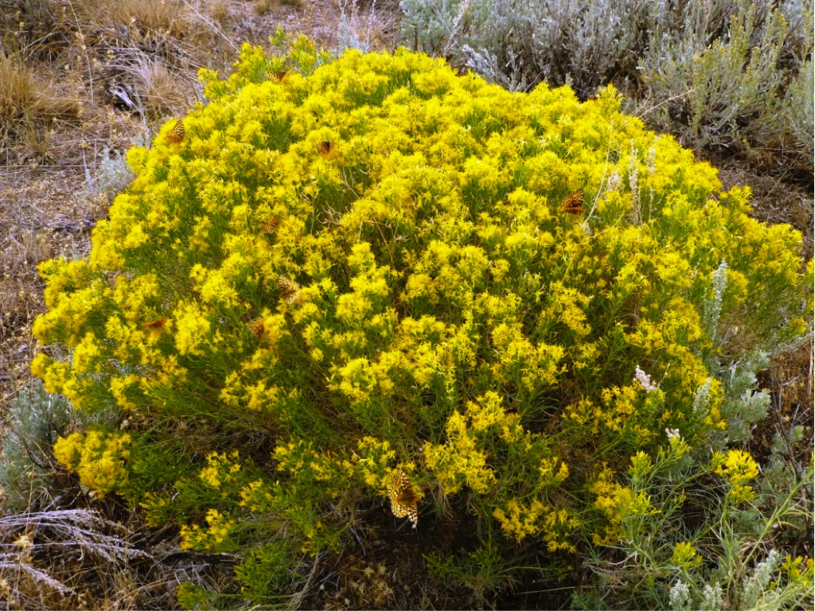
7. Rabbitbrush (Chrysothmnus) – several species – late summer/fall blooming.

Flowers

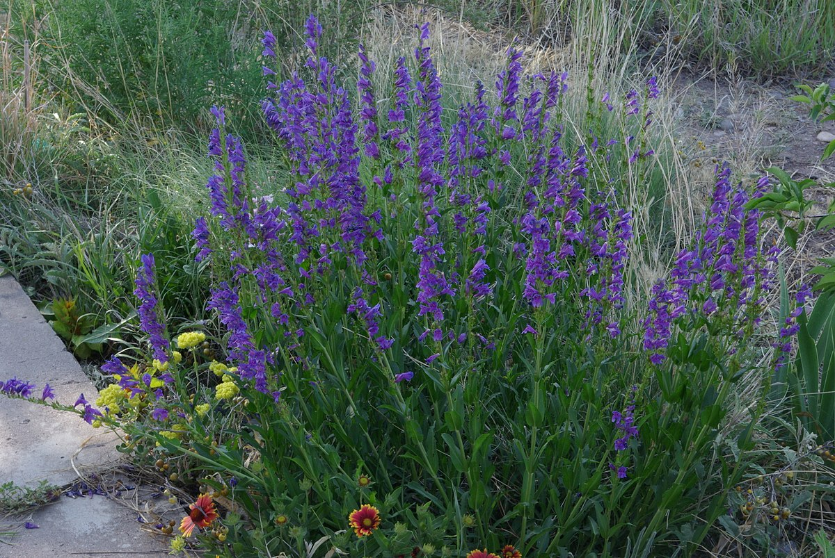
- Penstemons – many species that bloom at different times of the spring and summer. Some Examples
- For early spring – Low penstemon (Penstemon humilis) and Owens Valley penstemon (Penstemon confusus).

- For midsummer – Rocky Mountain penstemon (Penstemon strictus), Hot Rock penstemon (Penstemon deustus), Dark Blue penstemon (Penstemon cyaneus).

- For late summer – Bridge’s Penstemon (Penstemon rostriflorus), Richardson’s penstemon (Penstemon richardsonii).
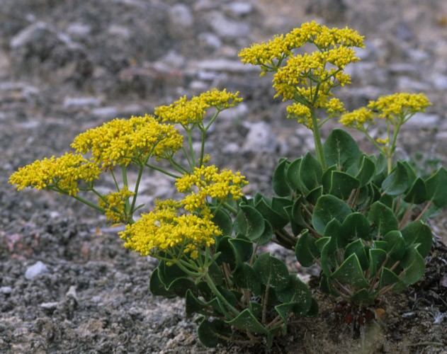
- Buckwheats (Eriogonum) – many species that bloom at different times of the spring and summer.
Some Examples
- For early spring – Matted buckwheat (Eriogonum caespitosum), Cushion buckwheat (Eriogonum ovalifolium), Sulphur flower buckwheat (Eriogonum umbellaturm var. aureum).
- For midsummer – Arrowleaf buckwheat (Eriogonum compositum), Sulphur flower buckwheat (Eriogonum umbellatum var. nevadense), Parsnipflower buckwheat (Eriogonum heracleoides).
- For late summer – Sulphur flower buckwheat (Eriogonum umbellatum var. ellipticum), Strict buckwheat (Eriogonum strictum).
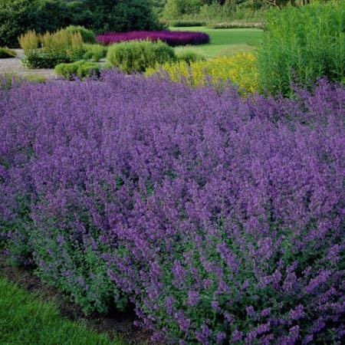
3. Catmint (Nepeta) – often will bloom twice during the summer, if cut back after the first bloom. This plant is an attractor of bumble bees.
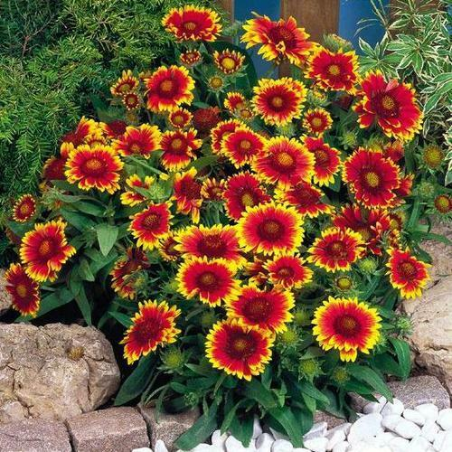
4. Blanket flower (Gaillardia aristata) – If they are kept deadheaded, they will bloom much of the summer.
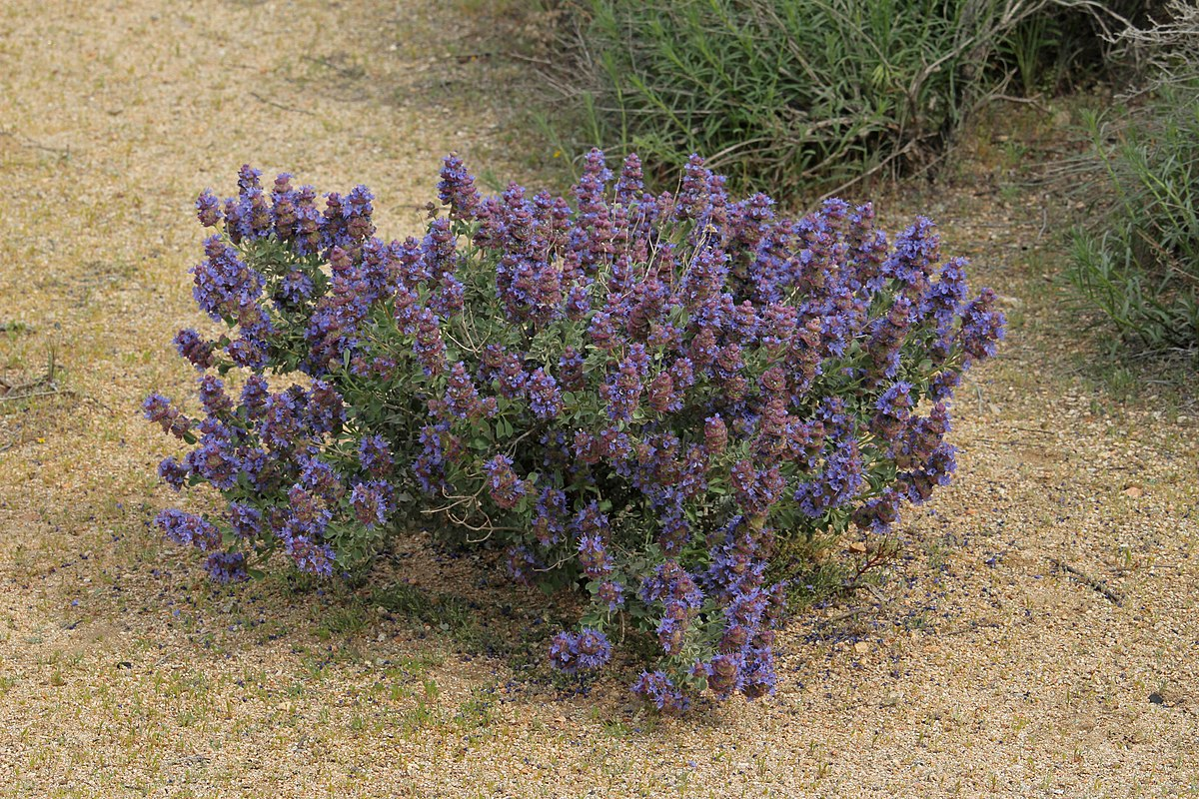
5. Dorr’s sage (Salvia dorrii) is native to southern Idaho. May bloomer.
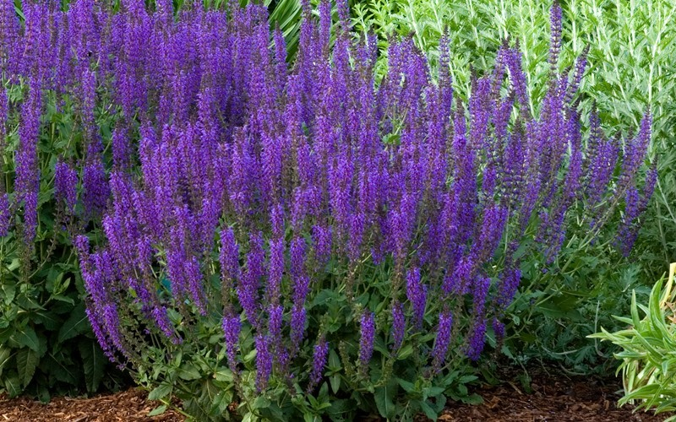
- Woodland sage (Salvia nemerosa) - native to central Europe and western Asia. Several cultivars - blooms for a long time in early summer and will rebloom if cut back after the first bloom.
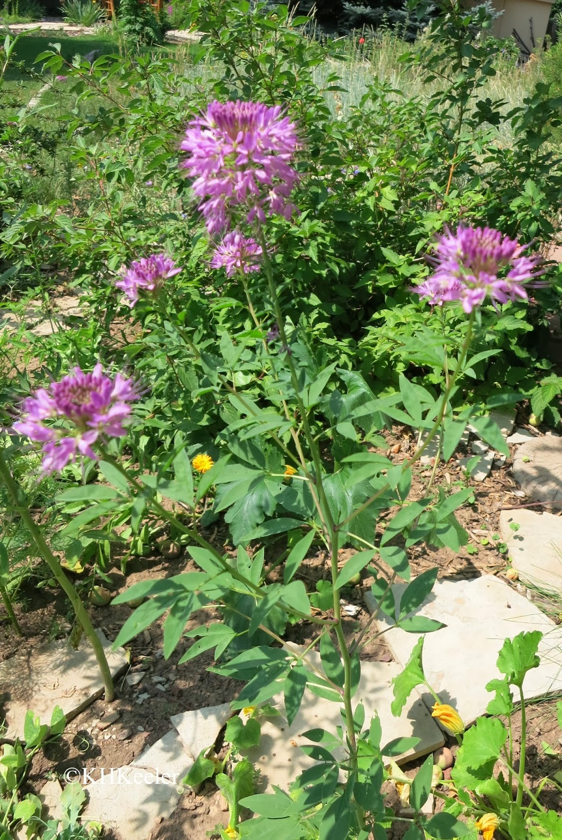
- Rocky Mountain bee plant (Cleome serrulata) – an annual that blooms in midsummer. Bees love the flowers and birds relish the seeds.
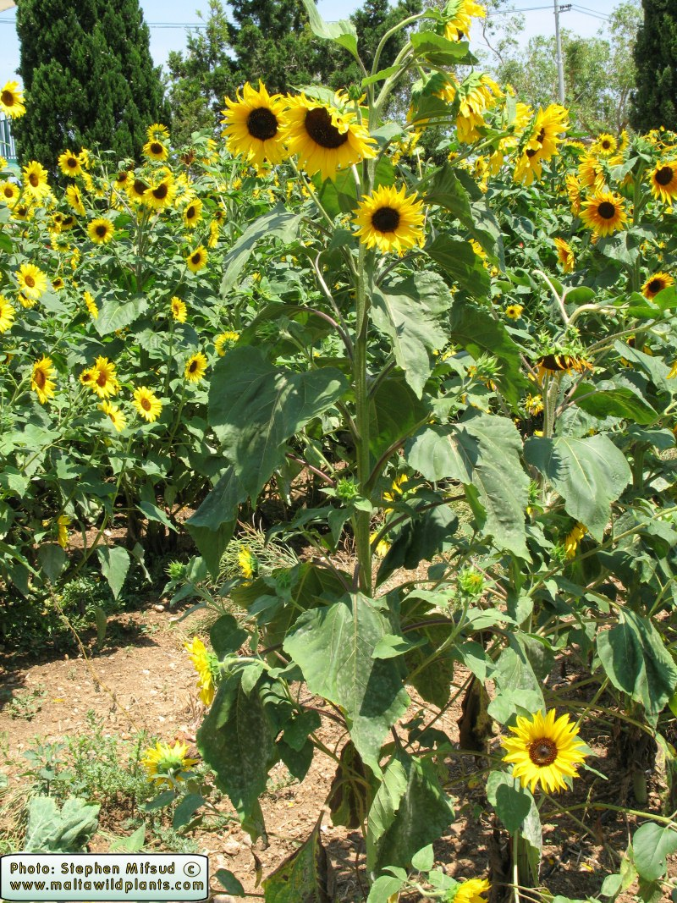
8. Annual Sunflower (Helianthus annuus) – Mid to late summer bloomer. Attracts many native bees and especially bumble bees. Bumble bees sleep in the center of flowers at night.
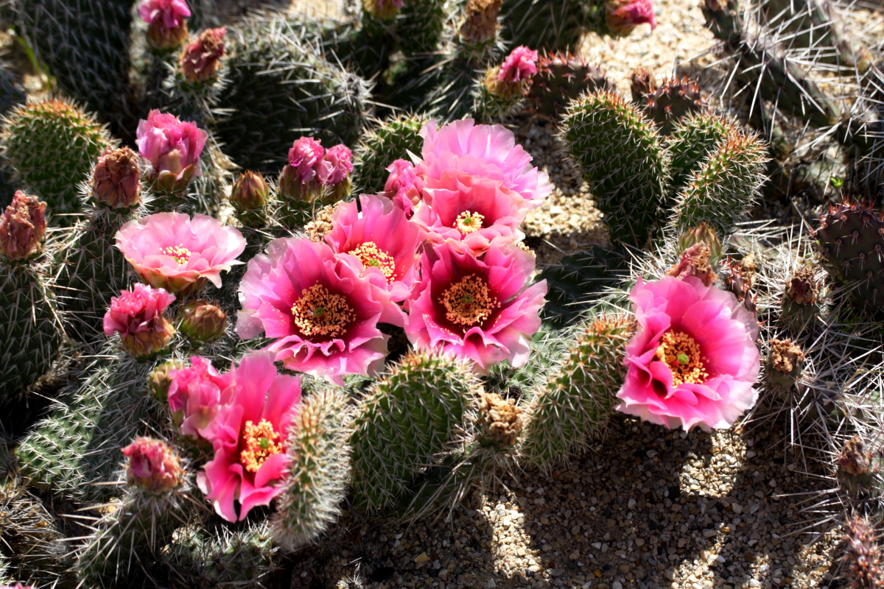9. Prickly pear cactus (Opuntia) – many species and flower colors. Blooms late May through early July.

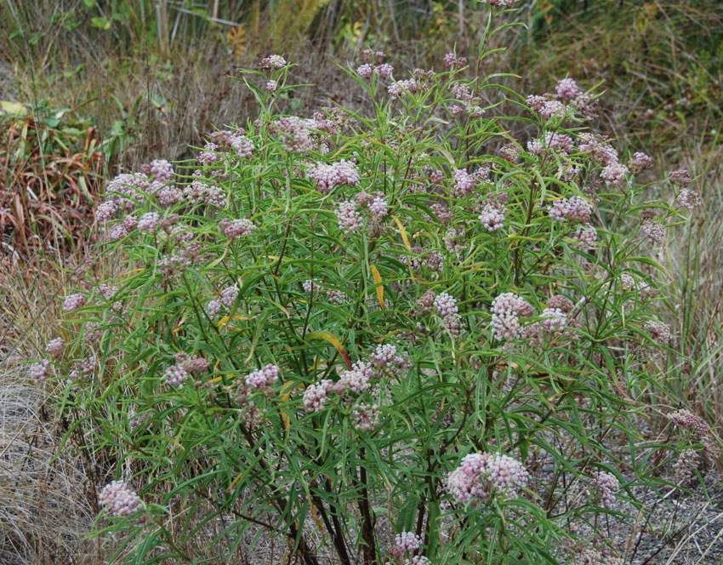10. Milkweed (Asclepias) – showy milkweed (Asclepias speciosa) and narrow leaf milkweed (Asclepias fascicularis) and swamp milkweed (Asclepias incarnata) are native to southern Idaho. Showy milkweed is rhizomatous and can spread quickly. The milkweeds are essential for butterflies.
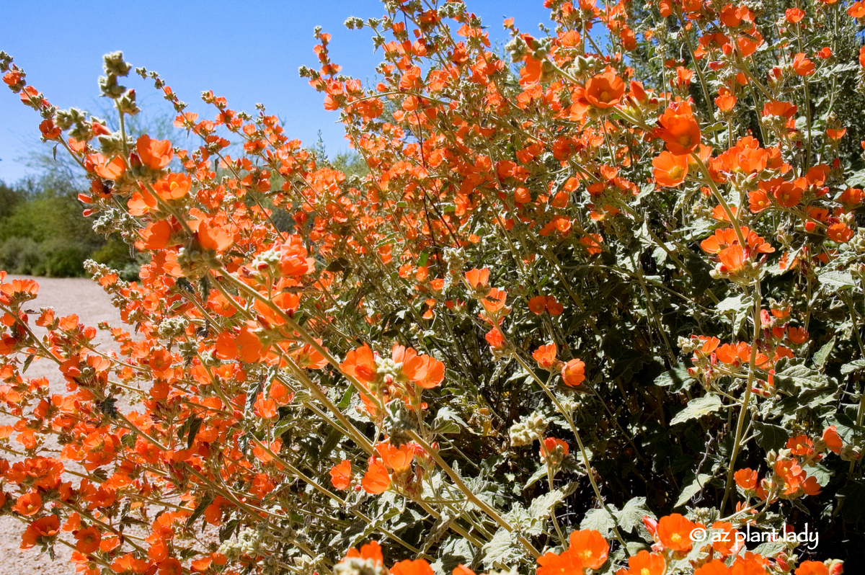11. Globe mallow (Sphaeralcea) – several species native to southern Idaho. Blooms in May-June. Will rebloom if cut back.

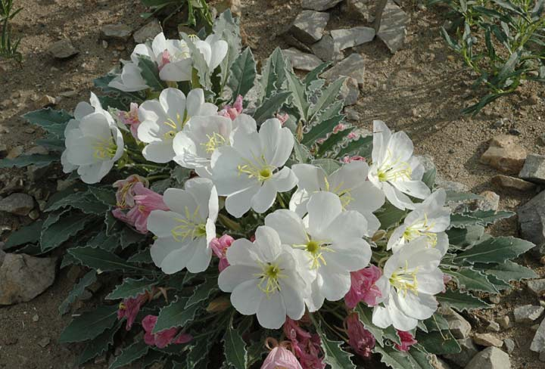
12. Tufted evening primrose (Oenothera caespitosa) – Idaho native and early spring bloomer
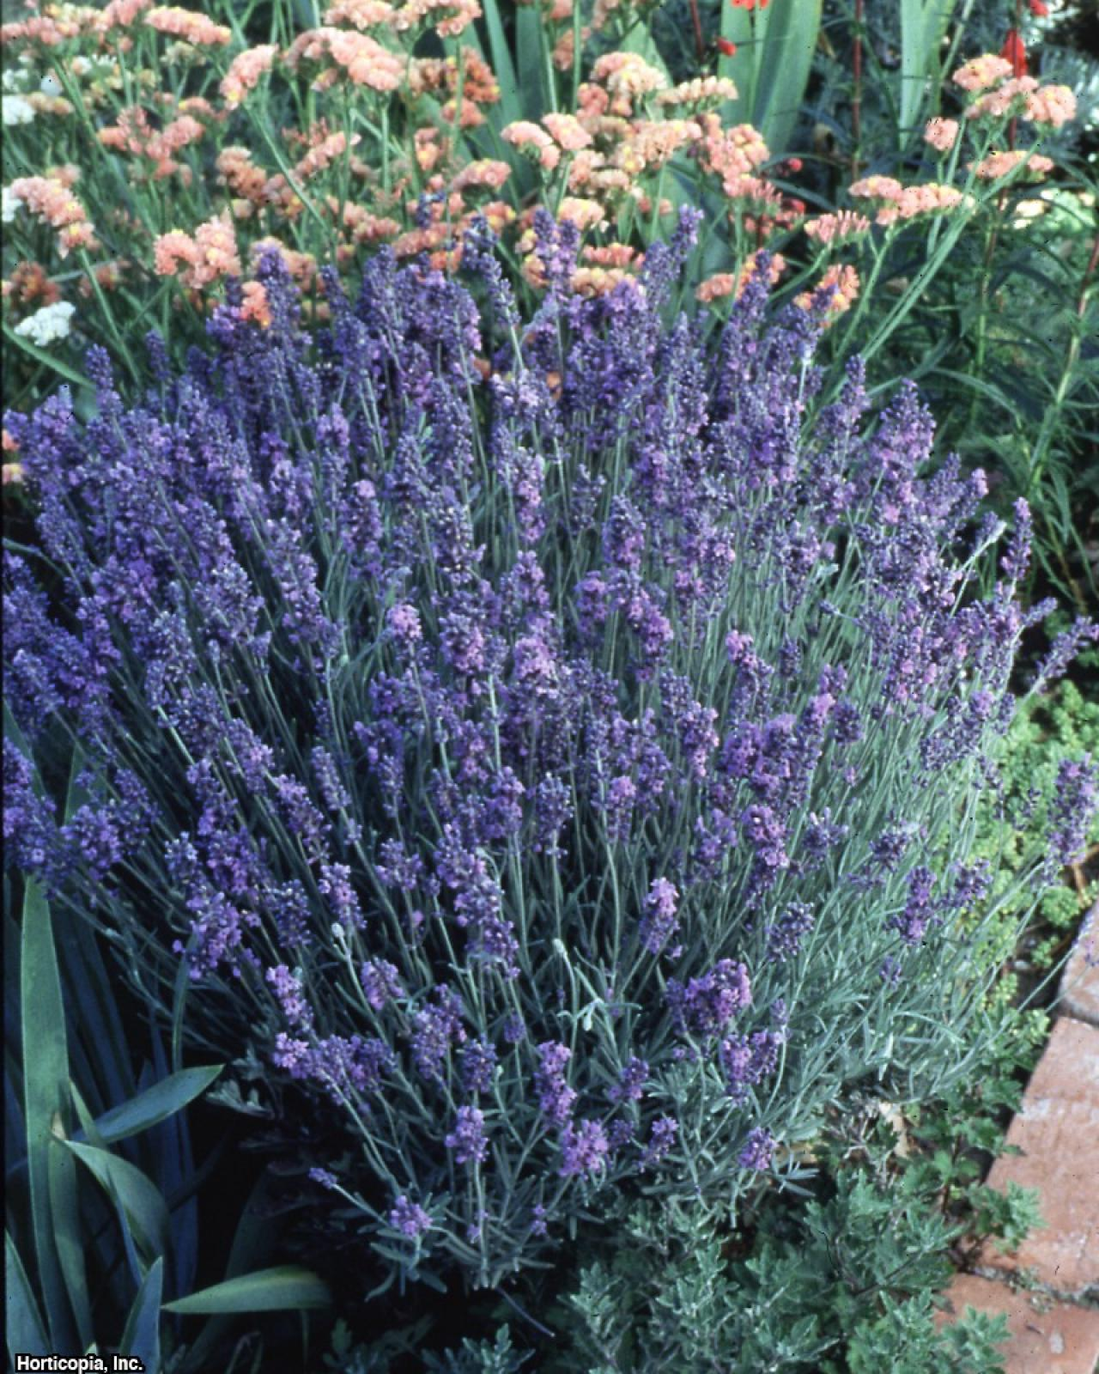
13. Lavender (Lavandula) – midsummer bloomer
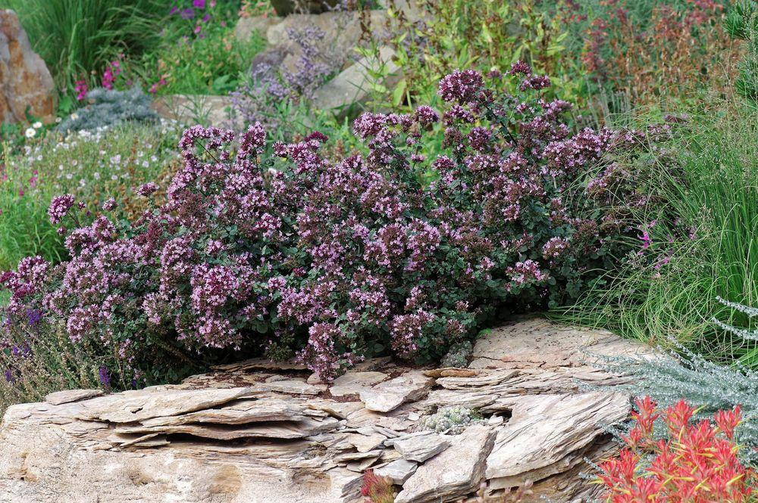
14. Rotkugel Ornamental Oregano – late summer bloomer

For Hummingbirds

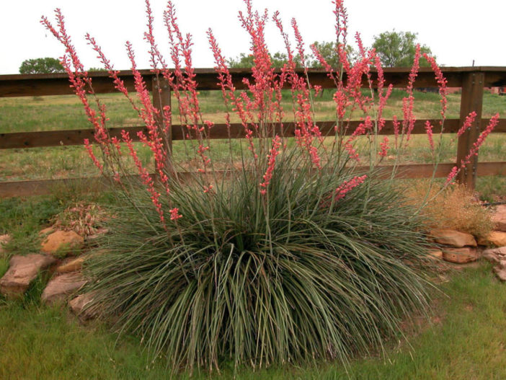1. Red Yucca (Hesperaloe parviflora var. parviflora) -
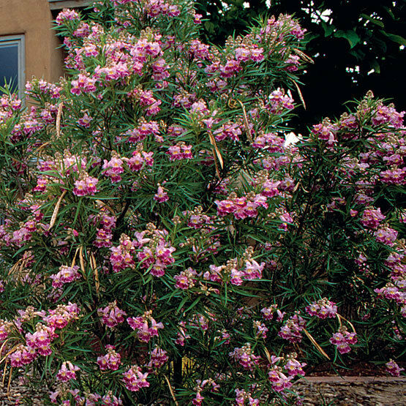
2. Desert willow (Chilopsis linearis)
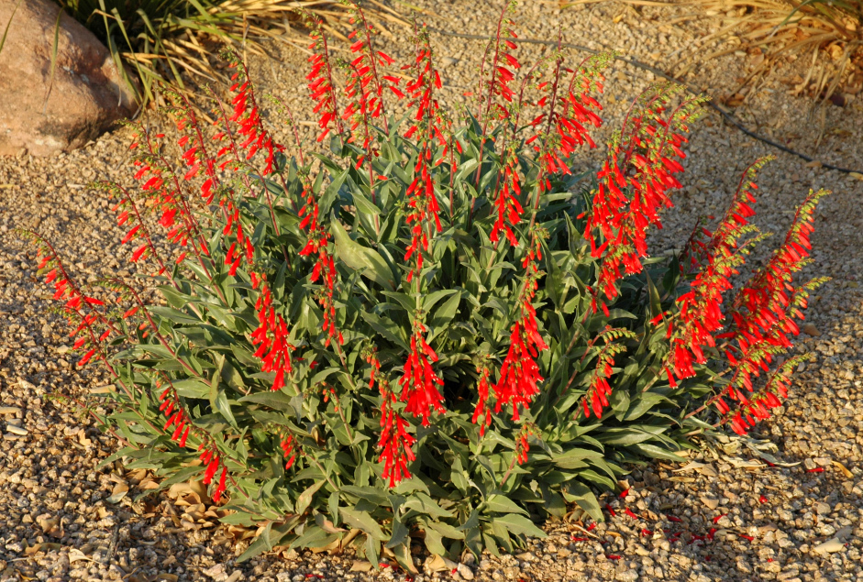3. Penstemons – Firecracker penstemon
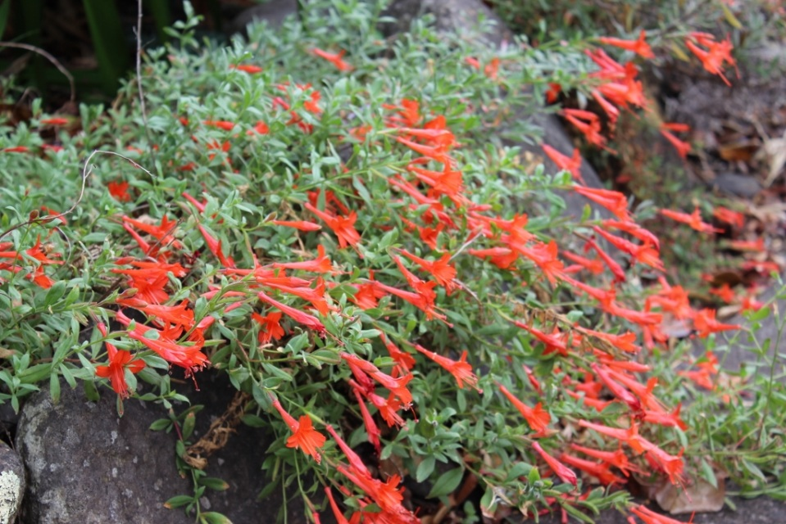4. Orange carpet (Epilobium canum ssp. garrettii) – orange trumpet flowers. Starts blooming around July 1.
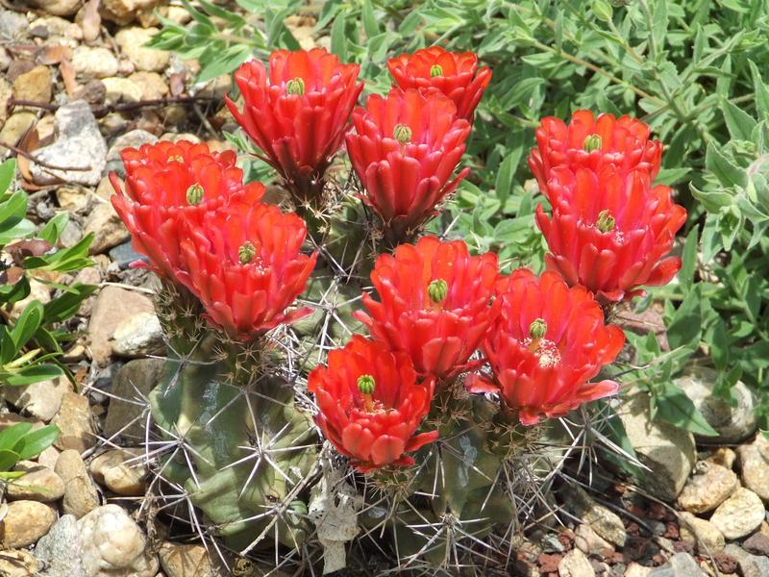5. Claret cup cactus (Echinocereus coccineus and triglochidiatus) – red flowers in May into June.

