Navigational Risk Assessment and Emergency Response Plan (North Devon Seaweed Farm)

Introduction
Macroalgae is targeted as an important contribution to food security, an important ingredient in non-chemical fertilisers, a leading solution in non-plastic packaging and many other innovative solutions that ecological problems. Growing macroalgae is extremely low impact compared to land-based agriculture because it does not require fresh water, land, fertilizers, or pesticides. Growing Macroalgae is also restorative; absorbing more CO2 than forests, absorbing nutrients and nitrogen that washes off the land from, reducing ocean acidity and creating a natural reef type habitat. Because of these benefits both the UK government and the crown estate are promoting the cultivation of macroalgae in farms.

We have chosen this site because it suits cultivation of macroalgae but it also has minimum impact on shipping, fishing and leisure use. This document will set out to show that our proposed macroalgae farm in the mouth of the Bristol Channel at North Devon poses little navigational risk to other marine users in the bay. This will be shown through an analysis of shipboard AIS data and engagement with various marine use stakeholders, IFCA, the North Devon Fisherman’s Association and local maritime engineers as well as a physical survey of these waters, the littoral and the adjacent ports. It will also discuss how any navigational risks that are present can be mitigated and will provide an emergency response plan for emergency situations (however unlikely) that may arise whilst the farm is operational. The site layout, apparatus and mooring arrangement can be found in Section 4.

Navigational Risk Assessment

Vessels with AIS
Using ship AIS data derived using data sets from The European Marine Observation and Data Network (EMODnet), it has been determined that proposed macroalgae farm will pose little to no navigational risk to vessels with AIS technology on board. The data is the average number of ships using AIS technology within a 1 km² pixilated area from 2017-2022. The yearly average for the pixel in which the proposed seaweed farm site is located is .94 ships. Below are the maps of both daily and yearly average in relation to the farm site. We do note that some fishing interests and recreational vessels will not have AIS on board. However, engagement with local fishing organizations and an assessment of leisure activity will be discussed in section 2.3.1.

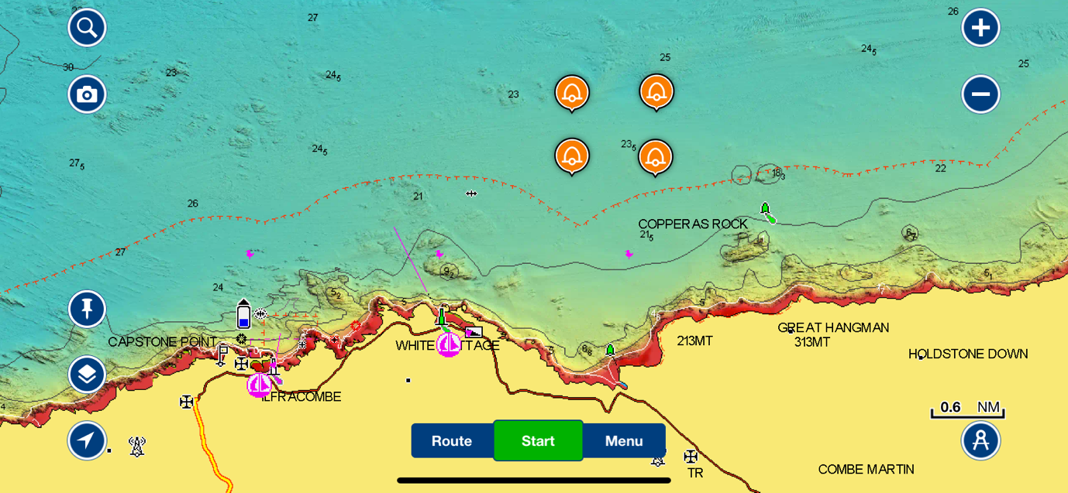
Figure 1: Reference chart for figures 2 to 5 the coordinates are Coordiantes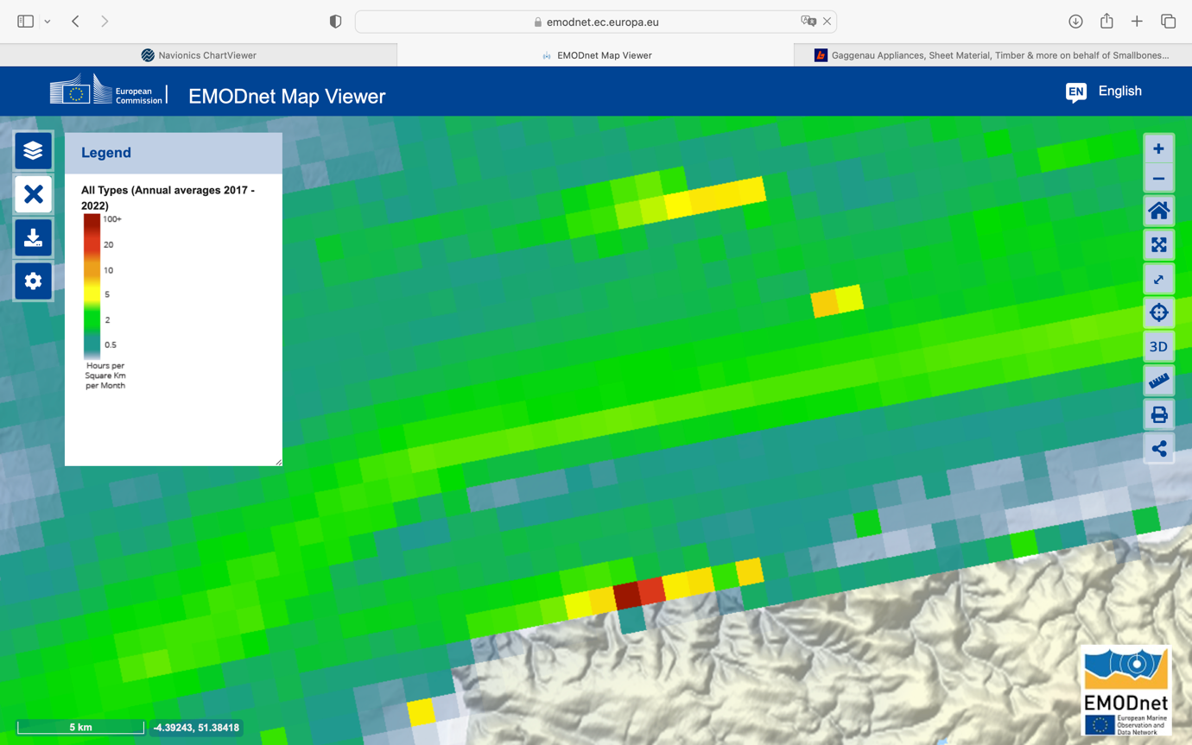
X
Figure 2: Monthly average ships per year using AIS (1 km² pixels) around the farm site shown in green hatched area

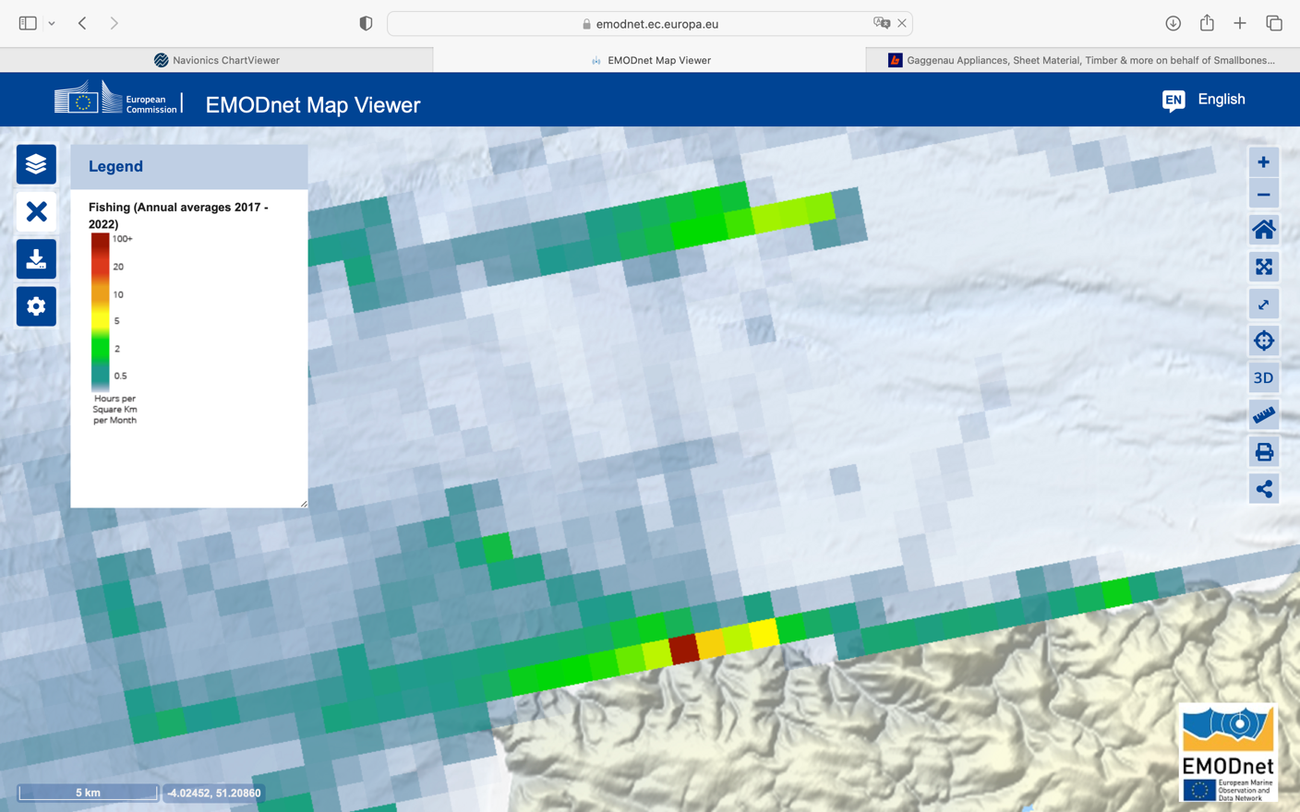
X
X
Figure 3: Monthly average fishing vessels per year using AIS (1 km² pixels) around the farm site shown in green hatched area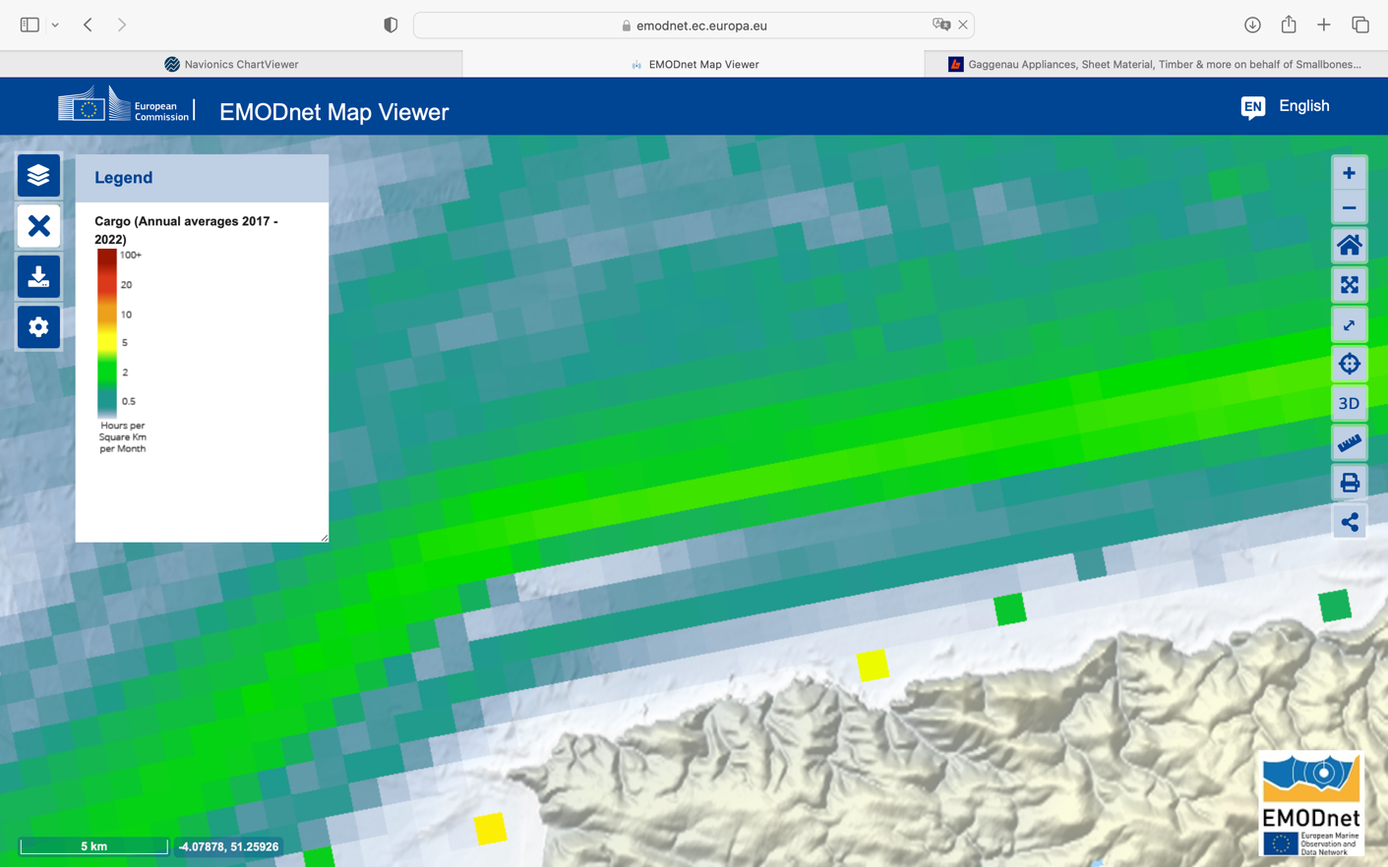
X
Figure 4: Monthly average cargo vessels per year using AIS (1 km² pixels) around the farm site shown in green hatched area

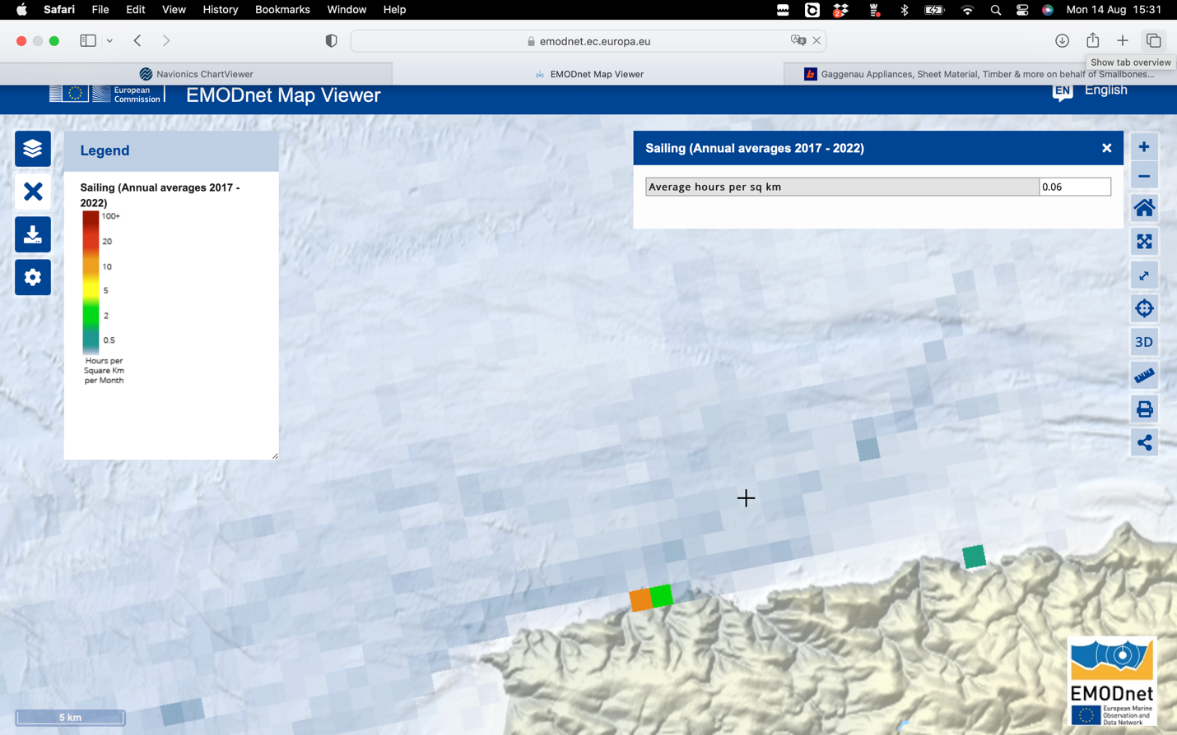

Figure 5: Monthly average sailing craft per year using AIS (1 km² pixels) around the farm site shown in green hatched area

Vessels without AIS
Vessels without AIS were carefully considered during the consultation with IFCA and North Devon Fisherman’s Association and physical survey of the ports along the coast. The proposed site was identified for two reasons. It is below the main shipping lane that runs through the Bristol Channel, and it is below the main fishing in the area which is potting and their prime activity is along Exmoor Coast littoral. Figure 6 below shows potting licenses and fishing activity along the Exmore Coast. Figure 7 shows the same over a larger area including Biddeford Bay. This also correlates with the AIS fishing traffic data shown above and confirms that most of the fishing activity is the potting shown on the chart below.

The harbours at Ilfracombe, Watermouth and Lynmouth have a small number of leisure craft and because they dry out at low tide, bilge keel sailing craft. Ilfracombe has a number of tourist boats that offer sport fishing as well as boat trips along the coast and out to Lundy Island. Some are sightseeing boats along the littoral; these tend to hug the coast. We have located the site where the coastal and rock fishing from boats is below the site and channel fishing is above the site. We have also located the site sufficiently outside the Marine Conservation Zone (MCZ) that runs along the littoral so that our installation and farming activates will not be near to the MCZ.

Also, the site is located to the east of Watermouth so that sailing craft leaving Watermouth can head straight out or beat out to the main channel or turn east and pass under the farm. The site is sufficiently far enough away from Lynmouth so as to not be an issue.

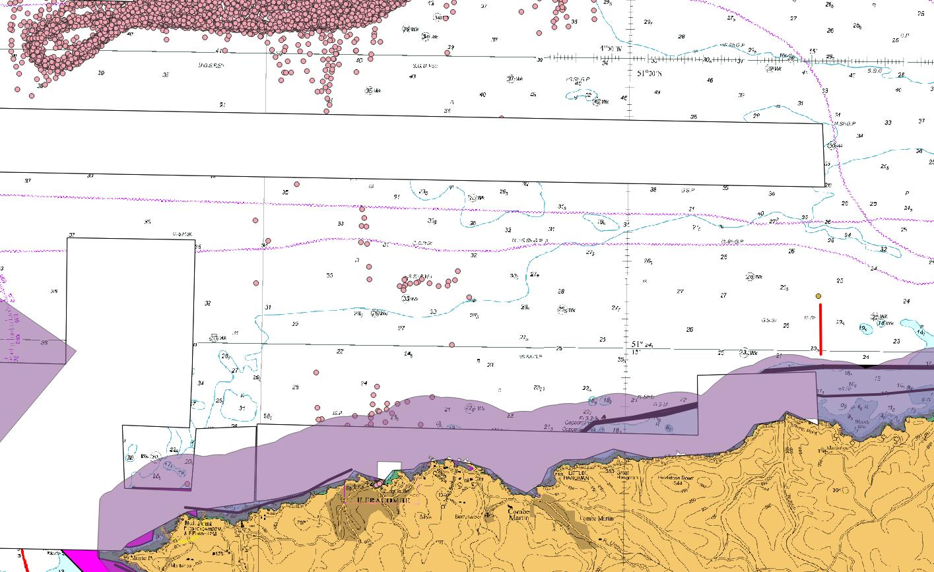
X
Figure 6: Potting licenses and fishing boats surveyed along the Exmoor Coast littoral, source IFCA

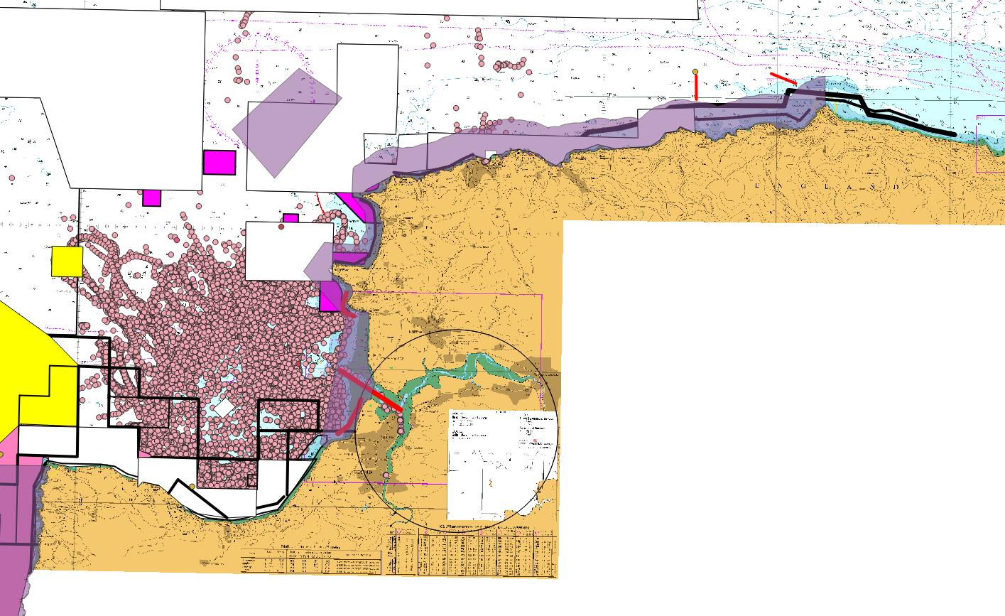
Figure 7: Potting licenses and fishing boats surveyed in North Devon including Biddeford Bay.

Emergency Response Plan
This plan will exist both here for information and as a stand-alone document that will be circulated to local HM Coastguard and RNLI stations, local vessel users, local houses and on a signpost overlooking the site from shore

Site Deployment, Monitoring, and Decommissioning

Deployment
The farm will cover an area of approximately 1 kilometre squared (100 ha). The site will be marked with Special Marker Buoys in accordance with Trinity House guidelines. The 4 corners of the farm to each be marked by yellow spherical shaped lighted buoys, exhibiting a Fl.Y.5s (flashing, yellow, every five seconds) light and surmounted by a yellow 'X' shaped top mark.

Method of Anchoring
In conjunction with Marine Farm Services Ltd, our infrastructure provider on the farm in Torbay, we have completed a preliminary assessment of the infrastructure requirements of the proposed site East of Ilfracombe. Marine Farm Services has local experience in North Devon waters.

Our assessment is the result of site visits, analysis of currents, tides and the sea energy potential especially in Southwest storm conditions. We have also made comparisons with case studies for kelp farm installations in areas of similar sea and tidal energy and exposure. Local knowledge of the sea bed in this area and benthic surveys have also been taken into consideration.

Because kelp likes cold strong current, the proposed North Devon location is good for growing kelp but not without challenges due to the strong estuary and tidal currents, direct exposure to the Atlantic and a big tidal differential. Due to the benefits for kelp farming in such conditions, farms have for many years been in locations with conditions similar to the proposed North Devon site. Examples are, Ratlin Island, NI; any number of Faroe Island and Norwegian sites; St Malo, France; and many Maine, USA sites. All these farms have either extreme tides or high energy sea exposure.

Although we do not do detail design of the infrastructure until we have secured the installation contracts and we know the exact technique, In order to satisfy ourselves of the feasibility of the location that we are proposing we have determined that it will be a rope configuration in either long lines or long lines with cross lines to form a mesh. Most importantly, the line infrastructure and marker buoys will be anchored by helix screw anchors driven into the seabed.

Figure 8 below illustrates the use of helical screw anchors with a typical kelp long line configuration.

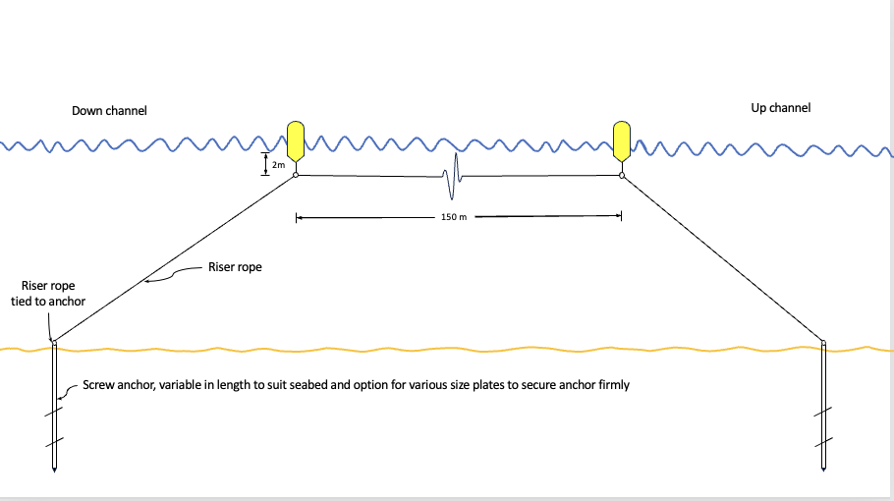
Figure 8

Such anchors require a seabed sand, course sediment or mud. The Sea Bed survey shown below of the North Devon waters show that the area of the proposed site is sedimentary.
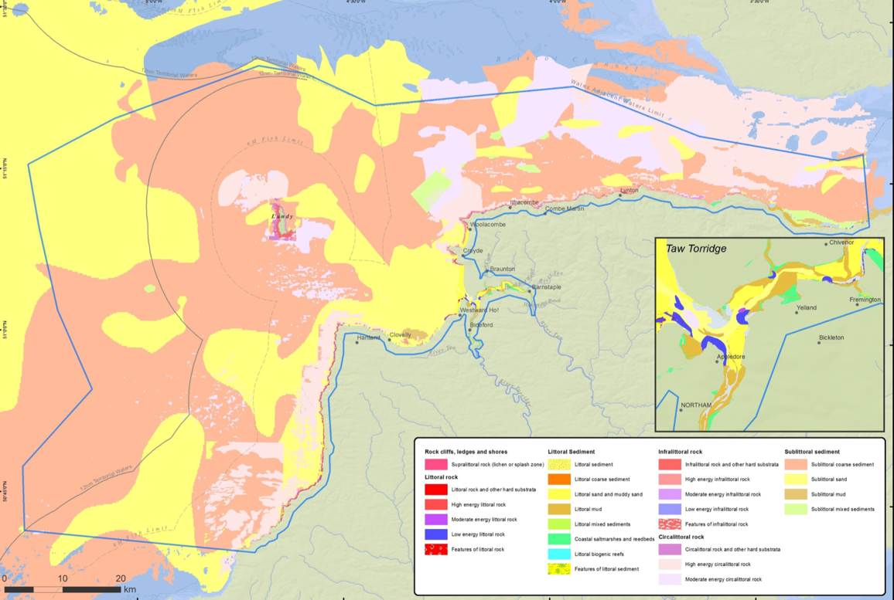
Figure 9
Ashley, M., Rees, S.E., Cameron, A. 2018. North Devon Marine Pioneer Part 1: State of the art report of the links between ecosystem and ecosystem services in the North Devon Marine Pioneer. A report to WWF-UK by research staff the Marine Institute at Plymouth University,

The detail design will be part of the anchor installation contract and will follow the same rigour as set out by the Recommended Design Practice recently published by the North Sea Farmers and the Dutch Government. When this was being adapted, Aqua Botanika participated in the consultation. https://www.northseafarmers.org/sector-support.

In making preliminary assessment we also assessed the recently published Engineering A Low-Cost Kelp Aquaculture System for Community-Scale Seaweed Farming at Nearshore Exposed Sites via User-Focused Design Process.

Installation of Helix Screw Anchors
We have chosen Helix Screw Anchors because these are easily deployed in sedimentary seabed and mud with little impact to the sea bed or the benthos. Installation of helical screw anchors also requires less on the water equipment than other anchoring systems such as blocks. At any rate, blocks would be totally inappropriate due to movement in storm conditions.

Helical screw anchors are installed by dropping 3 anchors or weights in the vicinity of the helical screw anchor position. These are connected to the helical screw anchor driver by cables which exert downward pressure on the driver. After the helical screw anchor is driven the driver and the temporary anchors are removed. The helical screw anchor is attached to a permanent rope that is attached to the long line at an angle.

To reduce cross load from sea and current forces on the long line the lines will run in the direction of the tide and dominant currents.

Impact on the MCZ

We are aware the Marine Conservation Zone is 150 meters from the proposed site. None of the operations for the installation that we have described above will need come anywhere near the MCZ. Also seeding, maintenance and harvesting of the seaweed operates directly over the farm and will not come close to the MCZ.

Having the proposed farm alongside the MCZ will undoubtedly be a benefit to the MCZ.

During deployment, the farm will be regularly monitored, and a qualified boat crew and HSE dive team will assist. The seeded seaweed lines will be deployed around October or November. This exact date of deployment will depend on factors such as sea temperature and weather. The seaweed seeded lines will come from local kelp which will be used to seed the rope in accordance with seaweed aquaculture guidelines on bio security. Work will only be conducted in daylight hours, weather permitting (calm conditions).

Monitoring
The seaweed will grow over the colder months. During this time, monitoring will take place on a bi-weekly basis. Monitoring will include a visual inspection of the seaweed farm and water quality testing. These visual inspections will ensure that no ropes have become tangled and no infrastructure has broken away. During these visits, inspections should be made of the accessible below surface infrastructure to:
- Identify and replace worn connections or wear points;
- Monitor for the presence of Invasive Non-Native Species;
- Remove biofouling where necessary;
- Adjust buoyancy of the lines; a little buoyancy is necessary when out-planted, but more
may need to be added during spring-summer.

Dives may be necessary to check on the moorings as well. However, this will be much less frequent than the surface visual inspections of the site. It will be completed by a trained employee of Aqua Botanika. We will also utilise drones to carry out regular visual inspections of the site

Food grade sugar kelp is harvested in April, May and sometimes early June. Over the rest of the summer sugar kelp can be harvested for other uses. At the end of the harvest the cultivation lines are cleaned and made ready for replanting in Oct/Nov. The seaweed farm is continuously worked throughout the year. However, the timing of the harvest will depend entirely on weather conditions and sea surface temperatures, so an exact date for harvest cannot be given. During harvest time a large crab/ lobster boat will be leased. The frequency of trips to the site will depend entirely on the tonnage of the crop. However, we are planning for a minimum fourteen site trips (harvesting every day for two weeks) for the main food grade kelp harvest. Lines will be hauled out of the water one by one until the boat has reached its carrying capacity. The lines will be stripped of seaweed and then the final product will be offloaded in Ilfracombe Appledore Harbour (arrangements on the exact location are still being arranged).

The same process of seeding, monitoring, and harvesting will take place every year for as long as the marine license is valid. Weights and buoys marking the farm location will be left in the water throughout the year.

The rig will be fitted with tracking devices (see below) that will provide us with notice if a section of the rig with the tracking breaks loose and floats out of the demise of the farm. These are standard devices that are monitored for this purpose.

Health and Safety on land and at Sea

Each campaign will be preceded by a method statement and ALARP (as low as reasonably practicable) the HSE principle that weighs risk against the trouble, time and money needed to control it. These follow the same procedures that are imperative with all campaigns on our Torbay Site. All personel have Certificates of Competency as required for their jobs by the Coast Guard. All vehicles are Coast Guard certified work vehicles. In deciding the location of the North Devon site and in fact, even the idea of locating macro algaculture in North Devon or the Bristol Channel we have specifically considered the extra intensity of the risk to working at sea in the swift currents and exposure to North Atlantic weather.

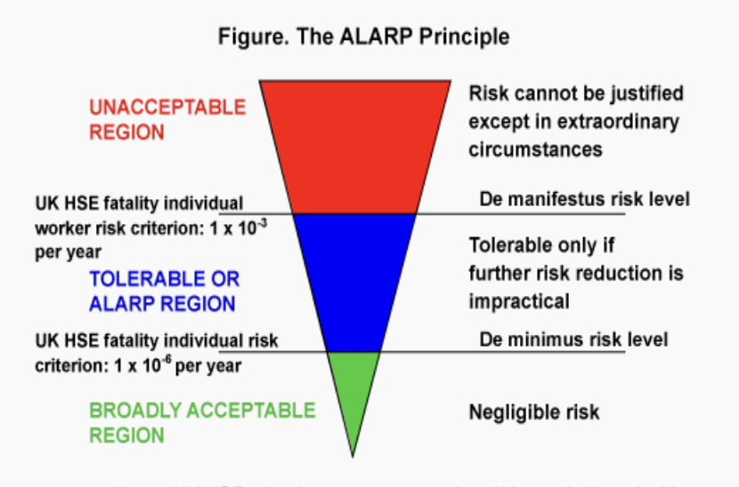

Special considerations of working at sea along the North Devon Coast and in the Bristol Channel.

We are fully aware that the Bristol Channel has one of the largest tides in the world and this washes the North Devon coast. We are also aware that the site is exposed to the Atlantic and South Westerly storms which can be fierce. Our practice is to try to never work at night or during heavy weather. As in all work at sea but especially offshore or areas of high sea energy as is the site we are proposing, we understand that there will be extra restrictions due to weather and tide. Each campaign method statement and risk assessment will take these extra conditions into consideration.

Also because of the tidal differential all the ports along this stretch of coast dry out. Ilfracombe has an outer harbour that has berths at low tide. Even with today’s advanced level of weather forecasting, we are also aware fronts move faster or slower than forecast. The potential conditions require that in case of a sudden storm safe havens need to be considered but because all the ports along this stretch dry out additional measures need to be considered. At the very least the work boats need to be able to dry out when the tide is out. The moorings for the farm will be sized to not only hold the farm in storms but moor work boats if need be.
The work boats will be required to have keels that can settle in a harbour that is dried out.

Recovery arrangements/procedures should the devices fail/break away
Should any lines or buoys break away whilst in the water they will pose a significant hazard to other marine traffic in North Devon. Within 24 hours of noticing infrastructure failure, we will notify the local harbour master, the Marine Management Organization, the Maritime and Coastguard Agency, the UK Hydrographic Office, and the sailing clubs operating in North Devon. We will then consult the relevant bodies about the sea conditions when the infrastructure may have failed. This will allow for an attempted recovery to be made.

Tracking monitors will be attached to the marking bouys in a proprietary casing. These trackers are based on proven Internet of Things (IoT), always on, long battery life, SIM free GPS trackers that are connected to Sigfox. Movement beyond a designated ring triggers an alarm. This is the same network that is being used by Plastimo for tracking of life rafts and jackets. This is technology that is global and both coastal and mid ocean.

Should any part of the farm break loose and become sea borne, or should a tracking notice be sent, Aqua Botanika (AB) will make a visit to site and assess the damage (if stormy, as soon as it is safe to make way) and determine the best course of action for recovery. If the breakaway section has tracking, then AB will use the signal to recover. If not, AB will use dead reconning to identify the most likely track of the waterborne materials.

Decommissioning
We plan to apply to renew our marine license six months before the original expires. Should this fail (or the company cease operation) the site will be decommissioned. Decommissioning will simply be a reverse of the installation process mentioned above

The risk log that is included in this NRA will be included in the Engineer’s Brief and the Engineer will be made responsible to update the log and identify any residual risks at the completion of the design. (Condition of License).

Emergency Scenarios and response

Vessel stranding – in the event of a vessel entering the Seaweed Farm exclusion zone (advisory only) and colliding with the Farm structure, the first concern is the safety of the vessel if life is not at-risk HM coastguard routine number should be called whereas if life is at risk 999 should be called and the coastguard/RNLI informed.

Aqua Botanika should also be contacted (number below) and repairs to the Farm structure will be enacted.

Cetacean entanglement – in the unlikely event of a seal, whale, dolphin or basking shark becoming entangled in the Seaweed Farm lines, The British Divers RESCUE HOTLINE: 01825 765546 should be called - https://bdmlr.org.uk/ float loss – occasionally, some line floats may become detached from the Seaweed Farm structure. This will not degrade the integrity of the Farm structure, but Aqua Botanika should be contacted (number below) so the float can be recovered and the replaced back where it came from.

Storm damage/loss of integrity of the structure – the design of the Seaweed Farm is such that multiple anchor lines hold the structure in place and the loss of several of these lines would not degrade the integrity of the Farm. But should it be observed that the Farm structure has been damaged or worse, lost from its moorings if life is not at-risk HM coastguard routine number should be called whereas if life is at risk 999 should be called and the coastguard/RNLI informed. Aqua Botanika should also be contacted (number below) and emergency repairs to the Farm structure will be immediately enacted. Local vessels (fishing and aquaculture boats) will be retained as emergency response and ropes, floats and other equipment held in preparation for such emergency repair by Aqua Botanika.
Aqua Botanika Contact details (to be contacted in all scenarios)
Ty Robinson – 07799 060671 – tyrobinson1@mac.com

Procedures During Emergency Scenarios
Detailed emergency procedures will be covered during an initial risk assessment with the contracted vessel operator. This will ensure that everyone on board is following maritime safety legislation. Should an emergency scenario arise, protocols discussed in the risk assessment will be followed and incidents will be reported to the relevant authorities (QHM, MMO, MCA, RNLI etc.). A Marine Emergency Action Card will be required, in consultation with HMCG (condition of licence).

Vessels, Equipment, and Personnel for Response
A detailed risk assessment will be conducted with the vessel operator before leaving the shore for farm maintenance. This will ensure that the vessel and equipment on board are suitable and adhere to maritime safety guidelines. The Ilfracombe, North Devon Harbour Master, and The Maritime Coastguard Agency are the main points of contact should an emergency arise while working on the site. All other relevant bodies will be notified within 24 hours of an incident occurring.

Emergency Contact Details
- Ty Robinson : 07799 060671 (mobile)
- Vessel Operator: To be confirmed

Site Layout and Mooring Arrangement

Layout and mooring arrangement
Schematic drawing of 1 hectare of the Kelp Farm
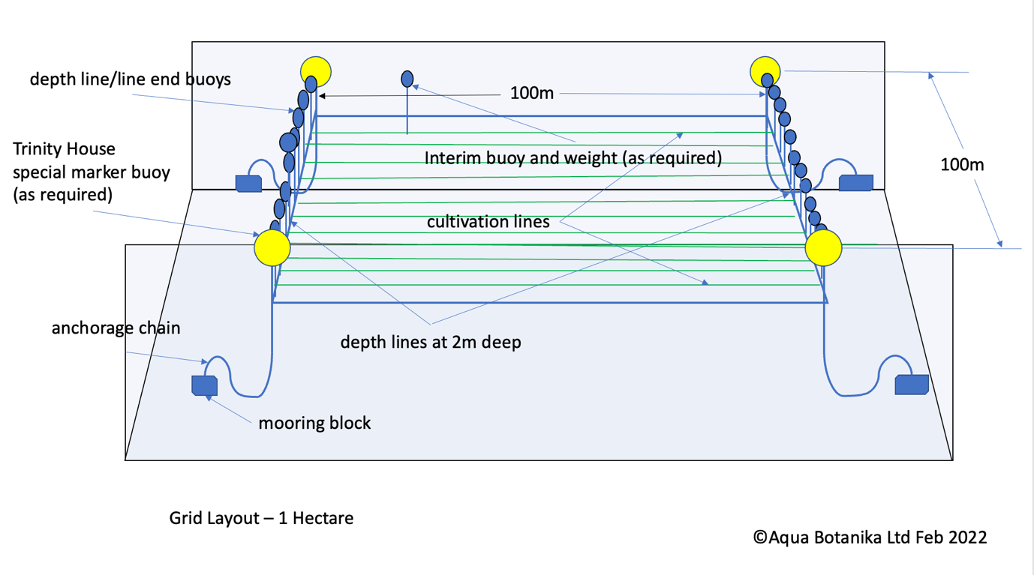

Figure 7:A schematic rendering of the farm including buoys, seaweed lines, and mooring weights
Throughout the world Kelp is cultivated in many different ways. The schematic above is based on successful kelp growing infrastructure in Maine, USA, Northern Ireland, Brittainy and Scotland. Please note that for this location in North Devon we will be using helical screw anchors rather than blocks as these are more suitable for the local conditions. The schematic above is for a 1hectare grid, which will repeat 100 times. The actual special marker buoy layout will be as dictated by Trinity House for the whole of the site. The component sizing, frequency and final layout will be determined by a profession marine engineer. In Principle the cultivation lines are strung on frame lines that are below the surface of the water. Intermediate buoys maintain this along the length of the line. The specific gravity of kelp is close to the specific gravity of sea water.

Mooring Arrangement Assessment
It is essential that the navigational and health and safety regulatory expectations
for mooring systems are set in proportion to the potential risks with a view to develop a
safe and sustainable seaweed growing platform for the long term. To do that Aqua Botanika will retain the services of a professional design team with experience in design, installation, and maintenance of Aquaculture structures to design a Seaweed Farm that incorporates oversized ropes, chains and anchors and appropriate components to ensure the structure:
can withstand such forces acting on it as are reasonably foreseeable including:
Environmental conditions, e.g., winds, waves, tidal currents
Loads during operational conditions including normal operation, contact loads from access boats and temporary loads during maintenance operations.
- The weight of the installation and anything on it, buoyancy, drag and inertia forces from movement
- Unplanned incidents including vessel-impact
- its construction, commissioning, operation, modification, maintenance, and repair of the Seaweed Farm may proceed without prejudicing the structure’s integrity.
- in the event of reasonably foreseeable damage to the installation or its moorings, it will retain sufficient integrity to enable action to be taken to organise appropriate safe repair, thus preventing mooring failure (thereby becoming a navigational hazard).
- it may be decommissioned and dismantled safely.
The Marine Engineer will be instructed to design the seaweed farm so that it will retain sufficient integrity in the event of reasonably foreseeable damage. The brief will include the following Risk Control Log with instructions to ameliorate these risks through the design of the infrastructure. The Marine Engineer will be instructed to maintain this log and add any additional risks. The Marine Engineer will be briefed to identify any residual risks in the Engineers final design report. At the end of the design the Navigation Risks Assessment will be revised including the updated Risk Control Log as will as identified residual risks.

Risk Control Log

 | Potential Risk | Likelihood  L/M/H | Impact  L/M/H | Score  1-10 | Control  Measures
1/. Anchor and Mooring system
Corner Buoy | Fatigue | L | H | 2 | Use of multiple 1 tonne Reef Cube anchor blocks
Position anchor | Failure | L | M | 2 | Use PE rope (uv resistant)
Position sinker | Sink collapsed | L | L | 2 | Use of suitable size buoys specified to take the loads in the design
Adjustment anchor | Damage | L | M | 2 | As above
Adjustment outer sinker | Corrosion | L | M | 2 | As above
Corner mooring line | Decayed | L | M | 2 | 10 year design life; inspect
Position mooring line | Destroyed | L | M | 2 | 10 year design life; inspect
Adjustment mooring line | Unsuitable materials | L | M | 2 | 10 year design life; inspect
Position buoy | Unsuitable size | L | M | 2 | Robust design
Adjustment buoy | Insufficient anchors, buoys or sinkers | L | M | 2 | Robust design
2/. Frame and Boundary
Frame line | Inadequate rope | M | M | 6 | Robust design, test and accept
Boundary line | Break | M | M | 6 | Use of uv resistant rope
End boundary line | Fatigue | M | M | 6 | Use of uv resistant rope
 | Unsuitable frame design | M | M | 6 | Use of uv resistant rope
3/. Buoy
Corner Buoy | The size and buoyancy | L | L | 8 | Robust design
Intermediate Buoy | The size and buoyancy | L | L | 8 | Robust design
4/. Connector
Buoy shackle | Types of connectors | L | L | 3 | Use stainless steel shackle
Sinker shackle | The uses of them | L | L | 3 | Used as a connecting link in many rigging systems
Line shackle | Loss | L | L | 3 | Robust design
Boundary sinker shackle | Hard to obtain | L | L | 3 | Fabricate if necessary
 | Maintenance
5/. Planting line
Planting line | Loose | M | M | 7 | Inhouse design, fabricate line with floats and inserted planting line
Web line | Slack line | M | M | 7 | Use connection rope
Clipper | Too heavy | M | M | 7 | Use stainless steel clipper
Adjustment Buoy | Cannot float | M | M | 7 | Use moulded float (20kg buoyancy)
 | Arrangement
6/. Environment
Wind | Including normal to extreme wind | H | H | 9 | System designed by experienced professionals to withstand all types of conditions
Wave | The wave height | H | H | 9 | Use reef cubes to avoid issues with soil conditions
Current | Maximum speed of the current | H | H | 9 | Test rig to failure before installing
Speed direction | The direction the weather and current is coming from | H | H | 9 | Use site specific wind and current data
Type of soil | Type of soil under the farm | H | H | 9 | This has been considered by NE in review of our Environmental Impact Assessment
Tide level | High and low tide | H | H | 9 | Use site specific tide data
Depth of sand | Maximum depth of sand layer | H | H | 9 | This has been considered by NE in review of our Environmental Impact Assessment
Seabed | Sand or reef etc | H | H | 9 | This has been considered by NE in review of our Environmental Impact Assessment
7/. Design
Inappropriate design | Poorly design, constructed and maintained infrastructure | H | H | 9 | Design undertaken by experienced farm designers
Configuration | Ability of the system components to carry the loads | H | H | 9 | Utilise high quality proven components
Structure | Failure | H | H | 9 | Everything fully detailed
Structural integrity | Fatigue | H | H | 9 | Specify suitable components for marine environment
 | Collapse | H | H | 9 | Full detailed planned and preventative maintenance plans
 | Corrosion | H | H | 9 | Full detailed planned and preventative maintenance plans
 | Incompatibilities | H | H | 9 | Evaluate in design (i.e. metals)
 | Connections | H | H | 9 | ditto
8/. Cost
Deployment of system | Higher than anticipated system costs | L | L | 2 | Establish a robust cost plan
Operation cost | Inflation on operation costs | L | L | 2 | Contingency in projected P&L and cash flow
Theft | Equipment or crop theft | L | L | 2 | Robust maintenance plans and budget; Insurance against damage and theft
Damage | Accidents
Maintenance | Higher than planned maintenance costs | L | L | 2 | Contingency in projected P&L and cash flow
9/. Location
North Devon | Inappropriate location of the farm would lead to increased risk of damage, create navigational hazards etc | H | H | 8 | Through consultation with the relevant stakeholders to select the best location
Anchorage in close proximity | Flotsam from a failure becomes entangled with anchored shipping | L | L | 9 | Robust Design and tracking.

The area of this application is 10 ha. Trinity house had reviewed a previous application that was 2 ha. It may be that Trinity House will require additional marking for this area.

