Dear Mr Meredith,

Re: Camel Fish Ltd Appeal - APP/ML/25/04

In response to the appeal document submitted by Camel Fish Ltd, I would like to reiterate my objection to the seaweed farm proposal for Port Quin Bay. My objection lodged with the Marine Management Organisation, and available on the MMO public register, still stands and my opinion of this proposal has not changed. I also endorse the ‘SPQBG Public Consultation Submission’, submitted in November 2024 on behalf of coastal communities during the third public consultation regarding this proposal, which is also available on the public register. The information presented in the Public Submission document is robust and evidenced, and proves, beyond doubt, that Port Quin Bay cannot support seaweed cultivation infrastructure, regardless of scale and site location.
Below I highlight a number of issues I think worthy of consideration by the Planning Inspectorate, but others, I am sure, will submit a more comprehensive review of the appeal document.

The appellant and Dr Angela Mead:

It is my opinion that the appellant and Dr Angela Mead attempted to move their original applications through the licensing process without meaningful public engagement. This has been true of previous seaweed farm applications in the South West with links to Dr Mead, including Port Isaac Bay and Gerrans Bay. In these cases, as with Port Quin Bay, it has only been public vigilance which has discovered and drawn attention to the applications. With this appeal, there was the opportunity for Camel Fish Ltd to engage more productively with coastal communities and stakeholders, but they failed to achieve this. In September this year, Camel Fish Ltd circulated two almost identical surveys amongst a select group of stakeholders, titled “Use of Port Quin Bay and Vessel Activity” and “Use of Port Quin Bay Fishing Activity”. I don’t believe that this was a rigorous or widely enough circulated consultation. Crucially, the only working fisher out of Port Quin was not consulted, neither was the only other Port Quin business, which uses the bay for kayak tours. Also, a considerable number of community members requested copies of the survey from Camel Fish Ltd, but these requests were ignored.
It is stated in the appeal document that ‘Diversification of fishers is to be supported and this is a clear case for Camel Fish’. From what we know of Mr Blewett of Camel Fish Ltd and Pentire Fishing Ltd, with his boat with national reach and his stake in an oyster business in the Fal, is that he is not in need of diversifying. He’s fine.

Dr Angela Mead, of Biome Algae Ltd, does not hold any licences for seaweed cultivation farming.
Dr Mead was an applicant, or worked as a consultant, on a number of seaweed farm applications for South West coastal waters in the 2020s. These include:

- Start Bay - applicant (rejected)
- Torbay - applicant (withdrawn)
- Gerrans Bay - applicant, consultant (withdrawn)
- Port Isaac Bay - consultant (licence suspended)
- Port Quin Bay - applicant, consultant (withdrawn/rejected/contested)
- St Austell Bay - consultant/operator (abandoned)
- Bideford Bay - consultant (operated by Algapelago)

It is notable that Dr Mead states in the appeal document that ‘My company applied for licenses in Start Bay, Torbay and Port Quin, over a period of seven years’. Is she forgetting that she and partners Carbon Sea Garden withdrew their applications for a 110 hectare site in Gerrans Bay on 5th January last year?
Dr Mead is also involved with Aqua Botanika Ltd, operating their 10 hectare pilot farm at Torbay. Aqua Botanika Ltd recently withdrew their application for a 100 hectare seaweed farm off Combe Martin, North Devon. Odd that Biome Algae describe the Torbay farm as ‘our farm’ on their website, when it categorically is not. There is some confusion here. Aqua Botanika Ltd hold a licence for this farm, but clearly it is Biome Algae Ltd who are operating it. Is this a contravention of licence conditions?
Also, Biome subsequently applied for their own licence for Torbay, which I believe was withdrawn.
None of the above sparks confidence in Dr Mead’s abilities or judgement. This ‘peer-reviewed, published marine biologist with 30+years-experience’, this ‘experienced UK seaweed farmer’, is not really having much luck.
A couple of other issues caught my eye:
- I don’t believe that Dr Mead has the appropriate qualifications to undertake a Navigational Risk Assessment.
- As a marine biologist, Dr Mead undertook the Formal Safety Assessment. Is that right?
- Dr Mead boasts an extensive list of publications, but these do not relate to seaweed farming in any way. Also, Dr Mead has had no peer reviewed publications since 2013.

Seaweed myth-busting:

It is important to understand that some of the press around ‘seaweed farming’
is not accurate, and does not apply to large scale (>50 hectares) seaweed
cultivation.

Carbon capture - Cultivating seaweed does NOT sequester carbon. On
harvest, the plant is destroyed and the carbon released. A UK seaweed
producer, with over 25 years of experience in the sector, said of the Port Quin
site that “the only way this project would sequester carbon would be if they
cut the biomass from the lines, sunk it straight to the bottom and buried it”.
Also, a leader in the North American seaweed industry stated, “Time to get off
this carbon sequestration in the ocean bandwagon and get real with what
seaweed can do on land in terms of reducing plastics, fertilizer etc. Otherwise
we will damage the sector's credibility”.
Habitat provision - In the growth period (Autumn-Spring), cultivated
seaweed will attract fish and other sea creatures. However, this habitat is
then destroyed at harvest (Spring/early summer). This coincides with
spawning for multiple native fish and crustacean species, removing roe and
spat with the biomass. There is also the likelihood of shading and smothering
of existing habitats (one study suggested up to 50% biomass loss in a
growing season). Also, by introducing seaweed cultivation into an otherwise
relatively untouched ecosystem there is considerable risk of attracting
Invasive Non-Native Species (INNS).

The appeal document references Corrigan et al 2024, but not these bits:
“However, as seaweed biomass was harvested through the summer, valuable
fish habitats were seemingly lost” and “The habitat provisioning for seaweed
cultivation lines, however, is markedly affected by harvesting, with dramatic
declines in fish abundance and richness subsequent to crop removal
highlighting that farms are not a replacement for natural kelp habitats”
(Corrigan et al 2024, pp.155 and159)
Food security - UK farmed seaweed products for human consumption and
pharmaceuticals are generally reserved for small-scale, hand-harvested seaweed from existing wild seaweed beds. Seaweed cultivated on larger-scale models can contain high levels of heavy metals and other contaminants, due to absorption, and this poses a risk to consumers. A chief technician from a large UK ingredients company confirmed that they would not purchase seaweed products from large-scale farms, and from the Port Quin Bay Farm proposal in particular, because of agriculture run-off, local historic mining and a nearby spoil site, which significantly affect water quality, and therefore the absorption of heavy metals and other contaminants.
“…heavy metals persist in the environment long past the industrial activities
that introduce them, meaning that areas seemingly pristine for kelp
aquaculture might still be at risk due to human activities long past. Research
has also shown that climate change and subsequent shifts to water column
properties can increase the availability and toxicity of such contaminants in
the water column” (Shaughnessy 2023)

Marine Management Organisation (MMO) process:
The thrust of this appeal is that there was ‘systematic failure by the MMO in
the determination of MLA/2023/00307’ (Camel Fish Ltd application number).
And that ‘Multiple legal issues, significant procedural mistakes and errors
have been identified’. The appeal specifically questions the change in fee
bands from Band 2 to Band 3, which significantly increased costs to the
applicant, and the fact that the applicant was not given the chance to respond
to actions suggested following MMO’s consultation with Cefas and Natural
England in October/November 2024.
I would suggest that both of these gripes are simply part of the marine licensing process. As an enabling agency, it is the MMO’s remit to grant licences, so by not granting licence, they are failing. This is not something the MMO would take lightly. The fact is that the applicants were given multiple chances over more than 2 years to prove the viability of the proposal, and they failed to achieve this.
As a community, our experience is quite the opposite to that of the appellant. Over the last two years, we have felt that the process is thoroughly biased towards applicants, to the detriment of stakeholders and communities, and in the face of overwhelming evidence. Can we both be right?

Sea conditions:

Locally, we all know that any infrastructure deployed in the bay will not last a season. This is what it comes down to. The conditions in the bay are consistently too rough. We know this from lifetimes of observing and working the bay, witnessing wrecks, groundings and rescues, and watching large cargo vessels, sheltering in the safe anchorage area, dragging their anchors.
The fact is that significant wave height in the bay is upwards of 8.5 metres, 2.5 metres over the recognised tolerance for seaweed farm infrastructure. All other issues with the applications and appeal are moot in the face of the reality of the situation. It won’t work here, that’s it.
There are other areas of potential for seaweed aquaculture on the south coast of Cornwall and Devon, where the conditions are more favourable. In fact, there are 180 lines licensed for seaweed cultivation in St Austell Bay which are currently not being used - why not guide the appellant to that location? Much closer to Camel Fish Ltd’s registered offices.

Port Quin Bay is an area of Safe Anchorage for vessels in distress. The Marine and Coastguard Agency publish two coordinates for this area, showing the western extremity at Rumps Point and the eastern extremity at Kellan Head. The appellant and their consultant have taken a line drawn between these two points as the designated seaward extent for safe anchorage, repositioning the farm site just offshore of this line. However, no seaward extent is marked, and AIS data clearly shows vessels anchoring and transiting the farm site area (see images overleaf). In heavy weather, large vessels negotiating around a barrier as substantial as the proposed farm is simply not a safe option.

“This stretch of coast is mostly north-west facing and therefore exposed to extremes in North Atlantic wave height and energy. The annual 10% exceedance wave height is 2.5m – 3m (Futurecoast, 2002), with a 1 in 50 year extreme offshore wave height of 20m”

This is taken from the Cornwall and Isles of Scilly Shoreline Management Plan (2011), which is available on the Cornwall Council website.
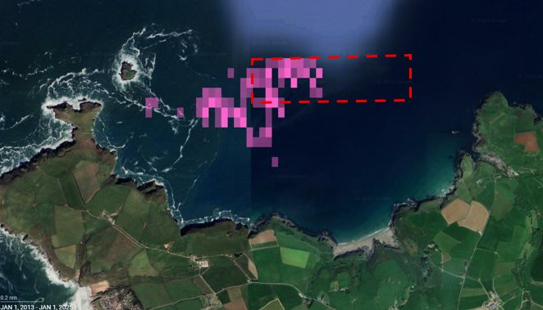
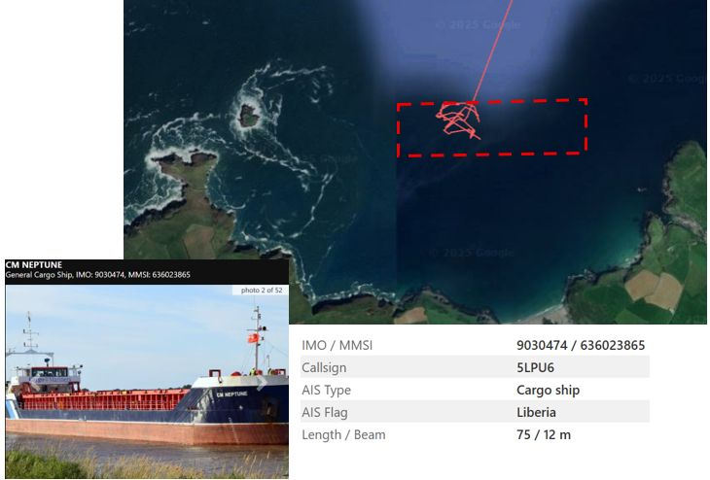

AIS data of vessels using Port Quin Bay safe anchorage, with new farm site overlaid.

This proposal would squeeze large vessels, like the CM Neptune above, out of the main approach to the bay, forcing them closer to the rocks at Kellan Head or Mouls Island. In the vast swells we experience in Port Quin Bay, this should be considered to be causing a significant danger to life.

Arc Marine Report:

The Arc Marine Report appears to wildly underestimate the water depth (and consequently the wave height) at the farm site. On P40 of the Arc Marine Report they calculate the water depth (dsea) at the farm site to be 5.85 metres. It is, in fact, 10-15 metres.
Also on P40 of the Arc Report, the 100 year significant wave height (Hw100) is calculated to be 4.563 metres. Honestly, that’s just any average Tuesday! On P41, Arc state that the 10 year significant wave height (Hw10) is 4.095.
A reasonable estimate for the 100-year Hw at Port Quin Bay, based on nearby data and models, is in the range of ~8.5–11 meters. It should be noted that this is an average height, not a maximum height.

Seabed/disturbance:

The sediment in the bay is sand, this has been established.
Regardless, much is made in the appeal document of the ‘sandy gravel sediment’, and how it ‘does not support spawning grounds’. Sandy gravel is a critical habitat for sand eels and a plethora of other marine species. Sand eels are a significant prey species for harbour porpoise (protected under the Bristol Channel Approaches SAC which covers the bay). Sand eels are also the primary food source for puffin chicks (‘pufflings’!) during the breeding season. This is the reason that Mouls Island, adjacent to the farm site, is home to the last breeding group of puffins on the South West peninsula. The farm site and surrounding area is used as foraging ground for both Atlantic puffins and harbour porpoise, and a multiplicity of other marine mammal and seabird species. There is particular interest this year in razorbill and guillemot numbers. Both these species nest on the Mouls, and both rely heavily on sand eels, especially during the breeding season.
Breeding season for auks on the Mouls (puffins, guillemots, razorbills), begins in March and runs through to fledging in late June/July. This coincides with seaweed harvest. Should this proposal be approved, disturbance of these breeding birds is inevitable and could be catastrophic.
Please note that the Mouls is covered by Padstow Bay and Surrounds Marine Conservation Zone, and the Pentire Site of Special Scientific Interest.

As Natural England state in their response during consultation in November 2024:
“Natural England advises that the proposal in its current form has the potential to damage the interest features for which the site has been notified (NE emphasis); specifically the following seabird interest features of the site:
• Guillemot (Uria aalge)
• Razorbill (Alca torda)
• Fulmar (Fulmarus glacialis)
• Puffin (Fratercula arctica)
Increased human activity in close proximity to the SSSI could disturb birds going to and from foraging grounds and the numbers of birds loafing and prospecting colonies. Increased lighting has the potential to impact fledglings and could also deter adults.
There is a puffin colony at Mouls Island which is in close proximity to the proposed sites, and this may be one of the few sites in this region that is undisturbed and able to maintain a colony. The most recent count data shows low numbers of individuals, indicating this represents a small-scale colony which may be highly vulnerable to any changes close to its nesting sites and/or within its foraging /loafing habitat at sea. The supporting information submitted with the application highlights that puffins form ‘sea flocks or rafts to the east of the Mouls before moving onto the island’. As such, there is the potential for visual disturbance and possible avoidance of habitat used for prospecting, foraging, loafing and rafting. It cannot be ruled out that the birds may be excluded from their usual habitats due to the presence of new lighting and infrastructure and the increased associated activity”.

Conclusion:

The appellant and their consultant, Dr Mead, have been given more opportunity than most to prove the viability of deploying seaweed farm infrastructure in the nearshore area of Port Quin Bay. Three rounds of consultation is uncommon, with a second round of consultation deemed sufficient for complex, high-impact, or contentious cases, such as this one. The MMO, the MMO’s primary and statutory advisors, and the public have found this proposal to be unviable.

For the reasons stated above, I object to the proposal, and I do not agree with the grounds for the appeal as set out in the Camel Fish Ltd/Angela Mead document.

This appeal should be dismissed.

Yours sincerely,

