New book tells the full story of Seagrove Beach.

When author Robert O. Reynolds was in Junior High in Montgomery, Alabama, his parents discovered a beach community that was close enough to drive to for weekends and offered a lot more water sports than central Alabama. The place was Seagrove Beach, and his new book Simply Seagrove tells not only how
they found it, but how Seagrove came to be.
The fits and starts in its development are described, from an original homestead in 1904 through an aborted development and a hotel in the 1920s, to the arrival of C.H. McGee in 1949 and his successful development.

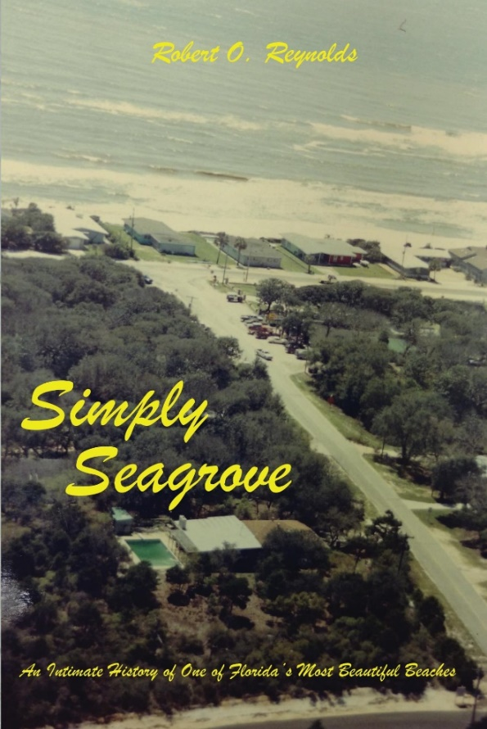

"Even if you've never set foot in Seagrove, this book will make you wish you had."
- Tim Hollis, author of Florida’s Miracle Strip: From Redneck Riviera to Emerald Coast

Reynolds’ family did a lot of boating and exploring in a Jeep and he describes adventures ranging from navigating shallow canals n a Boston Whaler, to excavating and piecing together pottery in the dunes to climbing the bluff in a Jeep. He covers the huge variety of waterways, including the story behind the coastal dune lakes, and tales of some devastating hurricanes. He describes all the plant and animal life you can expect to see, as well as a host of other phenomena from squeaking sand to red sunsets.

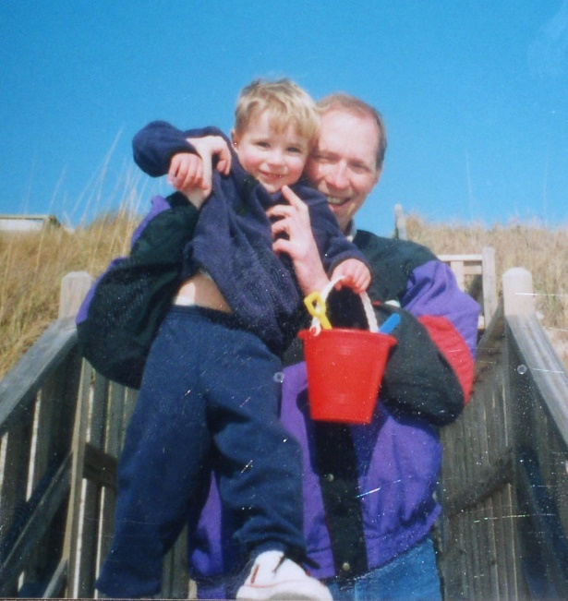

The author and his son.

Like others in the area, he and his school-age friends discovered the ‘Haunted House’ at Point Washington that later became Eden Gardens State Park. There are a couple of coming-of-age stories like a freezing camping trip on a dune and a poorly-planned visit to a dance hall called the Hangout in Panama City Beach.
Ever wonder where all those names came from, like “Emerald Coast” or “Redneck Riviera” – this book will tell you. There’s a chapter on art and artists from the area, and another covering the landmarks and attractions that have come and gone over the years.

“Simply Seagrove will resonate with readers who enjoy memoir and regional history. Seagrove’s small bit of space on the Florida Panhandle opens wide under Reynolds’ deft story-telling, photographs, and maps.”

Many readers like the relaxing descriptions of time spent walking at Deer Lake, casual boating with the family, or introducing others to the wonders of Seagrove. And there’s a special remembrance of Cube McGee, sometimes known as Mr. Seagrove, and his wife Babe.

Simply Seagrove is featured locally at Sundog Books in Seaside, the Hidden Lantern in Rosemary Beach, the Studio Gallery in Grayton Beach, and Fonville Press in Alys Beach. Further information is available at the publisher website emeraldwaterspress.com.

