WELCOME TO OUR 64TH ANNUAL TRAPPERS’ FESTIVAL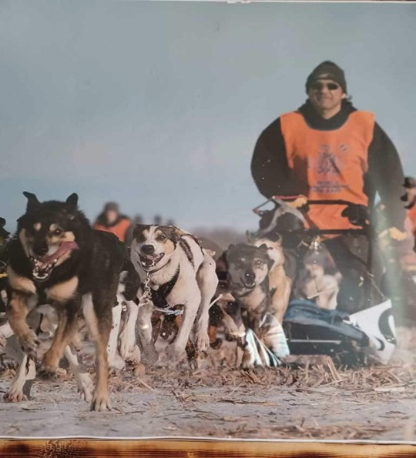
FEBRUARY 26^{TH-}
MARCH 4TH 2023.
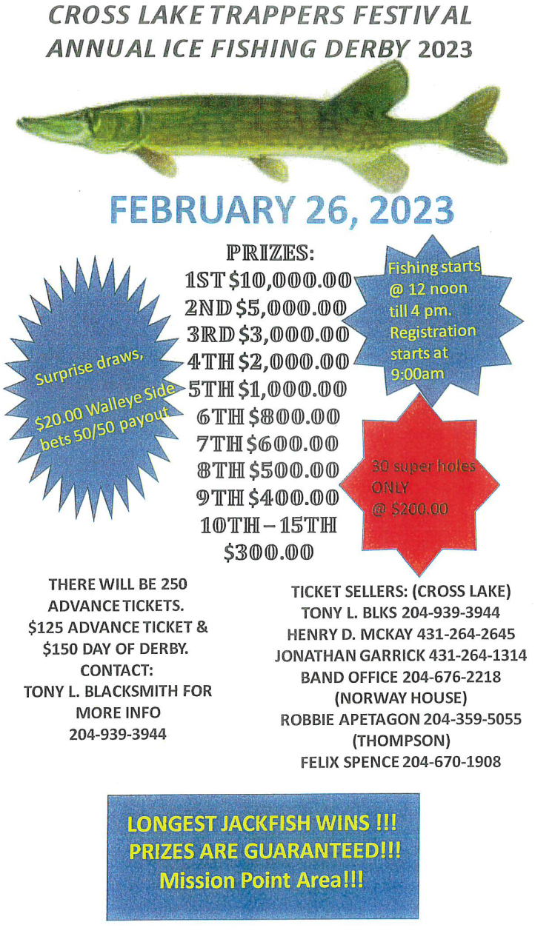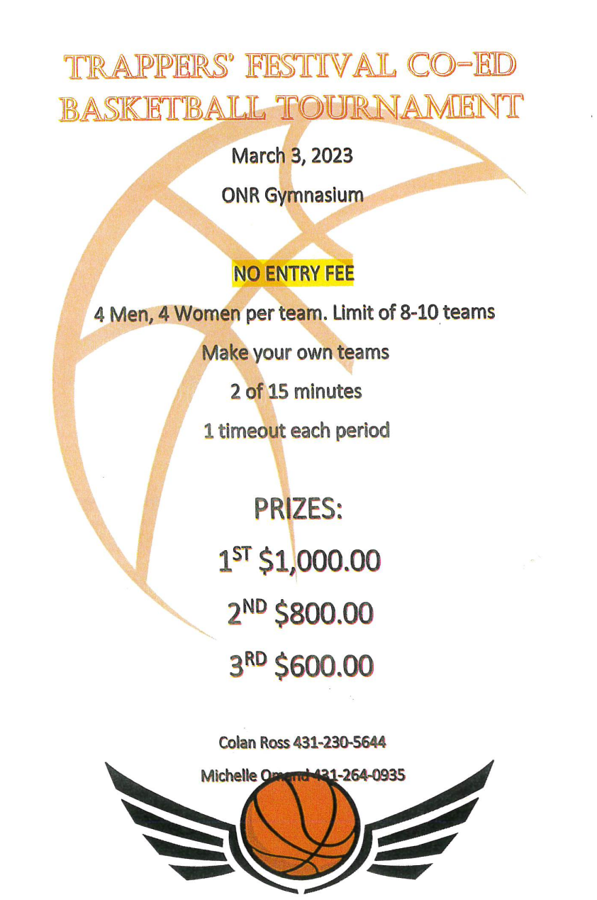
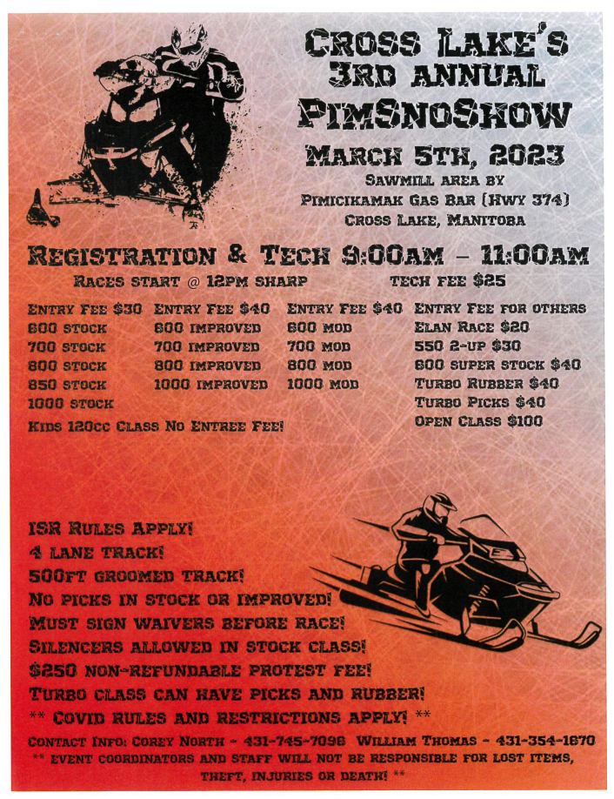
THE TRAPPERS’ FESTIVAL COMMITTEE WOULD LIKE TO WELCOME EVERYONE TO OUR 64TH ANNUAL TRAPPERS’ FESTIVAL. OUR FOCUS IS TO ENSURE THE SAFETY OF ALL COMPETITORS AND SPECTATORS, HOWEVER, THERE IS AN INHERENT DANGER FOR INJURY IN ALL COMPETITVE EVENTS, PLEASE BE CAREFUL. WE APPRECIATE YOUR PARTICIPATION AND SPORTSMANSHIP. WE ARE A COMMUNITY THAT ENCOURAGES ITS MEMBER TO BE GREAT HOSTS AND AMBASSADOR, WE EXPECT THE SAME FROM VISITORS PARTICIPATING IN OUR FESTIVITIES.
ENJOY THE FESTIVITIES, EKOSANI.
“KEEPING OUR TRADITIONS ALIVE THROUGH CULTURE AND RECREATION”
THE COMMITTEE:
PRESIDENT: RYAN CASTEL
VICE PRESIDENT: MARILYN MILES
SECRETARY: STARLA BALFOUR
TREASURER: ANGELA ROSS
MEMBERS:
TRACY HAMILTON BEATRICE ROSS TONY L BLACKSMITH HENRY D MCKAY
AURELIA MCKAY JONATHON GARRICK PEARL MCKAY LORI-ANNE MCLEOD
LOU ANN FLETT TANNIS TROUT SHAYLENE SCOTT JAMIE MASON
COLAN ROSS RAY MCKAY DIANE NORTH VAUGHN BLACKSMITH AMBER MILES
KENNY MISWAGGON MARGARET SCOTT HELGA HAMILTON JANET MCKAY
TRENT ROBINSON HEALTH STAFF CHRISTOPHER ROSS MIKE OMAND
***ENTRANTS YOU ENTER AT YOUR OWN RISK***
THE SCHEDULE AND EVENTS MIGHT BE CHANGED, AT THE DISCRETION OF THE COMMITTEE.
WE WISH EVERYONE AN ENJOYABLE FESTIVAL FILLED WITH LAUGHTER, VISITING, CAMARADERIE, COMPETITION AND ENTERTAINMENT.
2023 TRAPPERS FESTIVAL COMMITTEE
DAY 1 ICE LEVEL MONDAY, FEBRUARY 27,2023
1:00 PM EVENT #1
CO-ED SOCCER @ ICE LEVEL
- 18 Years & Up ONLY
- 4 Men and 4 Women
- 8 Team Limit
- Single Knockout Format
Prizes: 1st $800.00 2nd $600.00 3rd $500.00
Coordinator: Trent Robinson.
1:00PM EVENT #2
ICE WORM HUNT
- Clues will be handed out twice daily, posted on Facebook and announced on the radio.
Prizes: 1st $500 Baby Worm 2nd $400.00 Mama Worm 3rd $300.00 Papa Worm
Coordinator: Margaret Scott & Health Department.
2:00PM EVENT #3
KING FISHER
- Must bring your own rods and hooks.
- Location: Mission Point Area
- First fish to be caught.
- Any kind of fish.
Male/Female—18 & Up Category: $10.00 Entry Fee
Prizes: $100.00 2nd $75.00 3rd $50.00
Youth 13 – 17 Years Old Category: No Entry Fee
Prizes: $60.00 2nd $50.00 3rd $20.00
Youth 8 – 12 Years Old Category: No Entry Fee
Prizes: $60.00 2nd $50.00 3rd $20.00
Coordinators: Tony Blacksmith, Ray McKay, Starla Balfour and Tracy Hamilton

3:00PM EVENT #4
TRADITIONAL WEAR
MALE AND FEMALE YOUTH 17 & UNDER
Prizes: 1ST $80.00 2ND $60.00 3RD $40.00
MALE AND FEMALE ADULT 18 & UP
Prizes: 1st $100.00 2nd $80.00 3rd $60.00
Coordinators: Amber Miles & Lori Anne Mcleod

DAY 1 ARENA EVENTS MONDAY, FEBRUARY 27, 2023
1:00PM EVENT #5
FUR QUEEN CONTEST
18 – 25 YEARS OLD
- Formal wear - Evening Dress.
- Speech - in English then translate to Cree, Dream goal for the community.
- Traditional wear
- Talent performance.
Must still be in school or a graduate & must attend all week events.
Prizes: 1st $500.00 2nd $400.00 3rd $300.00 4th $200.00

7:00PM OPENING CEREMONIES:
MASTER OF CEREMONIES: Ryan Castel
OPENING PRAYER: Father Joe
OPENING AND WELCOMING REMARKS: Ryan Castel
CHIEF & COUNCIL: Chief David Monias
MAYOR & COUNCIL: Mayor Bob Smith
ELDERS CHIEF & VICE CHIEF: Flora J Ross, Roy Jones Scott
RIBBON CUTTING CEREMONY:
CROWNING FOR OUR TRAPPERS’ FESTIVAL FUR QUEEN.

8:00pm EVENT #6
RADIO ANNOUNCER
- OPEN to 18 year and UP
- Limit of 10 Contestants
- NO Impersonations
Prizes: 1st $80.00 2nd $60.00 3rd $40.00
EVENT #7
LYING CONTEST
- OPEN TO 18 YEARS & UP
- Limit of 10 Contestants
Prizes: 1st $80.00 2nd $60.00 3rd $40.00
EVENT #8
TRANSLATING
- OPEN TO 18 YEARS & UP
- Limit of 10 Contestants
Prizes: 1st $80.00 2nd $60.00 3rd $40.00

EVENT #9
FUNNIEST JIGGER
- OPEN TO 18 YEARS & UP
- Limit of 10 Contestants
Prizes: 1st $80.00 2nd $60.00 3rd $40.00

EVENT #10
STARING CONTEST
- OPEN TO 18 YEARS & UP
- Limit of 10 Contestants
Prizes: 1st $80.00 2nd $60.00 3rd $40.00

9:00PM EVENT #11
ERNEST MONIAS AMATEUR SINGING CONTEST
- MUST sing an Ernest Monias cover tune.
- No Rehearsals
- Limit of 10 contestants.
- Open to everyone
Prizes: 1st $200.00 2nd $150.00 3rd $100.00
Coordinator: Lori-Anne Mcleod, Amber Miles

DAY 2 ICE LEVEL TUESDAY, FEBRUARY 28, 2023
12:00PM EVENT #12
FAMILY SNOW SCULPTURE CONTEST
- Theme: Trappers Festival
- Registrations @ Band office on Monday February 27, 2023.
- Judging will be on Friday, March 3rd @3:00PM
Prizes: 1st $800.00 2nd $600.00 3rd $400.00 4th $200.00
Coordinators: Tracy Hamilton, Diane North. Pictures By: Tom Scott

1:00PM EVENT #13
2nd ANNUAL GARY MONIAS SO-SO-MAN THROW
- Male and Female Categories
- 10 Limit for Both Categories
- Must Bring Your Own So-So-Man
Prizes: 1st $75.00 2nd $50.00 3rd $25.00
Event sponsored by Rose Mary Monias and Family
Coordinators: Henry D. McKay, Ray McKay, and Jonathon Garrick

2:00PM EVENT #14
CO-ED SLED PULL
- Must bring your own sled.
- 1 Man and 1 Woman
- Teams will be drawn.
- Limit of 8 Teams
Prizes: 1st $60.00 2nd $40.00 3rd $20.00
Event Coordinators: Henry D. McKay and Jonathon Garrick
2:30PM EVENT #15
BONE SMASHING
18+ Prize: $40.00
13-17 AGE GROUP Prize: $40.00
Coordinators: Henry D. McKay, Ray McKay, and Jonathon Garrick

DAY 2 TUESDAY, FEBRUARY 28, 2023
3:00PM EVENT #16
KING & QUEEN TRAPPER
- Entry Fee: $20.00
- LIMIT OF 10 ENTRIES
- Log sawing
- Log chopping
- Log throwing
- Trap setting
- Axe throwing
- Snowshoe race
Location: Behind the band hall.
Each event has prize money: 1st $40.00 2nd $20.00.
Male Prizes:
1st $500.00 2nd $400.00 3rd $300.00 4th $100.00
Female Prizes:
1st $500.00 2nd $400.00 3rd $300.00 4th $100.00

Coordinators: Lori Anne McLeod & Glenn Scott.

3:30PM EVENT #17
CARDBOARD SLIDING
Bring your own cardboard.
17 & Under Prize: 1st $75.00 2nd $50.00 3rd $25.00
18 – 44 Years Old Prize: 1st $75.00 2nd $50.00 3rd $25.00
45+ Prize: 1st $75.00 2nd $50.00 3rd $25.00
Coordinators: Welfare Department: Tannis Trout, Shaylene Scott & Colan Ross

4:00PM EVENT #18
YOUTH CO-ED ROAD HOCKEY
- 6 Team Limit
- 8 Players to a team
- MUST always have 2 females.
- Location: Starting Line dog racing.
13 – 17 Years Old Prize: 1st $300.00 2nd $200.00 3rd $100.00
12 Years Old & Under Prize: 1st $300.00 2nd $200.00 3rd $100.00
Coordinator: Trent Robinson

DAY 2 ARENA EVENTS TUESDAY, FEBRUARY 28, 2023

6:00PM EVENT #19
FAMILY JIGGING CONTEST
- Can only dance in one category
- 10 Limit per category
- Mother and Son
- Father and Daughter
- Grandmother and Grandson
- Grandfather and Granddaughter
Prizes per Category: 1st $100.00 2nd $80.00 3rd $60.00
Coordinators: Health Department

7:00 PM EVENT #20
CELEBRITY SQUARE DANCE
- 10 Team Limit
- Invitational Only
Prizes: 1st $400.00 2nd $300.00 3rd $200.00
Coordinators: Health Department
8:00PM EVENT #21
DUET SINGING CONTEST
- 18 & UP
- OPEN
- NO REHEARSALS
Prizes: 1st $600.00 2nd $400.00 3rd $200.00

DAY 3 ICE LEVEL WEDNESDAY, MARCH 1, 2023

1:00PM EVENT #22
HAROLD MCLEOD MEMORIAL 10 DOG RACE REGISTRATIONS
    - Entry Fee: $200.00 non-refundable
    - Location: Ice Level – Starting Line
    - Registration 1pm – 6pm
Coordinators: Henry D. McKay, Ray McKay, Tony L Blacksmith, Jonathon Garrick & Starla Balfour.

1:00PM EVENT #23
MASOR TOURNAMENT – SKIP-BO TOURNAMENT
- Entry Fee: $10.00
- 18 Years Old & Up ONLY
- Prizes will depend on the number of entries.
- 100% Payout
- Location: BAND HALL
Prizes: 1st 50% of entries 2nd 30% of entries 3rd 20% of entries
Coordinators: Vaughn Blacksmith, Kenny Miswaggon & Trent Robinson

1:30PM EVENT #24
TRADITIONAL SCAVENGER HUNT
- The scavenger list will be announced on the radio and posted on Facebook.
- Bring Items to Band office Board Room
- 1:30 pm – 4:30pm
Prizes: 1st $500.00 2nd $400.00 3rd $300.00
4th $300.00 5th $100.00
Coordinators: Beatrice Ross & Pearl McKay

2:00PM EVENT #25
TRADITIONAL EVENTS INSIDE BAND HALL
- Must provide your own knives, animals, and equipment.
- Time limit will be given to skin—best results win!
Martin Skinning: 1st $100.00 2nd $80.00 3rd $60.00
Weasel Skinning: 1st $100.00 2nd $80.00 3rd $60.00
Pickerel Filleting: 1st $100.00 2nd $80.00 3rd $60.00
Coordinators: Kenny Miswaggon & Henry D McKay.

DAY 3 ARENA EVENTS WEDNESDAY, MARCH 1, 2023
7:00PM EVENT #26
FAMILY SQUARE DANCE
Prizes: 1st $1000.00 2nd $800.00 3rd $600.00
Coordinator: Starla Balfour, Tannis Trout, Lou Ann Flett & Jamie Mason
EVENT #27
1ST TIME JIGGING CONTEST
40-49 Years Old Category: 1st $150.00 2nd $100.00 3rd $80.00
50-59 Years Old Category: 1st $150.00 2nd $100.00 3rd $80.00
60 & Up Category: 1st $150.00 2nd $100.00 3rd $80.00
Coordinator: Lou Ann Flett, Tannis Trout, Starla Balfour & Jamie Mason

EVENT #28
WALTZ 2-STEP
40-49 Years Old Category: 1st $150.00 2nd $100.00 3rd $80.00
50 -59 Years Old Category: 1st $150.00 2nd $100.00 3rd $80.00
60 & Up Category: 1st $150.00 2nd $100.00 3rd $80.00
Coordinator: Angela Ross, Lou Ann Flett, Tannis Trout, Starla Balfour & Jamie Mason

EVENT #29
CHILDREN’S JIGGING – CO-ED
Limit of 15 per Category
5 Years & Under Prizes: 1ST $60.00 2nd $50.00 3rd $40.00
6 – 12 Years Old Prizes: 1st $60.00 2nd $50.00 3rd $40.00

EVENT #30
EXCEPTIONAL PERSONS JIGGING
Prizes given to all contestants.
1st $60.00 2nd $50.00 3rd $40.00

EVENT #31
INTERMEDIATE JIGGING – CO-ED
- Limit of 10
13 – 17 Years Old Prizes: 1st $100.00 2nd $80.00 3rd $60.00

EVENT #32
ORANGE BLOSSOM SPECIAL
(17 & UNDER)
- Limit of 15 per Category
prizes: 1st $150.00 2nd $100 3rd $80.00 4th $60.00
DAY 4 ICE LEVEL/BAND HALL THURSDAY, MARCH 2, 2023

10:00AM EVENT #22 CONT’D
HAROLD MCLEOD MEMORIAL 10 DOG RACE—FIRST LAP MA-MA-WE-TAK RULES.
Prizes: 1st $10,000.00 2nd 8,000.00 3rd $6,000.00 4th 4,000.00
5th $3,000.00 6th 2,000.00 7th $1,000.00 8th $1,000.00
9th $1,000.00 10th $1,000.00

Local Prize – to qualify for local prize, musher must reside in Cross Lake and dogs must be from Cross Lake Kennel – Dogs can’t be borrowed.
Prizes: 1st $4,000.00 2nd $3,000.00 3rd $2,000.00
Coordinators: Henry D. McKay, Ray McKay, Jonathon Garrick, Starla Balfour & Tony L Blacksmith

12:30PM EVENT#33
BAND HALL EVENT
- Moose Calling
- Goose Calling
- Mallard Calling
- Blue Bill Calling
Prizes: 1st $60.00 2nd $40.00 3rd $20.00
Coordinator: Trent Robinson,

12:30PM EVENT #34
KENNETH MCLEOD CLASSIC 6 DOG RACE REGISTRATIONS
    - Entry Fee: $100.00 non-refundable
    - Location: Ice Level – Starting Line
    - Registrations 12pm – 6pm
Coordinators: Henry D. McKay, Ray McKay, Jonathon Garrick, Starla Balfour & Tony L Blacksmith.

3:00PM EVENT #35
HUGHIE HALCROW MEMORIAL BANNOCK AND TEA BOILING
- Location: Behind the Band Hall
Prizes: 1st $200.00 2nd $150.00 3rd $100.00
Coordinated and Sponsored by the Halcrow Family

3:30pm EVENT #36
YOUTH SNOWSHOE MARATHON
MUST COMPETE AT AGE GROUP
11 – 14 Years Old Category – 3 Miles
Prizes for both Male and Female: 1st $300.00 2nd $200.00 3rd $100.00 4th $50.00
15 – 17 Years Old Category – 3 Miles
Prizes for both Male and Female: 1st $300.00 2nd $200.00 3rd $100.00 4th $50.00
Coordinators: Trent Robinson & Nikan

4:00PM EVENT #37
ROAD HOCKEY TOURNAMENT
- Entry Fee: $50.00
- 18 & up.
- 4 Players and 1 Goalie
- 2- 15 minute periods
- 8 Team Limit – first eight teams paid in full will be put in the draw
- Single Elimination Format
- Location: Ice Level Starting Line.
Prizes: 1st $500.00 2nd $400.00 3rd $300.00
Coordinators: Trent Robinson
6:00PM EVENT #38
TEXAS HOLD’EM POKER TOURNAMENT
- Registrations will be taken at 2:00PM at the Band Hall
- $60.00 Advance Tickets
- Only 60 Advance Tickets will be printed.
- $80.00 at the door
- Rebuys - $20.00
- Addons - $40.00
- Side Bet - $10.00 High Hand
- Prize Payout 70% - Must be a winner – No Split Pot
Prizes: 1st 35% 2nd 16% 3rd 10% 4th 9% 5th 8% 6th 7% 7th 6% 8th 5% 9th 4%
Coordinator: Kenny Miswaggon & Health Staff

DAY 4 ARENA EVENT THURSDAY, MARCH 2, 2023
7:00PM EVENT #39
REGISTRATIONS
RULES ON PAGE 21.

11:00AM SQUARE DANCE COMPETITION
- MUST have Square Dance outfits to compete.
- Rules are on Page.
CHILDREN’S CATEGORY
- Ages 12 & Under
- No Entry Fee
Prizes: 1st $1000.00 2nd $800.00 3rd $600.00

INTERMEDIATE CATEGORY
- Ages 13 – 17 Years Old
- No Entry Fee
Prizes: 1st $1,500.00 2nd $1,000.00 3rd $800.00
ADULT CATEGORY
    - Ages 18 – 49 Years Old
    - Entry Fee: $200.00
Prizes: 1st $3,000.00 2nd $2,000.00 3rd $1,000.00

SENIORS CATEGORY
- Ages 50 & Up
- Entry Fee: $100.00
Prizes: 1st $2,000.00 2nd $1,500.00 3rd $1,000.00

ADULT’S JIGGING CONTEST – 3 CHANGES
- 18 Years old and up ONLY (male & female)
Prizes: 1st $400.00 2nd $300.00 3rd $200.00 4th $100.00
- 50 years & up
Prizes: 1st $400.00 2nd $300.00 3rd $200.00 4th $100.00

ORANGE BLOSSOM SPECIAL – 2 CHANGES
- 18 Years Old & Up ONLY
- Limit of 15
Prizes: 1st $400.00 2nd $300.00 3rd $200.00
Coordinators: Lou Ann Flett, Tracy Hamilton, Diane North & Starla Balfour.

DAY 5 FRIDAY, MARCH 3, 2023
10:00AM EVENT #22 CONT’D
HAROLD MCLEOD MEMORIAL 10 DOG RACE – SECOND LAP
1:30PM EVENT #40
KENNETH MCLEOD CLASSIC 6 DOG RACE (14 MILES) – FIRST LAP
- Entry Fee: $100.00
Prizes: 1ST $2,000.00 2ND $1,800.00 3RD $1,600.00 4TH $1,400.00 5TH $1,200.00
6TH $1,000.00 7TH $800.00 8TH $600.00 9TH $400.00 10TH $300.00

Local Prizes: 1st $800.00 2nd $600.00 3rd $400.00 4th $200.00 5th $100.00
Coordinators: Henry D McKay, Jonathon Garrick, Tannis Trout & Starla Balfour.
2:00PM EVENT #41
GIDEON MCKAY MEMORIAL FLOUR PACKING
Men’s Prizes: 1st $800.00 2nd $600.00 3rd $400.00
Women’s Prizes: 1st $800.00 2nd $600.00 3rd $400.00
Coordinator: Lori Anne Mcleod

2:30PM EVENT #42
CHILDREN’S EVENT @ BAND HALL ICE LEVEL
SEE PAGE 22 & 23 FOR AGE CATEGORIES AND PRIZES
Coordinator: Nikan Staff

3:00pm EVENT #43
CO-ED SNOWSHOE RELAY RACES
Bring Your Own Snowshoes.
17 Years & Under Prizes: 1st $100.00 2nd $80.00 3rd $60.00
18+ (OPEN) Prizes: 1st $100.00 2nd $80.00 3rd $60.00
45 – 59 Years Old Prizes: 1st $100.00 2nd $80.00 3rd $60.00
60 plus Prizes: 1st $100.00 2nd $80.00 3rd $60.00
Coordinator: Henry D McKay, Jonathon Garrick, Tony L Blacksmith & Tannis Trout.
4:00PM EVENT #44
MEN’S SNOWSHOW MARATHON 6 MILES. (3LAPS)
18 & UP ONLY
Prizes: 1st 1,000.00 2nd $800.00 3rd $600.00 4th $400.00 5th $200.00 6th $100.00
WOMEN’S SNOWSHOW MARATHON 4 MILES. (2LAPS)
18 & UP ONLY
Prizes: 1st 1,000.00 2nd $800.00 3rd $600.00 4th $400.00 5th $200.00 6th $100.00

DAY 5 ARENA EVENT FRIDAY, MARCH 3, 2023

7:00PM EVENT #45
64TH ANNUAL TRAPPERS’ FESTIVAL COUNTRY MUSIC TALENT SHOWCASE
Adult – OPEN – Entry Fee: $100.00
- Limit of 25 Contestants.
- Showcase will be aired on the local radio and on TV—Channel 54
- Singing will start at 7:00PM SHARP.
- Showcase Registration deadline will be on March 2nd, 2023
- Rehearsal time will be limited to 15 minutes per Contestant.
- Rehearsal’s March 2nd. @10 am
- 15 Minutes per rehearsal.
- Admission $5.00 to ALL
Adult Prizes: 1st $1,500.00 2nd $1,000.00 3rd $800.00
4th $600.00 5th $400.00 6th $200.00
Crowd Favorite - $200.00
5 DOOR PRIZES – ADVANCE BINGO TICKETS. DONATED BY CHIEF AND COUNCIL
Coordinators: Marilyn Miles, Louann Flett, Pearl McKay, Aurelia McKay, & Beatrice Ross

DAY 6 ICE LEVEL SATURDAY, MARCH 4, 2023
10:00AM EVENT #22 CONT’D
HAROLD MCLEOD MEMORIAL 10 DOG RACE – FINAL LAP
11:00AM EVENT #46
CROSS LAKE’S 3rd ANNUAL PIM SNOSHOW REGISTRATIONS
RACES START SUNDAY MARCH 5TH @ 12:00PM SHARP.
** See Page 4 for Categories, Prizes and Poster **
Coordinators: Corey North and William Thomas
1:30PM EVENT #33 CONT’D
KENNETH MCLEOD CLASSIC 6 DOG RACE – FINAL LAP

1:00PM EVENT #47
CHILDREN & YOUTH EVENTS
COORDINATOR: NIKAN.
SEE PAGE 21 & 22 FOR AGE CATEGORIES AND PRIZES
2:00PM EVENT #48
TRADITIONAL TRAPPERS’ DISPLAY
- Set up will begin at 11:00AM
- Judging will begin @ 4:00PM
- Set up tent, traps, and furs.
- Must cook fried Bannock & tea.
- Location: Behind Band Hall
Prizes: 1st $1,000.00 2nd $800.00 3rd $600.00 4th $400.00
Coordinators: Health department, Lori-Anne Mcleod, Kenny Miswaggon
3:00PM EVENT #49
FOOT RACES – ICE LEVEL
18 & UP ONLY.
Men’s Foot Race 18 & UP ONLY – Starting line at Ice Level – Run towards George Hamilton’s – Run to main road – Continue running towards and around Nursing Station Loop – Back to Ice Level – Finish Line
Prizes: 1st $500.00 2nd $400.00 3rd $200.00 4th $100.00
Women’s Foot Race 18 & UP ONLY – Starting Line at Ice Level – Run towards George Hamilton’s – Run to main road – Continue running towards and around Nursing Station Loop – Back to Ice Level – Finish Line
Prizes - 1st $400.00 2nd $300.00 3rd $200.00 4th $100.00
YOUTH FOOT RACES – Waiver forms MUST be signed.
Youth Male – Starting line at Ice Level – Run towards George Hamilton’s – Run to Mistasineek – Run back to Ice Level – Finish Line
Prizes: 1st $200.00 2nd $150.00 3rd $100.00 4th $50.00
Youth Female - Starting line at Ice Level – Run towards George Hamilton’s – Run to Mistasineek Loop – Run back to Ice Level – Finish Line
Prizes: 1st $200.00 2nd $150.00 3rd $100.00 4th $50.00
50 & UP FOOT RACES
50+ Male - Starting line at Ice Level – Run towards George Hamilton’s – Run to Mistasineek – Run back to Ice Level – Finish Line
Prizes: 1st $200.00 2nd $150.00 3rd $100.00 4th $50.00
50+ Female - Starting line at Ice Level – Run towards George Hamilton’s – Run to Mistasineek – Run back to Ice Level – Finish Line
Prizes: 1st $200.00 2nd $150.00 3rd $100.00 4th $50.00
Coordinators: Colan Ross, Jonathon Garrick, Tannis Trout, Jamie Mason & Shaylene Scott.

2:30PM EVENT #50
3 DOG RACE (5 MILES) OPEN
- Starting line at Ice Level – Go to Robinson’s pump house – Back to Finish Line
- 18 & Up ONLY
Prizes: 1st $400.00 2nd $300.00 3rd $200.00
Coordinators: Henry D. McKay, Ray McKay, Tony L Blacksmith, Jonathan Garrick and Tannis Trout
3:30PM EVENT #51
YOUTH 1 DOG RACE:
(10&UNDER) NO PROFESSIONAL DOGS
Prizes: 1st $100.00 2nd $80.00 3rd $60.00
YOUTH 1 DOG RACE
(12-17 YR OLD) NO PROFESSIONAL DOGS
Prizes: 1st $100.00 2nd $80.00 3rd $60.00
Coordinators: Henry D. McKay, Tony Blacksmith, Jonathon Garrick & Tannis Trout

4:30PM EVENT #52
MARLON MCKAY 5 DOG JUNIOR RACE (10 MILES)
- No Entry Fee
- Waiver forms MUST be signed.
- Sponsored by Mistasineek
OPEN – 15 Years Old and Under
Prizes: 1st $400.00 2nd $300.00 3rd $200.00 4th $100.00 5th $100.00 6th $100.00
Coordinators: Henry D. McKay, Ray McKay, Tony Blacksmith, Jonathon Garrick

DAY 6 ARENA EVENTS SATURDAY, MARCH 4, 2023

4:00PM EVENT #53
64TH ANNUAL TRAPPERS’ FESTIVAL MONSTER BINGO
QUICKIES WILL START @ 4:00PM
12 FACED CARDS ADVANCED TICKETS: $150.00
@ THE DOOR: $200.00
** SEE GAME SHEET ON PAGE 24**

8:00PM EVENT #54
YOUTH TALENT SHOW CASE
YOUTH – OPEN – Entry Fee: $100.00
- Limit of 15 Contestants per Category – Male and Female.
- Showcase will be aired on the local radio and on TV—Channel 54
- Singing will start at 7:00PM SHARP.
- Rehearsal time will be limited to 15 minutes per Contestant.
- Rehearsals 12pm-5pm The day of Youth Talent Show.

Youth Prizes: 1st $1,500.00 2nd $1,000.00 3rd $800.00
4th $600.00 5th $400.00 6th $200.00
Crowd Favorite - $200.00
Coordinators: Tannis Trout, Jamie Mason, Starla Balfour, Justina Flett, & Lou Ann Flett.

7:00PM DOG MUSHERS PRESENTATIONS
BAND HALL.
CLOSING CEREMONIES WILL BE AFTER THE YOUTH TALENT SHOWCASE
11:00PM FIRE WORKS BEHIND THE BAND HALL.

SQUARE DANCE COMPETITION RULES
- Square dance groups can only register in ONE category.
- All groups are required to register one hour prior to the square dance competition.
- Names and positions of couples must be provided on the registration entry form. The dance group will not be allowed on until the registration fee is paid, no exceptions. It is the responsibility of the coach to ensure that registration fees are paid on time.
- All participants are required to adhere to the age limits set out in each category. Proof of age may be requested. If proof of age is not available, the team at the discretion of the coordinator may be disqualified.
- Fiddler and back-up band is provided.
- There is a minimum of four couples per set.
- Abusive and profane language by the instructors or dancers will not be tolerated. Any infraction will result in immediate disqualification of the entire group.
- All dance groups are required to remain to their dancing outfits during the competition. Taps are allowed and optional.
- The order in which the group will dance, will be consistency with the order of entry.
- The coach may guide their group, interference during the competition will not be allowed, or result in disqualification.
- In the case where a tie may result, the groups that are tied will dance off to a breakdown.
- Anyone under the influence of alcohol or drugs will not be permitted to compete. Should they appear during their designated time of dance under the influence, the group will be disqualified, and the entry fee will not be refunded.
- Judging will be based on PERFORMANCE, PRESENTATION and APPEARANCE.
- A point system will be used; the judges’ decision is final.
- Individual waiver/consent forms must be completed prior to start of completion.
- 18 years old & up category, no underage dancers allowed!
- 13 – 17 years old category, no overage or underage dancers allowed!
- 4 Male and 4 Female per team.

CHILDREN’S EVENTS
1 YEAR OLD – Male and Female Categories
Crawl to Parent 1st $20.00 2nd $15.00 3rd $10.00
Event 2 1st $20.00 2nd $15.00 3rd $10.00
Event 3 1st $20.00 2nd $15.00 3rd $10.00
2-YEAR-OLD – Male and Female Categories
Run to Parent 1st $20.00 2nd $15.00 3rd $10.00
Crawl Race 1st $20.00 2nd $15.00 3rd $10.00
Ball Throw 1st $20.00 2nd $15.00 3rd $10.00
3-YEAR-OLD – Male and Female Categories
Run to Parent 1st $20.00 2nd $15.00 3rd $10.00
Crawl Race 1st $20.00 2nd $15.00 3rd $10.00
Hop Race 1st $20.00 2nd $15.00 3rd $10.00
4-YEAR-OLD – Male and Female Categories
Run to Parent 1st $20.00 2nd $15.00 3rd $10.00
Crawl Race 1st $20.00 2nd $15.00 3rd $10.00
Hop Race 1st $20.00 2nd $15.00 3rd $10.00
5-YEAR-OLD – Male and Female Categories
Run to Parent 1st $20.00 2nd $15.00 3rd $10.00
Crawl Race 1st $20.00 2nd $15.00 3rd $10.00
Hop Race 1st $20.00 2nd $15.00 3rd $10.00
6-YEAR-OLD – Male and Female Categories
Sprint Race 1st $25.00 2nd $20.00 3rd $15.00
Crawl Race 1st $25.00 2nd $20.00 3rd $15.00
Crab Race 1st $25.00 2nd $20.00 3rd $15.00
7-YEAR-OLD – Male and Female Categories
Sprint Race 1st $25.00 2nd $20.00 3rd $15.00
Crawl Race 1st $25.00 2nd $20.00 3rd $15.00
Crab Race 1st $25.00 2nd $20.00 3rd $15.00
8-YEAR-OLD – Male and Female Categories
Sprint Race 1st $25.00 2nd $20.00 3rd $15.00
Crawl Race 1st $25.00 2nd $20.00 3rd $15.00
Crab Race 1st $25.00 2nd $20.00 3rd $15.00

9-YEAR-OLD – Male and Female Categories
Sprint Race 1st $25.00 2nd $20.00 3rd $15.00
Crawl Race 1st $25.00 2nd $20.00 3rd $15.00
Crab Race 1st $25.00 2nd $20.00 3rd $15.00
10-YEAR-OLD – Male and Female Categories
Sprint Race 1st $25.00 2nd $20.00 3rd $15.00
Crawl Race 1st $25.00 2nd $20.00 3rd $15.00
Crab Race 1st $25.00 2nd $20.00 3rd $15.00
11-YEAR-OLD – Male and Female Categories
Sprint Race 1st $25.00 2nd $20.00 3rd $15.00
Crawl Race 1st $25.00 2nd $20.00 3rd $15.00
Crab Race 1st $25.00 2nd $20.00 3rd $15.00
EVENT #40
YOUTH EVENTS
12-YEAR-OLD – Male and Female Categories
Sprint Race 1st $30.00 2nd $25.00 3rd $20.00
Backward Race 1st $30.00 2nd $25.00 3rd $20.00
Crab Race 1st $30.00 2nd $25.00 3rd $20.00
13 -14-YEAR-OLD – Male and Female Categories
Sprint Race 1st $30.00 2nd $25.00 3rd $20.00
Backward Race 1st $30.00 2nd $25.00 3rd $20.00
Crab Race 1st $30.00 2nd $25.00 3rd $20.00
15-17-YEAR-OLD – Male and Female Categories
Sprint Race 1st $30.00 2nd $25.00 3rd $20.00
Backward Race 1st $30.00 2nd $25.00 3rd $20.00
Crab Race 1st $30.00 2nd $25.00 3rd $20.00

PIMICIKAMAK WINTER FESTIVAL 2023
MONSTER BINGO
12 To View
ADVANCE TICKETS $150.00 @ TOBACCO SALES TIL 9 P.M. March 3rd/23
$200.00 -March 4/23
QUICKIES $5.00 -5 PAGE BOOKLET @$500.00 ea.

1st DOUBLE ACTION $5.00 ea. – 50/50

Page1 GAME #1 – 1ST BLACKOUT $5,000.00

Page 2 Game 2: 2 Postage Stamps ……….$500.00 con’t
Game 3: 4 Postage Stamps………..$1000.00

Page 3 Game 4: Top, Middle & Bottom Lines…$1000.00

Page 4 Game 5: Any 3 outside lines……….$1000.00

Page 5 Game 6: 2ND BLACKOUT $10, 000.00

Page 6 Game 7: 2 lines anyway……….$500.00 con’t
Game 8: 3 Lines Anyway ……..$1000.00

Page 7 Game 9: 2 Lines the Hard Way ……$1000.00

Page 8 Game 10: Block 9 Anyway………$500.00 con’t
Game 11: Block of 12 Anyway….$1000.00

Page 9 Game 12: Full Diamond………….$1000.00
******2nd DOUBLE ACTION – 50/50 PAYOUT********
Page 10 Game 13: Small House……..$500.00 con’t
Game 14: Around the Card….$1000.00 con’t
Game 15: 3rd BLACKOUT ……………..15,000.00

DRAW: 2023 SUV License #16-RA

