+SAS Public School Narsinghpur, Rampur Distt Satna
Half yearly Examination Session 2025-26
Subject - Mathematics
Time: -2:30 Hours Class -5 Max Marks 60
Multiple choice questions. (Q.1 to 5)
Instructions - Choose and write the correct option. Each question carries 1 marks.
Q.1 Write 800+40+5 in numeral form
a) 800 b) 600405 c) 3076 d) 845
Q.2 Find out which letters in the English alphabet look the same after half a turn.
a) BC b) NX c) EF d) MY
Q.3 Find out the next number of the given pattern 7,9,11,13,………………….
a) 14 b) 15 c) 16 d) 17
Q.4 If the perimeter of a chessboard is 80 cm then length of its one side is
a) 20cm b) 40cm c) 60cm d) 80cm
Q.5 The height of which student is shortest in the given bar chart
Length of the students | 180 cm_
Length of the students | 160 cm_
Length of the students | 140 cm_
Length of the students | 120 cm_ |  |  |  |  |  |  |  | Anjali
Length of the students | 100 cm_ |  |  |  |  |  |  |  | Anjali
Length of the students | 80 cm_ |  | Mukesh |  |  |  |  |  | Anjali
Length of the students | 60 cm_ |  | Mukesh |  | Golu |  |  |  | Anjali
Length of the students | 40 cm_ |  | Mukesh |  | Golu |  | Rohan |  | Anjali
Length of the students | 20 cm_ |  | Mukesh |  | Golu |  | Rohan |  | Anjali
 |  | Name of the Students
a) Mukesh b) Rohan c) Golu d) Anjali
Fill in the blanks. (Q.6 to 10)
Instructions -Each question carries 1 marks.
Q.6 Length of a closed circle is called……………………………..
Q.7 Perimeter of a square = 4 x……………………………….
Q. 8 The mirror image of English alphabet E is………………..
Q.9 If the price of 1 pen is 2 rupees then price of 10 pens will be……………..
Q.10 There are ………………….litrs in 4000 millilitres
Very Short Answer Type Questions. (Q.11 to 16)
Instructions –Answer the following questions. Each question carries 2 marks.
Q.11 How many degrees is an angle twice the measure of a right angle……………………………………………..
Q.12 Look at the time in the clocks given below and find what kinds of angles are formed by the needles
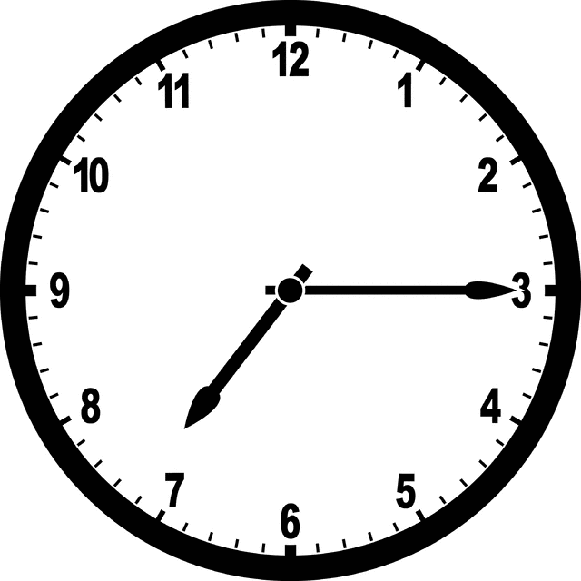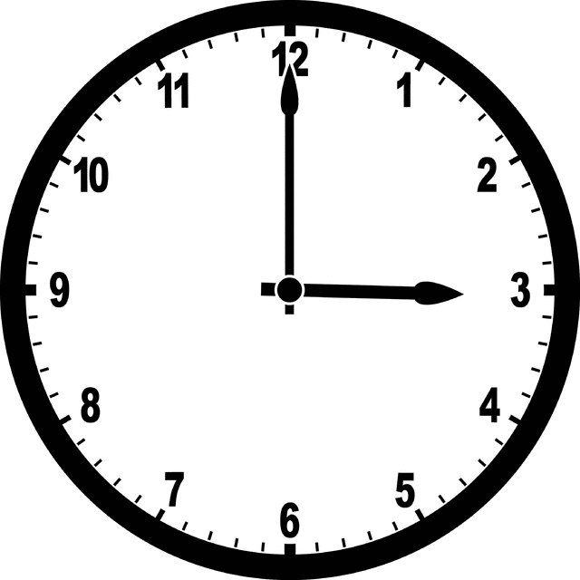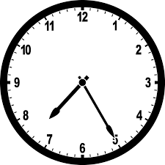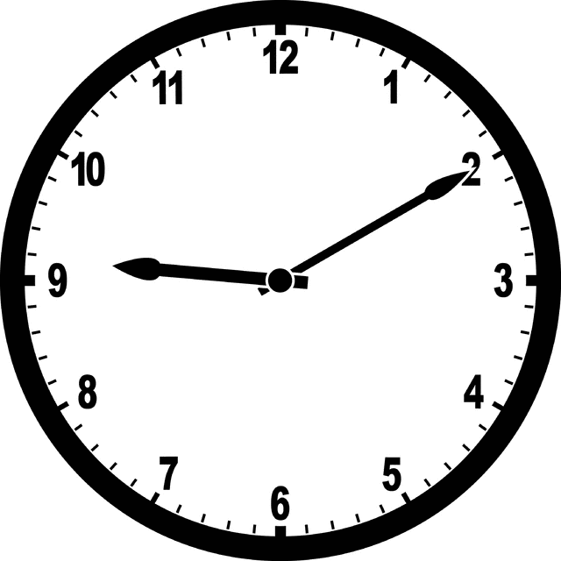
……………… ………………. ………………….. …………………………….
Q.13 Find out the area of a rectangular table tennis board of length 50cm and width 20cm
………………………………………………………………………………………………………………………………………………………………………………………………………………………………………………………………………………………………………………………..
Q.14 Draw a type of design , which would look the same after half a turn.

Q.15 How many faces and corners are there in a cuboid ?

Q.16 If the weight of a ball is 50 gms then find out the weight of 5 balls of same weight.

Short Answer Type Questions. (Q.17 to 22)
Instructions –Answer the following questions. Each question carries 3 marks.
Q.17 Draw the pattern forward

→
↗
↑

Q.18 How many doors, windows are there in the given map of a room
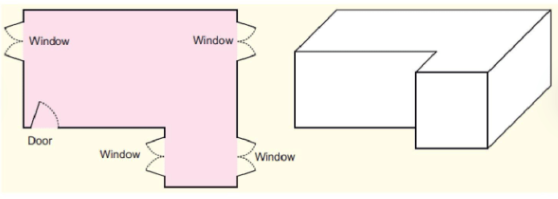
Q. 19 Convert 7.5 into fraction
Q. 20 A rectangular shape is formed by a 30 cm long wire. If the length of the rectangle is 9 cm then what will be its width.

Q. 21 Look at the chart and find out what part the children like playing football and what part like playing hocky?
What they like to do | Number of children
Playing Football | 25
Playing Hocky | 75
Q.22 Solve with Urdhva triyak method.
32 x 12

Long Answer Type Questions. (Q.23 to 26)
Instructions –Answer the following questions. Each question carries 5 marks.
Q.23 250 children of a school are going to a picnic. They will be taken in a bus. If 50 children can go in one bus. How many buses do they need ?

Q.24 Raju coloured 3/8 part of a wall on Monday, 4/8 part on Tuesday. How much area has he coloured in two days and how much area is left ?

Q.25 Find out HCF of 15,30,45.

Q.26 Rajesh borrowed 41580 rupees from his friend to buy a motorcycle. He returns the money in the next 6 months in equal amount. Find out how much money he gives to his friend every month?

