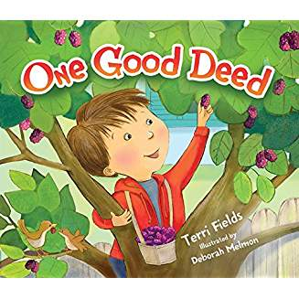
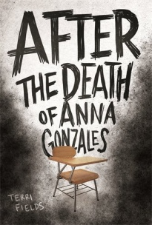
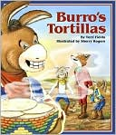
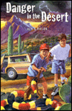
Terri Fields
www.terrifields.com
authorterrifields@yahoo.com

Thanks for asking about my author visits!
I love working with all grade levels, and I have age-appropriate books for grades K-12. Each presentation is unique and geared toward the group and school’s needs.
Grades 6-12—Two different workshops
Character and voice--I show students the importance of voice in writing. It is probably the hardest of the six traits for students to truly understand. They see how I create a biography of 22 questions to ask my characters before I begin to write. Then I show them how I have answered the questions for two different characters, and how those answers gave me the voice for those two characters.

When I have multiple days with the same group, this becomes the opening for a writing workshop. Next, I have the group create a character as a class. I have each student create a character, and finally, each student puts his/her character into a poem that s/he writes and revises. To totally complete this process, I spend an entire 5-day week with students. However, in a lesser amount of time, I take it as far as I can get. Students have produced some amazing writing from these workshops.
Sneak attack--I tell students a little about my writing and myself, and then I tell them that I'm going to turn the floor to them, that I just want to answer whatever questions they have about writing, about my books, about being an author. However, working within the context of whatever they ask, I work in 6-trait writing information, the importance of revision in writing and what constitutes revision versus rewriting, techniques to improve reading, and the importance of perseverance in creating effective writing. It's fun for me to reinforce the things English teachers have been telling the students with the students never realizing that I'm doing anything more than answering their questions. Having taught high school for many years, I realize that teens are always more impressed with the ideas they think they've generated!

Grades 3, 4, 5, 6
What I Really Want To Know Is…Each presentation is different, but in all of them, there are common themes. 1) the importance and effectiveness of revision in writing 2) ways to avoid writers' block or blank-page syndrome, 3) inspiration for starting a story, 4) the importance of persistence in creating successful writing 5) development of character 6) reading fluency If the school wishes, I can work in 6-trait writing and reading strategies. These presentations are interactive and energetic and leave students excited about reading and with ideas for their own creative writing.
Grades K-2
Be the Character—Be the writer! Children come to the front and become one of the various characters in Burro's Tortillas. In a fun, age-appropriate manner, this teaches them about characterization and voice. I also show them the steps in creating a book. OR Children look at lots of different animals from The Most Dangerous, discover what makes them dangerous, and then see if they can predict which animal is the most dangerous of all is and why. To end the presentation, I have the children help me lead the audience in what it takes to be a writer. It's a lot of fun, and I have all the children quite involved. I've had nice compliments from teachers on this presentation, but my favorite came from a class of 1st graders who, as I ended my presentation, begged their teacher, "Please...do we have to go to recess. Can't we just stay here instead?"

Teacher In-service
Creative Ways to Hook Reluctant Readers
Give teachers and opportunity to earn recertification credits and learn great information.
I am the award-winning author of books for kids from kindergarten through high school and a former Arizona Teacher of the Year, I provide teachers with a highly interactive workshop which invites new characters on the scene, dishes up different points of view, and plays with puns. It also works to help students understand voice through choral reading. By the time teachers leave, they’ll have directly participated in the laughter and the learning, and be ready to try a new group of tricks to get reluctant readers actively interacting with literature.

In addition to giving workshops for schools and school districts, I have been a featured presenter at National Teachers of English National Convention, The International Reading Association National Conference, and many regional ALA and IRA conferences.

Parent Night
I can provide a key note speech to involve parents and children in an interactive and entertaining speech about the importance of reading and ways to make reading a fun activity with their children. I am also available to autograph books sold that night. Some schools like to combine this with the author visit.

Lengths of School Visits
Multi Day I love doing writer-in-residence visits to schools. I tailor them to the school’s needs. I approach them not only as a successful writer, but for the 30+ years I taught, my students won creative writing contests every single year.

Full Day I will present 5 (50-60) minute sessions OR 6 sessions if 2 of them or no more than 25 minutes and the other 4 are 50-60 minutes. (Shorter sessions work better for grades K-2.) My author visits are high-energy, interactive, and filled with excitement. This is the best money-wise.

Half Day I will present 2 (50-60) minute sessions and one 25-minute session.

Assemblies I will present two assemblies, one for younger children and one for older children.

Skype Visits While in-person visits are always the best, I understand that costs and distances can sometimes make them impossible. I am happy to set up interactive Skype visits for a very reasonable price.

Costs Please do not hesitate to contact me asking for prices for any type of visit. Cost depends on length of visit and distance. I try to work with the school, and there is a discount if multiple schools from the same district book a visit. (You’ll never know if it can work unless you try!)
A Final Note
I adjust and personalize my presentations to my audience. In fact, at one school, the librarian mentioned to me that I was the first author she'd ever heard present totally different things to each session. I told her it probably comes from having been a teacher for 30 years. I can easily "modify and adjust!" I key in to my audience, make sure that I get the important points across and keep the kids in each group totally involved.

Whew! That was a lot to read, but you did it!

Do you still have questions?
Please ask. Just shoot an email to authorterrifields@yahoo.com

