1. login in to the http://portal.rack-experts.com/usercp/login and find the credentials for your session (if account is not created then create account using as same as scheduler email id)

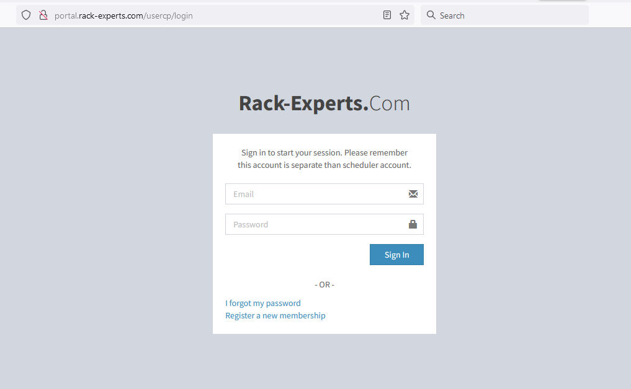

1. For NXOS session : <http://rack1.rack-experts.com:180/>

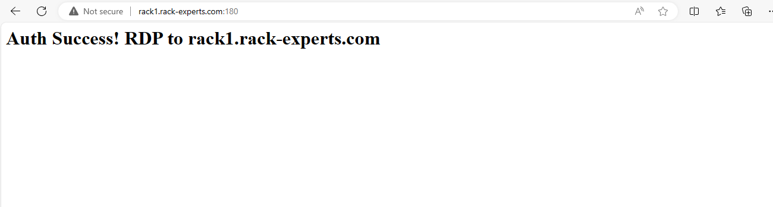

For UCS session : 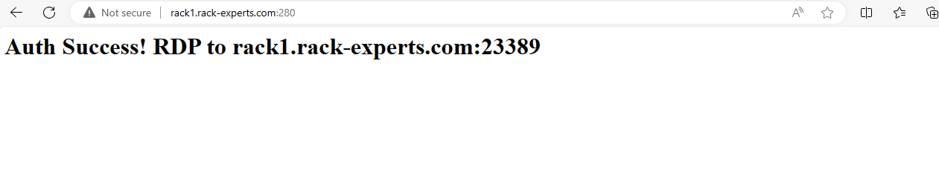

(Enter credentials collected from <http://portal.rack-experts.com/usercp/login>)

1. For taking RDP: press windows key+r and enter mstsc and hit enter

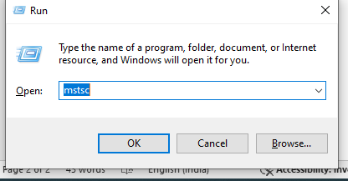

1. For NXOS session, enter rack1.rack-experts.com and click connect  
     
   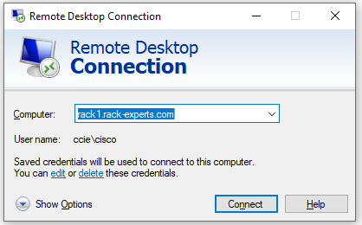

For UCS session, enter rack1.rack-experts.com:23389 and click connect

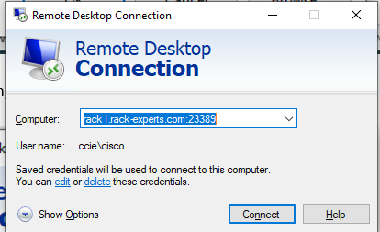

1. Click yes button

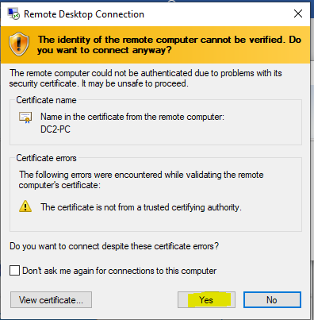

1. RDP Credentials

Username : cisco

Password : Cciedc01

**Device reset or Rollback**

**DC1-NXOS:**

1. Inside RDP machine **RESET RACK INITIAL** icon and click to open

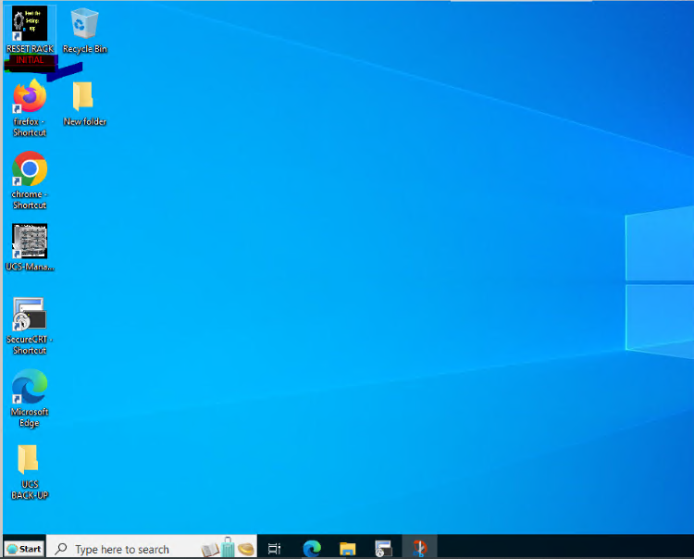

1. For LAB-1 NXOS devices reset or rollback click below options

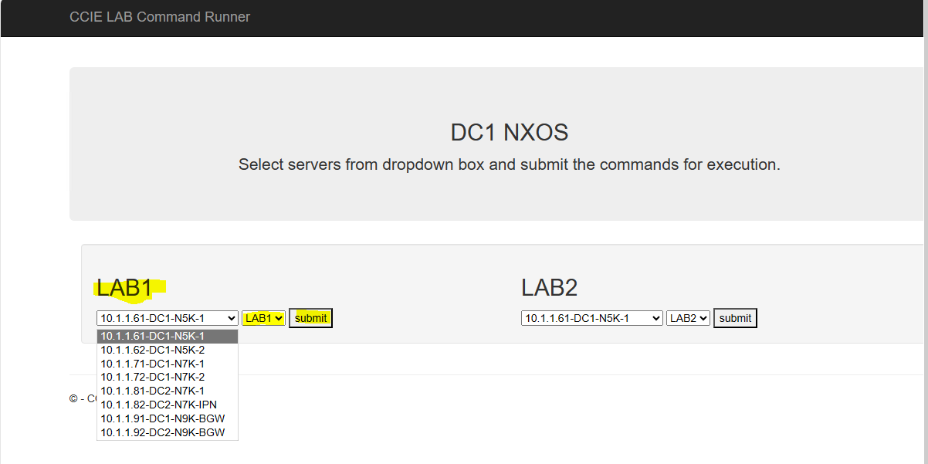

1. For LAB-3 NXOS devices reset or rollback click below options

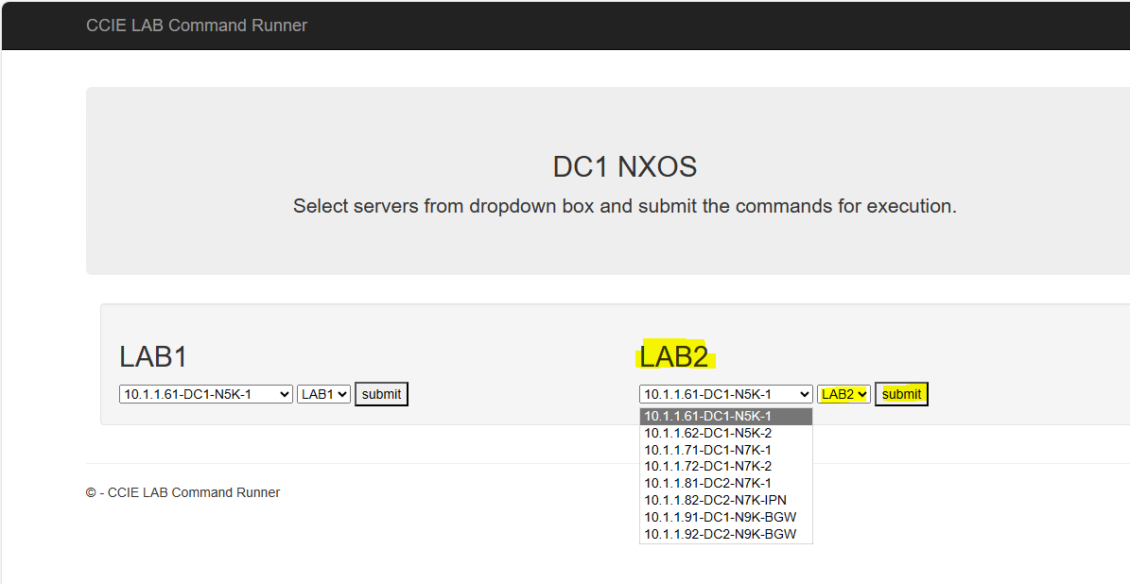

1. For DCNM (<https://10.1.1.217>)

Username : cisco

Password: Cciedc01

**DC2-UCS:**

1. Inside RDP machine **RESET RACK INITIAL** icon and click to open



1. For LAB-2 NXOS devices reset or rollback click below options

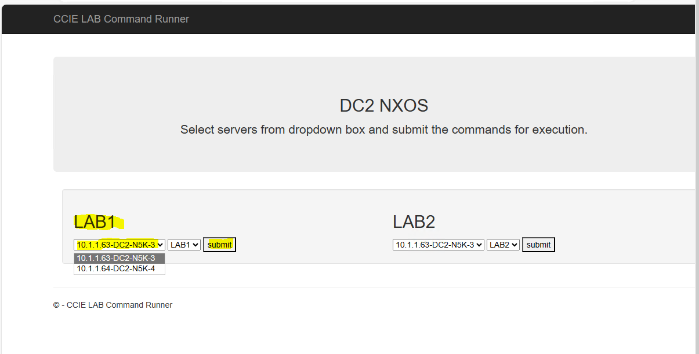

1. For LAB-3 NXOS devices reset or rollback click below options

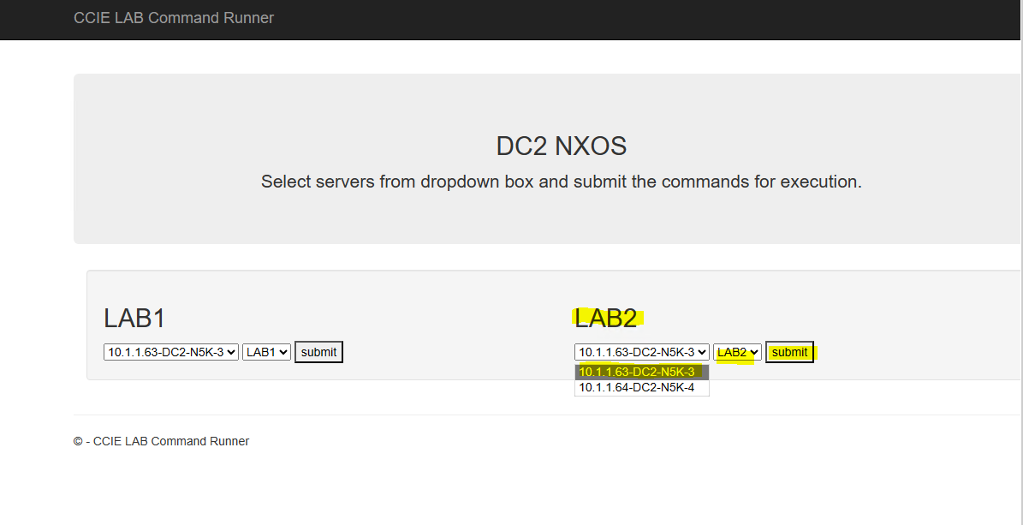

1. Login to UCS (<https://10.1.1.40>)

Username: cisco

Password: Cciedc01

Domain: TACACS

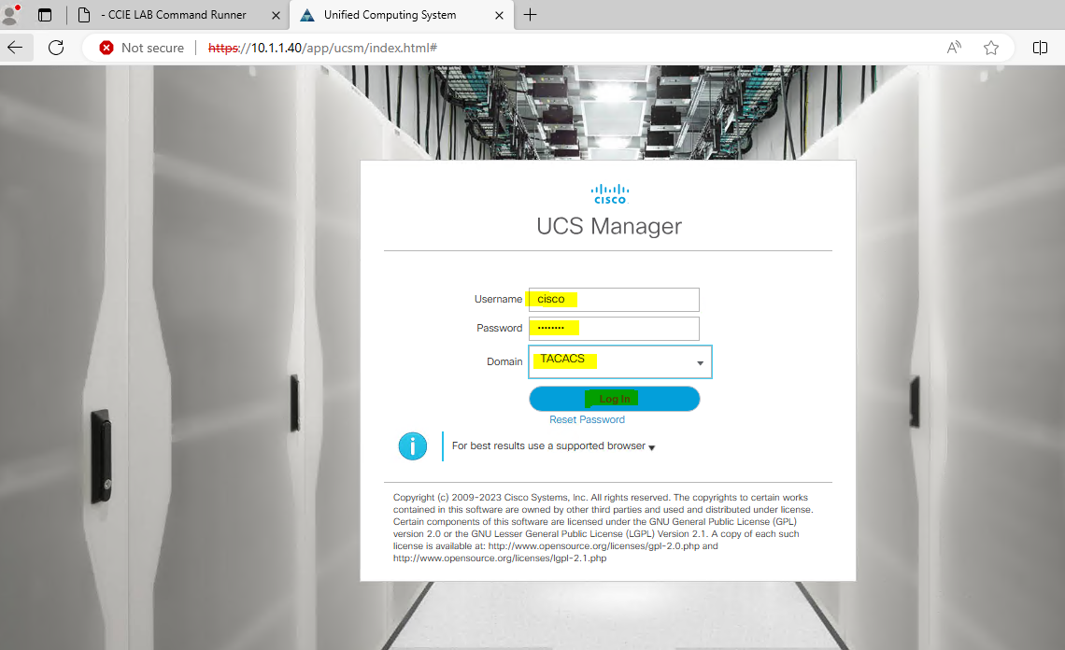

1. UCS rollback

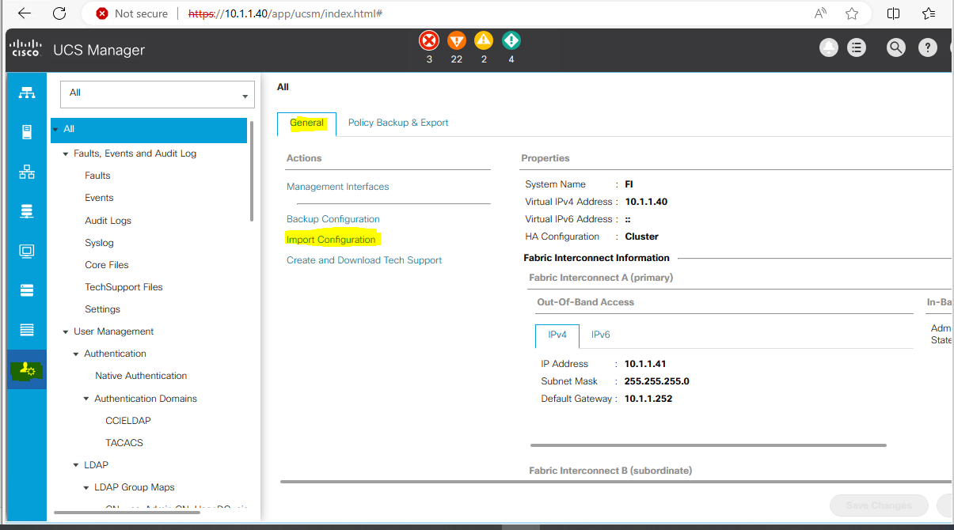

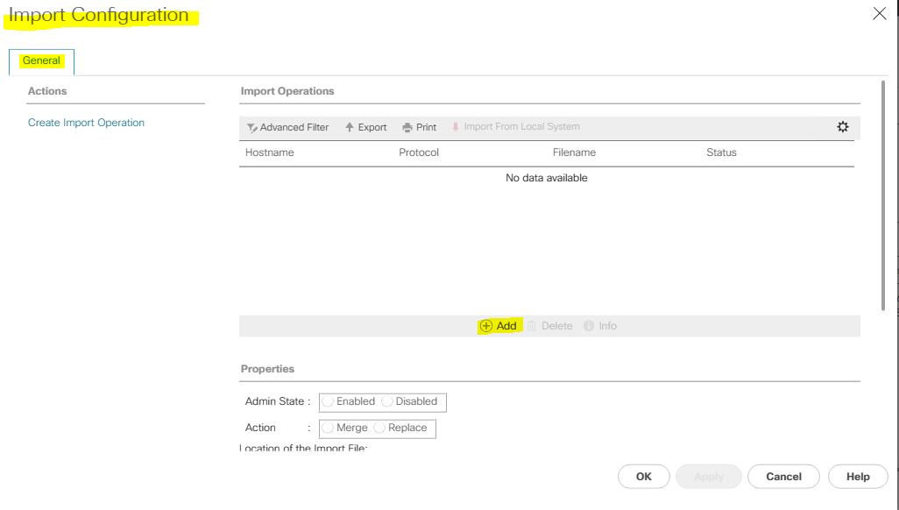

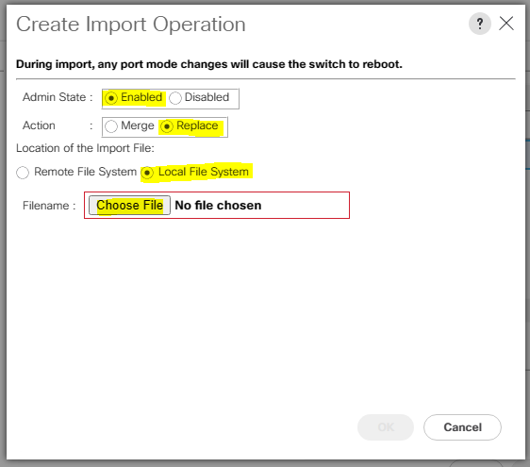

Based on your requirements select deploy-1 or deploy-3 file

