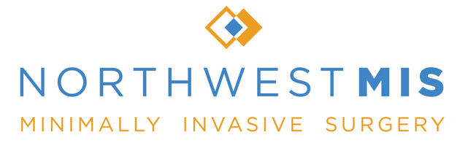

POST OPERATIVE INSTRUCTIONS: Peroral Endoscopic Myotomy (POEM)
Activity
First 2 days: take easy at home. Walking is encouraged for short distances and as frequently as tolerable. You may drive as long as no narcotics are taken within 8 hours.
1wk-4wks: May increase activity including bicycle riding, light jogging as tolerated. You may return to work with a note at this point. You may lift objects as tolerated.
Pain
Most pain is due to the incisions and can be controlled often ibuprofen alone. However, narcotics will be given after surgery, and should be used as needed. Avoid taking narcotics on an empty stomach to help prevent nausea from occurring.
Incisional pain typically last for up to a week, but varies with each patient. If refills are needed, please call the office during regular work hours 9am-4pm M-F. Narcotic refills will only be given during these hours when a physician is available.
Diet
First 24 hours: Clear liquid only
First 7 days: Anything you can take through a straw. Small frequent liquid-type meals. If you sense fullness, stop eating and take a break, then resume when it passes. Avoid ALL carbonated beverages. Crush pill (if possible)
Week 2: Soft foods only – please refer to the Soft Food Diet
Weigh loss is common during these diet changes. Additionally, take 1-2 tablespoons of Milk of Magnesia (available over the counter) every 6 hours on the third day home if you have not had a bowel movement.
Wound Care if Laparoscopic surgery was performed
The band-aids may be removed after 48 hours from surgery, at which time it is safe to shower. The underlying steri-strips are to remain on for 7 days total. After 7 days, it is easiest to remove them in the shower by peeling them off at the edges. The suture below is absorbable and therefore there is nothing else to remove. No baths, swimming pools, or saunas for at least 1 month after surgery.
Problems
Please contact us immediately if you experience any of the following: worsening nausea/vomiting increased pain, fevers (temp >100.4), redness or drainage from your incisions. If you think there is something wrong, please do not hesitate to call.
Appointment
We will need to see you approximately 2 weeks after the day of your surgery unless otherwise specified. Please call to make an appointment when you are released from the hospital and inform the receptionist that you need to make a post-operative appointment.

Daniel Tseng MD FACS Jeffrey Watkins MD
2222 NW Lovejoy Suite 322 Portland, OR 97210 9155 SW Barnes Suite 318 Portland OR 97210
P (503) 914-0024 F (503) 0025 www.northwestmis.com

